## 

**ENGLISH HL 08 March 2025 GRADE 12 LANGUAGE NOTES: Paper 1**

**Cartoons And Adverts**

**Notes Compiled by Ms J.Govender**

|  |  |  |
| --- | --- | --- |
|  | **Persuasive techniques** | **Aim/Intention/Purpose** |
| 1. | **Visual** – pictures / photos | **Identify** the **link** between the **text** (words) and the **image** (pictures).  **Adds credibility, validity, authenticity**.  To **convince, manipulate, persuade, highlight** and **makes it easier to understand**.  **Evokes** an **emotive response** – e.g., a **little teary-eyed toddler.** |
| 2. | Use of **personal pronouns**  **‘We’**, **‘Us’**, **‘You’** or **relating to a common**  **cause/shared view** | Shows **personal involvement and experience**.  **Adds credible, reliable, sincere and believable**.  **Involves us more directly**.  To **engage readers (participation)**.  Shows a **shared concern** – **comrades/friends**. |
| 3. | **Literary expressions, puns, clever sayings** | To **impress, astonish, imprint**.  Gets the **reader’s attention**. Makes you **remember – recall**. |
| 4. | **Repetition** | Has a **pounding effect** – hammers a point. Makes you **remember - Recall**. **Familiar**.  It **emphasises**.  To **add credibility, validity, authenticity**.  To **convince, manipulate, persuade**.  To **emphasise, highlight.** |
| 5. | **Rhetorical Questions** | To **provoke involvement**, an **emotional response**, **answer**, **reaction**.  To **involve reader more directly** / **personally**.  To **add credibility, validity, authenticity**. |
| 6. | **Emotive Adjectives** | Emotive words - e.g. A new principal. vs A new, foolish principal.  Emotive words **create an expectation/bias/prejudice**  … an unusual comment will now be seen as ‘foolish’. Just **ONE word can swing things**.  To **provoke emotional responses**.  To **emphasise, highlight**.  To **engage readers - (participation).**  To **encourage thinking/ an OPINION**. |
| 7. | **Numbers, statistics, data, research** | To **add credibility, validity, authenticity.**  To **convince, manipulate, persuade, emphasise, highlight**. |
| 8. | **Arouse** **feelings of** **Guilt** – **manipulation/exploitation/ blackmail** | **Encourage a response**, **play on feelings**.  To **encourage thinking/an opinion**.  To **involve us more directly / personally**. |
| 9. | **Font/Punctuation** | **Attract attention, to highlight, engage readers (participation).** |
| 11. | **Celebrities/**  **Avarice(greed)/Lifestyle/**  **Attractive people** | To **attract attention**. **Celebrity endorsements build credibility-validity, authenticity**.  To **engage readers (participation).**  To **encourage thinking/an opinion.**  To **manipulate**. |

**QUESTION 1 – TEXT A**

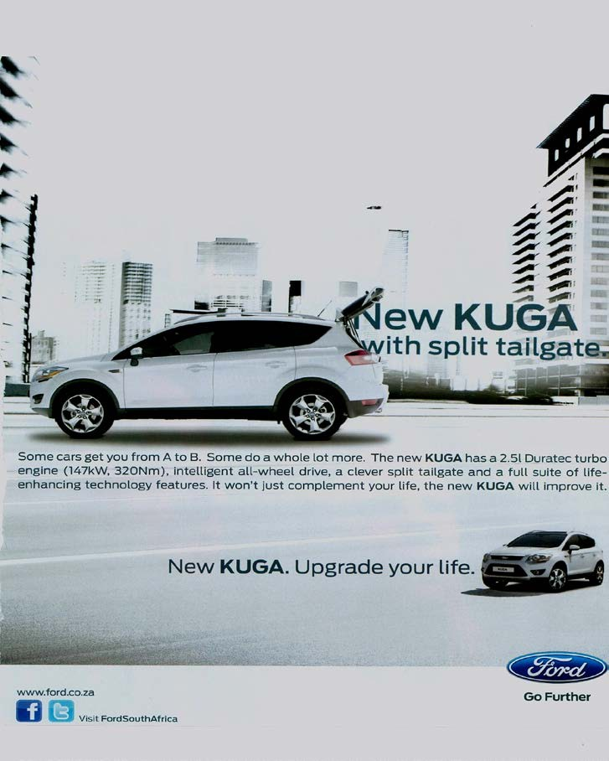

**[Source: *Elle*, August 2011]**

**The text in the advertisement reads:**

Some cars get you from A to B. Some do a whole lot more. The new **KUGA** has a 2.5 ℓ Duratec turbo engine (147 kW, 320 Nm), intelligent all-wheel drive, a clever split tailgate and a full suite of life-enhancing technology features. It won't just complement your life, the new **KUGA** will improve it.

**TEXT B**

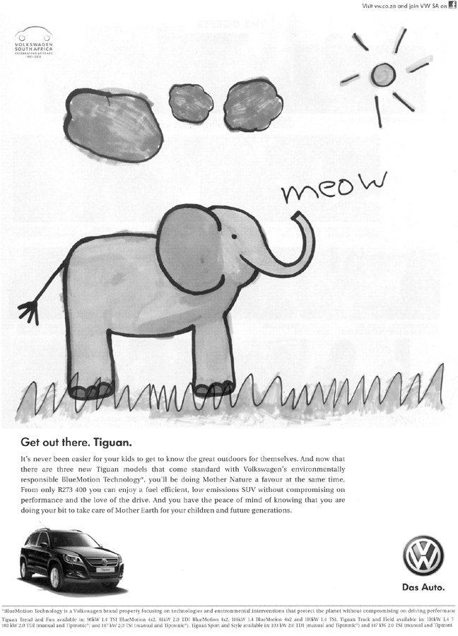

Get out there. Tiguan.

It's never been easier for your kids to get to know the great outdoors for themselves. And now that there are three new Tiguan models that come standard with Volkswagen's environmentally responsible BlueMotion Technology*, you'll be doing Mother Nature a favour at the same time. From only R273 400 you can enjoy a fuel efficient, low emissions SUV without compromising on performance and the love of the drive. And you have the peace of mind of knowing that you are doing your bit to take care of Mother Earth for your children and future generations.

*BlueMotion Technology is a Volkswagen brand property focusing on technologies and environmental interventions that protect the planet without compromising on driving performance.

|  |  |  |
| --- | --- | --- |
| 1.1 | Explain how the visual image supports the idea that the 'New KUGA' will  'Upgrade your life'. | (2) |

|  |  |  |
| --- | --- | --- |
| 1.2 | The advertiser makes reference to 'Mother Nature' and 'Mother Earth'.  Discuss whether these phrases are appropriate in context. | (2) |

|  |  |  |
| --- | --- | --- |
| 1.3 | In your opinion, is the illustration a suitable choice for the product being  advertised? Motivate your response. | (2) |

|  |  |  |
| --- | --- | --- |
| 1.4 | Carefully read the written texts of TEXT D and TEXT E.  Critically discuss the effectiveness of the style and language in conveying the intention of each of the advertisers. | (4)  [10] |

# **MARKING GUIDELINES**

|  |  |  |
| --- | --- | --- |
| 1.1 | The car is positioned amid modern city business blocks, suggesting that the  owner is highly successful. | (2) |

|  |  |  |
| --- | --- | --- |
| 1.2 | Yes.  Personifying nature shows that the company values the environment/gives the impression that the company prioritises environmental issues. 'Mother' has positive connotations such as nurturing. | (2) |

|  |  |  |
| --- | --- | --- |
| 1.3 | Yes.  The advertisement targets parents who would like to expose their children to the outdoors and/or are concerned about environmental issues. It captures attention since it is an unusual illustration for a vehicle. The fact that it is so much larger than the visual of the car conveys the advertisers concern for environmental issues in their technologies. The clouds, grass and sun are also relevant ideas. 'Meow' is 'cute'/ childlike and has pleasant connotations/links to a child's innocent consciousness.  No.  The childlike drawing detracts from the technological features of the product. It is unrealistic to believe that the public would accept the claim that families and the environment are the company's major concern. (2) |  |

|  |  |  |
| --- | --- | --- |
| 1.4 | TEXT A:  The intention is to attract a yuppie market/those who are image-conscious and ambitious with the short, snappy style and pseudo-scientific jargon. This is clearly captured in 'intelligent' and 'clever', suggesting that those who are bright and young will be attracted to the advanced technology offered. The term 'upgrade' links the car to the digital revolution which is important in the lives of such people.  TEXT B:  The whole advertisement is emotive, longer and colloquial. It plays on the currently fashionable interest in environmentalism. The emphasis on 'Mother', 'children' and 'future generations' is meant to appeal to young families. | (4) |

**Cartoons**

**WHEN ANALYSING A CARTOON, LOOK AT THE FOLLOWING ASPECTS:**

**ACTION:** What is happening in the cartoon?

**CHARACTERS:** The relationships between characters?

**LANGUAGE:**  How has punctuation/words -used to suggest emotion?

**SETTING:** Where and when is the cartoon set? Observe surroundings (background and foreground)

**FACIAL EXPRESSIONS:**

* Raised eyebrows: shock, enthusiasm, interest
* Furrowed eyebrows: scepticism, concentration focus, frustration
* Frown: sadness, confusion
* Smile: joy, pleased, satisfaction
* Enlarged eyes: shock, admiration, energetic
* Rolled eyes: annoyance, frustration
* Wide open mouth: excitement, shock, enthusiasm
* Smirk: satisfaction, conceited, smug, self- satisfied, playful
* Grimace: pain, disgust, disapproval

**BODY LANGUAGE:**

* **Outstretched arms:** exaggeration, emphasis
* **Slumped posture:** uninterested, bored, tired
* **Head buried hands:** overwhelmed, frustrated, tired, crying
* **Head placed on one hand:** annoyance, impatience, frustration
* **Head/ body turned away:**  disinterested, ignoring someone/something
* His **fury** is **indicated** by his **clenched fists**; he gnashes his teeth; he is sweating, **as shown** by the droplets.
* The **action lines** around his arms and legs **reinforce** the sense of his anger.
* Pointing/wagging index finger.
* Hand on hips – in control.

**CARTOON TERMINOLOGY**

|  |  |
| --- | --- |
| **TERM** | **EXPLANATION** |
| **FONT**  **PUNCTUATION** | It refers to the size and type of letters used. Larger or bold letters are used for emphasis.  Clever use of Punctuation to create meaning. !!!!! |
| **Tone** | The most important way in which words can create comic effect is through the tone used. Ask yourself the following questions.   * Is the writer being serious? * Is he mocking? * Is there a contract between seriousness of the character and the absurdity of the situation? |
| **Caricature** | When one or more physical features is exaggerated to convey a message. E.g. Huge hands that reach out could show that someone is greedy. |
| **Climax** | The climax of the cartoon is the most exciting or important moment in it, usually near the end, often after a series of events. |
| **Ellipses** | An ellipsis can show that a thought is extended and that the reader should consider what has been said.  It can show hesitation in the speaker.  It can create suspension. |
| **Contrast between frames …., action, font and diction/ Attitude** | Action: In frame 2, the speaker is contemplative and passive. In Frame 4, the scene is in stark **contrast** to Frame 2. The girl shouts, as **indicated by** her wide open mouth, and it results in the boy's tumbling on the bed. The action lines clearly demonstrate the difference between Frames 2 and 4.  Font: The font in Frame 4 is bold **as opposed** to the smaller font in Frame 2. **This highlights** how the girl shouts out her statement.  Text: The diction in Frame 2 denotes her sincere (or apparently sincere) 'caring' concern at waking her brother, **whereas**, in Frame 4, she is bullying and this is shown by the domineering tone. |
| **Layout** | Slanted frames- disorientation |
| **Absence of dialogue** | Character is shocked/lost for words. Looking directly at the reader as they are in a helpless situation. |
| **PARODY** | An imitation of a piece of writing used to ridicule the original or create a satirical point. |
| **Movement Lines** | These lines are squiggles that indicate movement or a specific action.  A powerful punch can be indicated by sharp movement lines around a hand and the person who is hit, this will then show aggression, anger etc. |
| **Thought Bubble** | A character is very deep in thought/ concentrating hard and is thus not speaking.  Someone has a thought but does not want to say it **aloud**; they do not want others to know what they are thinking.  This could be an exclamation, or a ‘secret’ comment, example: A character is annoyed with their classmates but will not voice their irritation (it stays in their thought bubbles) as it will lead to more, unnecessary conflict.  It could also show the thought **process** behind what has been said, for example: the thoughts of a child before asking their parent for money |
| **POINT OF HUMOUR** | |
| **Stereotype** | A fixed, generalised image of a character or person.  NOTE: Advertisers often create  stereotypical images in order to appeal to a specific target audience,  e.g. the dumb blonde, the perfect mother, the jet setter, the popular teenager.  Name the stereotyping and then say how it contributes to the effectiveness of the cartoon. |
| **Sarcasm** | One thing is said but something else is intended, like irony. The difference is that sarcasm intends to hurt, insult or humiliate.  “You must have worked *very hard* to be at the bottom of the class!” “Oh, you think you’re God’s *gift to mankind*, don’t you?” |
| **Anti-climax (Bathos)** | This is when tension is created and we expect something important or exciting to happen, but instead, the ending is very ordinary or a let-down.  A build-up of ideas, but the final statement is often flat and unexpected. Humour is created.  They lost everything in the fire: their home, their possessions and their lunch.  I intend to be a great writer, to write short stories and letters to the press. |

|  |  |
| --- | --- |
| **Satire** | In an amusing way, social or political weaknesses or stupidities are highlighted. The satirist uses sharp wit, irony or sarcasm to expose these follies. |
| **Pun** | The play on words is where two possible meanings of a word are referred to, one of them the expected meaning, the other an absurd or comic meaning in context. |
| **Irony** | When one thing is said, but something else is meant. |

**QUESTION 1: UNDERSTANDING OTHER ASPECTS OF THE MEDIA**

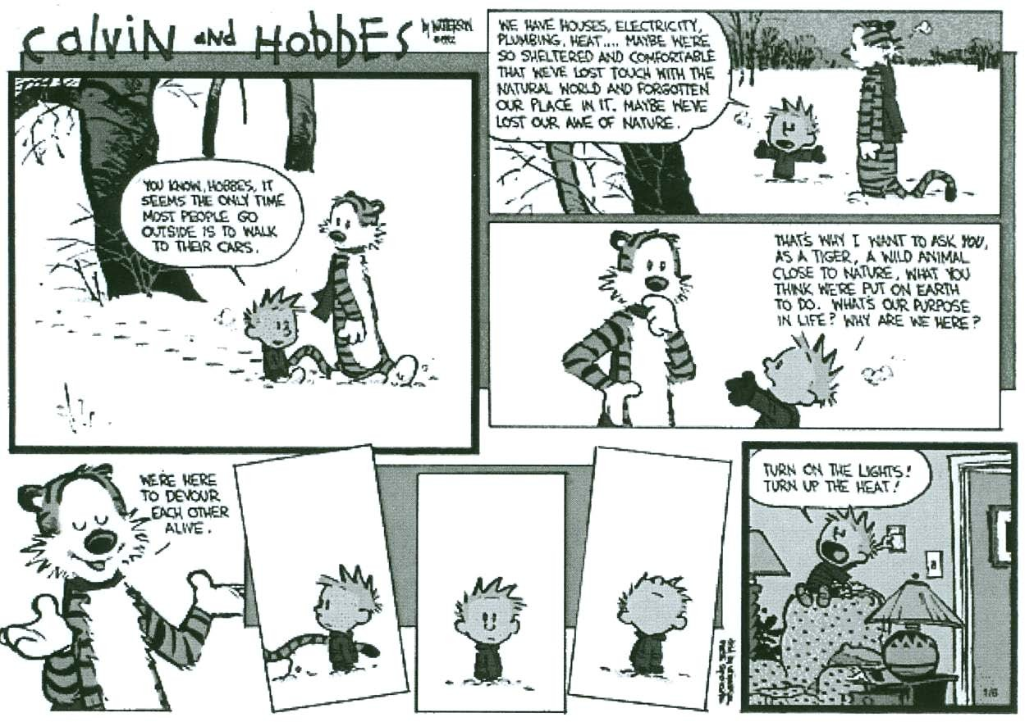

**YOU KNOW, HOBBES, IT SEEMS THE ONLY TIME MOST PEOPLE GO OUTSIDE IS TO WALK TO THEIR CARS.**

**WE HAVE HOUSES, ELECTRICITY, PLUMBING, HEAT ... MAYBE WE’RE SO SHELTERED AND COMFORTABLE THAT WE’VE LOST TOUCH WITH THE NATURAL WORLD AND FORGOTTEN OUR PLACE IN IT, MAYBE WE’VE LOST OUR AWE OF NATURE.**

**Frame 2**

**Frame 3**

**THAT’S WHY I WANT TO ASK YOU AS A TIGER, A WILD ANIMAL CLOSE TO NATURE, WHAT YOU THINK WE’RE PUT ON EARTH TO DO. WHAT’S OUR PURPOSE IN LIFE? WHY ARE WE HERE**?

**Frame 1**

**WE’RE HERE TO DEVOUR EACH OTHER ALIVE.**

**TURN ON THE LIGHTS! TURN UP THE HEAT!**

|  |  |  |  |  |
| --- | --- | --- | --- | --- |
| **QUESTIONS ( Nov 2012)** | | |  | |
| 2.1 | | Explain what the language and illustration in frame 1 reveals about the  relationship between Calvin and Hobbes. | (2) | |

|  |  |  |
| --- | --- | --- |
| 2.2 | Suggest why the tiger's body language changes from frame 3 to frame 4. | (2) |

|  |  |  |
| --- | --- | --- |
| 2.3 | Discuss how humour is created in this cartoon. | (3) |

|  |  |  |  |  |  |  |  |  |  |  |  |  |  |  |
| --- | --- | --- | --- | --- | --- | --- | --- | --- | --- | --- | --- | --- | --- | --- |
| 2.4 | Refer to frames 5, 6 and 7.  Comment on the effectiveness of the techniques used by the cartoonist in these frames.  **MARKING GUIDELINES**   |  |  |  | | --- | --- | --- | | 2.1 | The footprints suggest that they have been walking together for a while. They are walking side-by-side and Hobbes is listening attentively to Calvin. The language used reveals the friendship that exists between the characters. The  casual tone indicates that they are comfortable with each other. | (2) |  |  |  |  | | --- | --- | --- | | 2.2 | The tiger is contemplative. He is perplexed by the question that Calvin has posed. In frame 4, his confidence/smugness is apparent. Hobbes is a tiger –  a carnivore/a clever cat that 'devours' the living. | (2) |  |  |  |  | | --- | --- | --- | | 2.3 | Humour is created through the use of irony. In frame 2, Calvin is philosophical and preaching to the tiger about how humans have lost touch with nature because of their need for comfort. However, in frame 8, it is evident that Calvin himself has difficulty in surviving without modern comforts. When he grasps that nature is deadly dangerous, he desperately wants the protection offered by the modern world. | (3) |  |  |  |  | | --- | --- | --- | | 2.4 | * The slanted panels/frames accurately capture Calvin's sense of isolation/ inability to respond to the tiger's remark. * The lack of text and speech bubbles is effective in conveying confusion. * In frame 5, we only see a piece of the tiger's tail, which makes us wonder whether the tiger will act on what he suggests in frame 4. * The direction in which Calvin is facing in each of the frames is an indication of his disorientation/fears/confusion about the friendship he shares with the tiger. | (3)  **[10]** | |  |