**THE ORIGIN OF MAN ACCORDING TO THE THEORY OF EVOLUTION (ANTHROPOLOGY)**

**EXAM PREPARATION**

**PAPER 2 – NOVEMBER 2019**

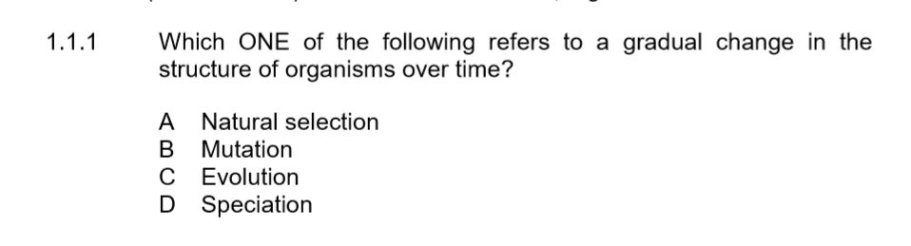

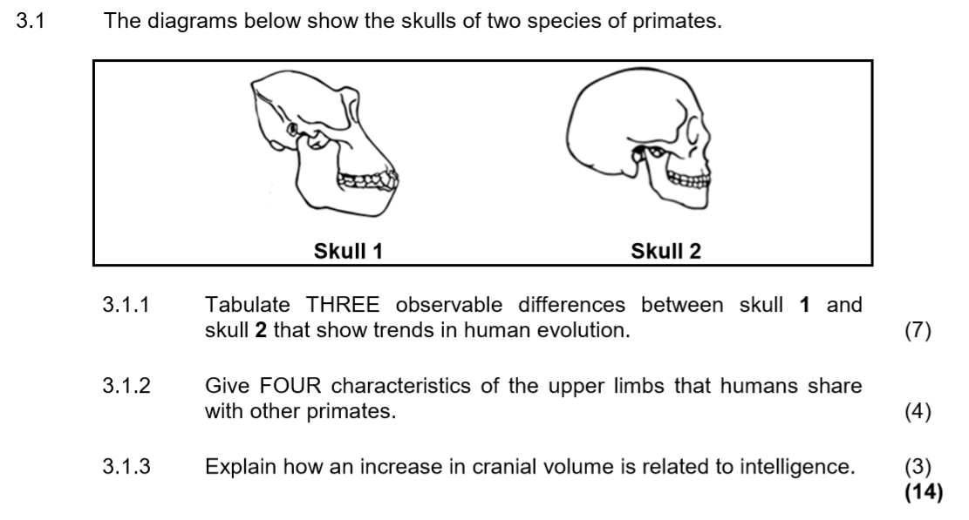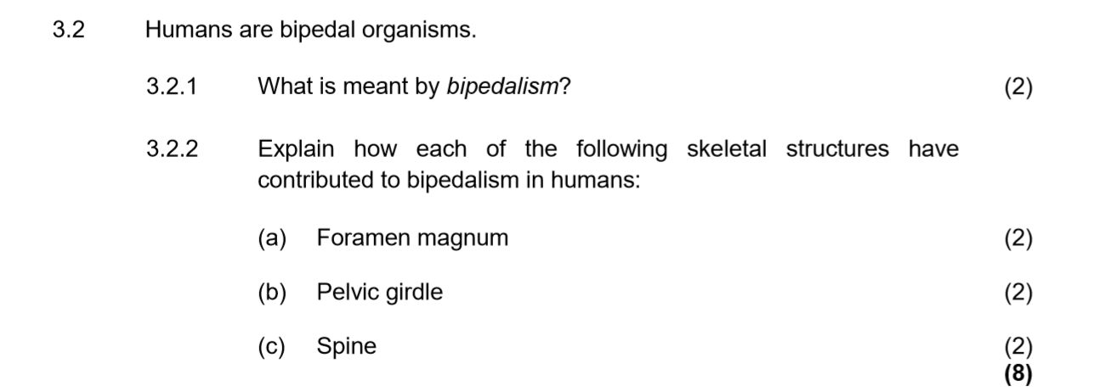

**PAPER 2 – NOVEMBER 2018**

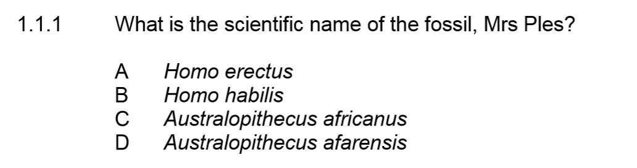

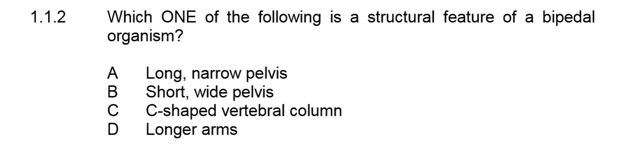

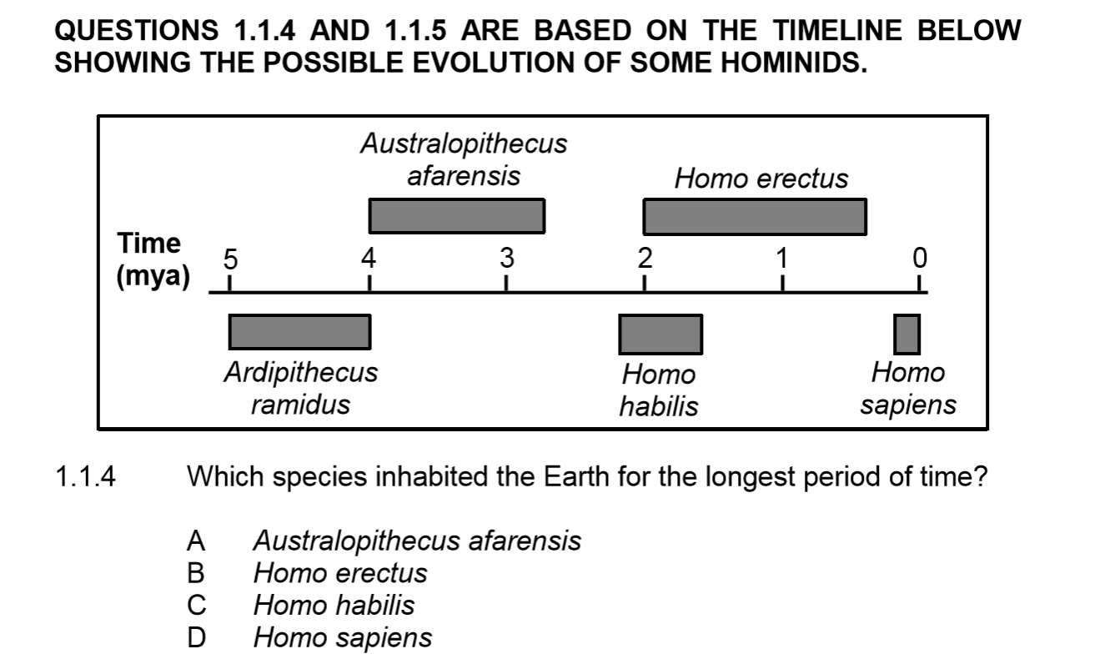

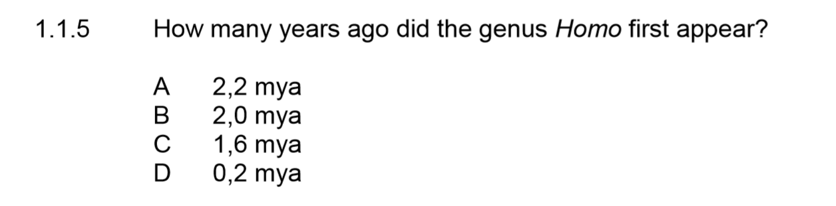





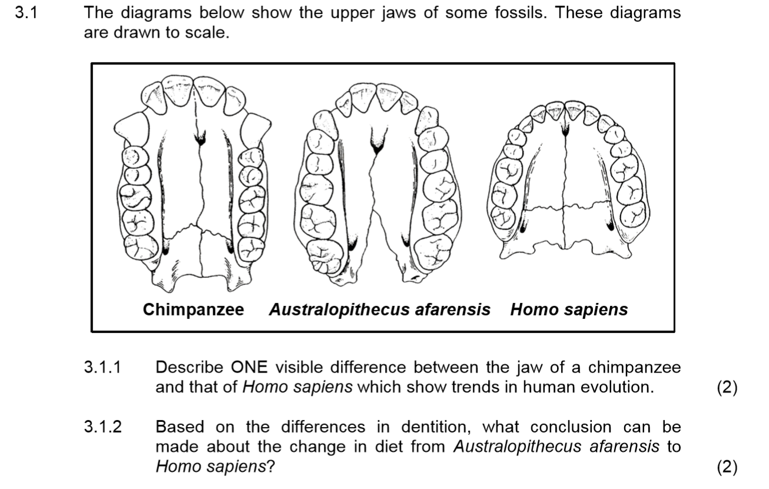

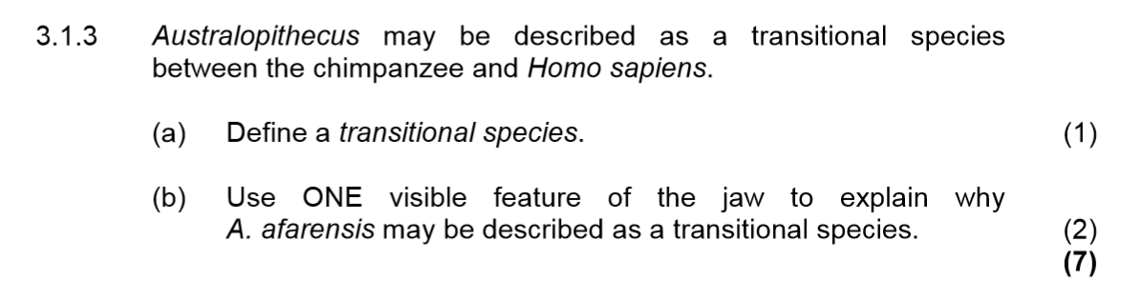

**PAPER 2 – NOVEMBER 2017**





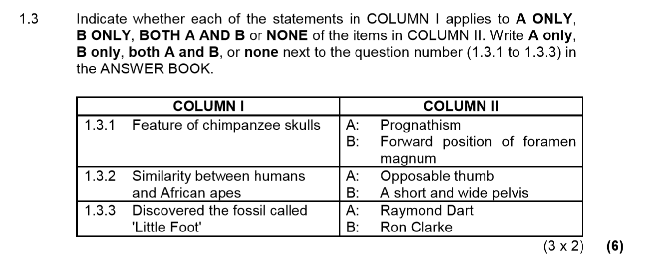

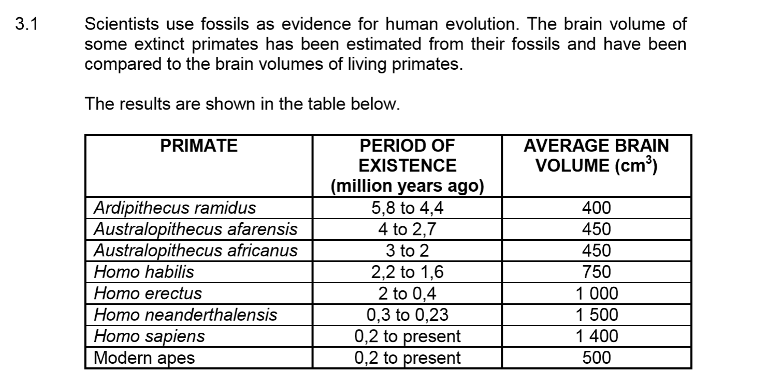

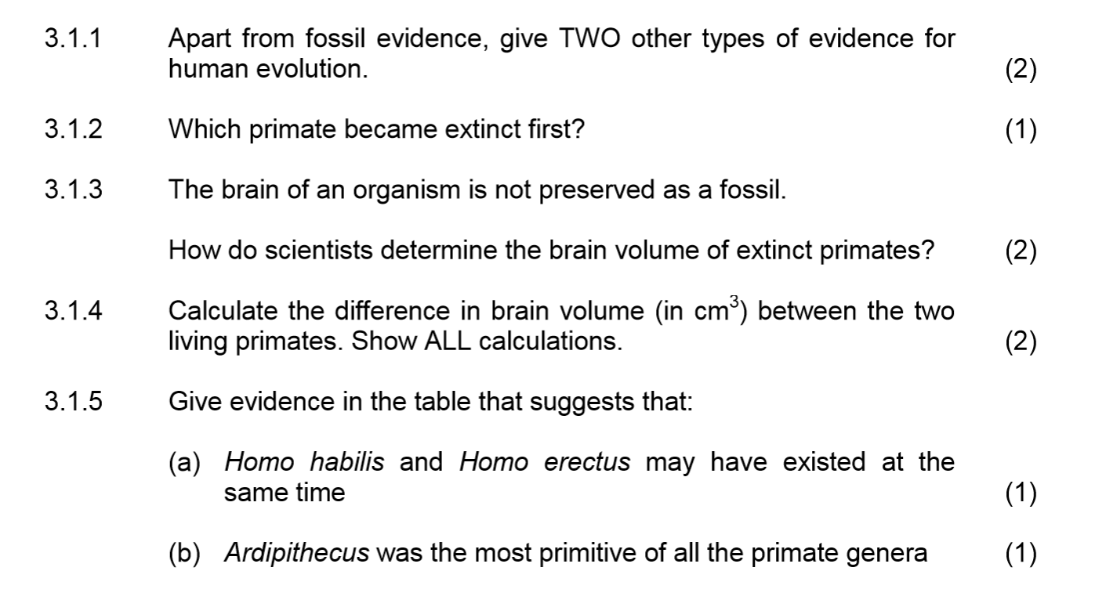

**PAPER 2 – NOVEMBER 2022**

