REVISION
Cℓˉ
CHEMICAL CHANGE: GALVANIC CELLS

TERMS AND DEFINITIONS
Anode | The electrode where oxidation takes place.  In a galvanic cell it is the negative electrode.
Cathode | The electrode where reduction takes place.  In a galvanic cell it is the positive electrode.
Cell notation | A shorthand way of specifying a galvanic cell.  - Cell terminals (electrodes) are written on the outside of the cell notation.  - || = salt bridge and | = phase separation e.g. between gas and solution.  - Order always: RA | oxidized species || OA | reduced species.  E.g.: Ni(s) | Ni ²⁺ (1 mol.dm⁻³) || Ag⁺ (1 mol.dm⁻³ | Ag(s)  - If inert electrodes used: Pt | RA | oxidized species || OA | reduced species|Pt.  E.g.: Mg(s) | Mg²⁺(1 mol∙dm⁻³) || H⁺(1 mol∙dm⁻³) | H₂(g) | Pt(s)
Cell potential | Measure of the potential difference between two half-cells in an electrochemical cell. Formula: E^{θ}_{cell} = E^{θ}_{cathode} – E^{θ}_{anode}
Electrode | A solid electric conductor through which an electric current enters or leaves an electrolyte.
Electrolyte | A solution that conducts electricity through the movement of ions.
External circuit | The wires that connect the two electrodes in the half-cells, light bulbs, meters.
Galvanic cell | An electrochemical cell in which chemical energy is transferred to electrical energy.
Internal circuit | The electrolytes in the half-cell as well in the salt bridge.
Oxidation number | Charge that an atom would have if all bonds formed are ionic.
Oxidation | Loss of electrons OR increase in oxidation number.
Oxidising agent | The substance that is reduced OR gains electrons OR whose oxidation number decreases.
Reduction | Gain of electrons OR decrease in oxidation number.
Reducing agent | The substance that is oxidised OR loses electrons OR whose oxidation number increases.
Salt bridge | A bridge of a salt solution (usually potassium chloride) placed between the two half-cells of a galvanic cell to maintain electrical neutrality in the cell and completes the circuit.
Standard conditions for a galvanic cell | Temperature = 25 °C / 298 K  Pressure = 1 atmosphere / 101,3 kPa (1,013 x 10⁵ Pa)  Concentration of electrolytes = 1 mol∙dm⁻³
Standard hydrogen electrode (SHE) | The reference electrode used to compile the Table of Standard Reduction Potentials  Cell potential: 0,00 V Cell notation (if anode): Pt(s) | H₂(g) | H⁺(1 mol∙dm⁻³)
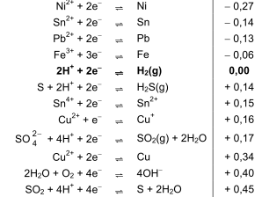
Most negative reduction potential
Strongest reducing agent
Most positive reduction potential
Strongest oxidising agent
Most negative reduction potential
Weakest oxidising agent
Most positive reduction potential
Weakest reducing agent
Section of the TABLE OF STANDARD REDUCTION POTENTIALS (4B)

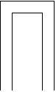
Galvanic cells
OR
Voltaic cells
TYPE OF ELECTROCHEMICAL CELL in which chemical energy is converted to electrical energy.
Spontaneous redox reaction takes place.
The reaction is exothermic i.e. energy is released.
Cell reactions involving gases
One inactive electrode;
One active electrode
Mg
Mg²⁺(aq)
Cℓ⁻(aq)
Pt
°
°
°
°
°
°
°
°
°
Cℓ₂(g)
V
salt bridge
Anode
Oxidation
Mg → Mg²⁺ + 2e⁻
Cell reaction: Mg + Cℓ₂ → Mg²⁺ + 2Cℓ⁻

Cell notation: Mg(s) | Mg²⁺(aq) || Cℓ₂(g) | Cℓ⁻(aq) | Pt(s)
Cathode
Reduction
2Cℓ₂ + 2e⁻ → 2Cℓ⁻

The half-reaction with the more negative reduction potential is always the oxidation and takes place at the anode.
The half-reaction with the more positive reduction potential is always the reduction and takes place at the cathode.
Anode
Oxidation
Zn → Zn²⁺ + 2e⁻
Cell reaction: Cu²⁺ + Zn → Zn²⁺ + Cu

Cell notation: Zn(s) | Zn²⁺(1 mol·dm⁻³) || Cu²⁺(1 mol·dm⁻³) | Cu(s)
Cathode
Reduction
Cu²⁺ + 2e⁻ → Cu

salt bridge
Zn
Cu
Zn⁺(aq)
Cu⁺(aq)
V
Active electrodes
graphite
V
graphite
I⁻(aq)
I₂(s)
MnO₄(aq);
Mn²⁺(aq)
H⁺(aq)
Cathode
Reduction
MnO
+ 8H⁺ + 5e⁻→ Mn²⁺ + 4H₂O
Cell reaction: 2MnO
+ 16H⁺ + 10I⁻ → 2Mn²⁺ + 5I₂ + 8H₂O
Cell notation: C(s) | I⁻(aq) | I₂(s) || H⁺(aq), MnO
(aq), Mn²⁺(aq) | C(s)
Anode
Oxidation
2I⁻→ I₂ + 2e⁻

If all reactants and products are solutions or solids (e.g. I₂) that are non-conductors.
salt bridge
Inactive electrodes

Rules for assigning oxidation numbers:
Cℓˉ
- The convention is that the cation is written first in a formula, followed by the anion. For example, in NaH, the H is H-; in HCl, the H is H+.
- The oxidation number of a free element is always 0. The atoms in He and N₂, for example, have oxidation numbers of 0.
- The oxidation number of a monatomic ion equals the charge of the ion. For example, the oxidation number of Na⁺ is +1; the oxidation number of N³⁻ is -3.
- The usual oxidation number of hydrogen is +1. The oxidation number of hydrogen is -1 in compounds containing elements that are less ​electronegative than hydrogen, as in CaH₂.
- The oxidation number of oxygen in compounds is usually -2. Exceptions include OF₂ because F is more electronegative than O, and BaO₂, due to the structure of the peroxide ion, which is [O-O]²⁻.
- The oxidation number of a Group IA element in a compound is +1.
- The oxidation number of a Group IIA element in a compound is +2.
- The oxidation number of a Group VIIA element in a compound is -1, except when that element is combined with one having a higher electronegativity. The oxidation number of Cl is -1 in HCl, but the oxidation number of Cl is +1 in HOCl.
- The sum of the oxidation numbers of all of the atoms in a neutral compound is 0.
- The sum of the oxidation numbers in a polyatomic ion is equal to the charge of the ion. For example, the sum of the oxidation numbers for SO₄²⁻ is -2.

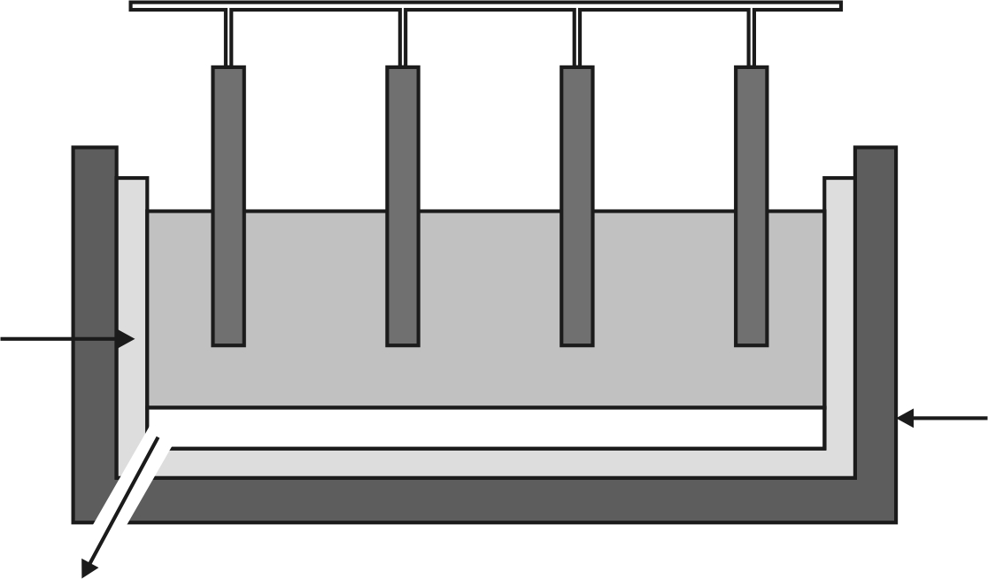
Electrolytic cells
PROCESS in which electrical energy is converted to chemical energy
Electrolysis
TYPE OF ELECTROCHEMICAL CELL in which electrical energy is converted to chemical energy
Solutions using ACTIVE electrodes
Basic components:
Two electrodes
•An electrolyte – solution/ melt that conducts electricity through the motion of ions
•A source of direct electric current
Molten salts using INERT electrodes
Extraction of aluminium
Positive carbon anodes
Carbon
cathode

Aluminium is drained
aluminium
aluminium oxide + cryolite
Steel
container
Aℓ³⁺ + 3e– → Aℓ
2Aℓ₂O₃(ℓ) → 4Aℓ(ℓ) + 3O₂(g)
2O²⁻ → O₂ + 4e⁻
Electrolysis of molten sodium chloride
Anode Cathode
Carbon
electrode
2Cℓˉ → Cℓ₂ + 2eˉ 2Na⁺ + 2eˉ → 2Na
2Na⁺(ℓ) +2Cℓˉ(ℓ) → 2Na(ℓ) + Cℓ₂(g)

Molten
NaCℓ
Na⁺

Cℓˉ
Carbon
electrode
+
eˉ
Electrolysis of a copper(II) solution
Refining of copper
eˉ
+
Anode Cathode
Copper
electrode
Cu → Cu²⁺ + 2eˉ Cu²⁺ + 2eˉ → Cu

Cu²⁺(aq) + Cu(s) → Cu(s) + Cu²⁺(aq)

CuCℓ₂(aq)
Cu²⁺

Copper
electrode
H₂O
Cℓˉ
Solutions using INERT electrodes
Chlor-alkali industry
Electrolysis of a sodium chloride solution
+
Anode Cathode
Carbon
electrode
2Cℓˉ → Cℓ₂ + 2eˉ 2H₂O + 2eˉ → H₂ + 2OHˉ

2H₂O(ℓ) + 2Cℓˉ(aq) → H₂(g) + 2OHˉ(aq) + Cℓ₂(g)
NaCℓ(aq)
Na⁺
Carbon
electrode
H₂O
Cℓˉ
eˉ
Electrolysis of a copper(II) chloride solution
Anode Cathode
Carbon
electrode
2Cℓˉ → Cℓ₂ + 2eˉ Cu²⁺ + 2eˉ → Cu

Cu²⁺(aq) + 2Cℓˉ(aq) → Cu(s) + Cℓ₂(g)
CuCℓ₂(aq)
Cu²⁺

Carbon
electrode
H₂O
Cℓˉ
+
eˉ
Does not take part in reaction

Takes part in reaction

Electroplating
+
Anode Cathode
Metal
electrode
Ag → Ag⁺ + eˉ Ag⁺ + eˉ → Ag

Ag⁺(aq) + Ag(s) → Ag(s) + Ag⁺(aq)

AgNO₃(aq)
Ag⁺

Silver
electrode
H₂O
eˉ
Cathode: object to be plated
Electrolyte: ions of metal used as plate
Anode: Metal used as plate

Both electrodes made of Cu
Electrolyte: Cu²⁺ ions
Anode: impure copper
Electrolyte: ions of metal used as plate

Cℓˉ

