**GRADE 12 REVISION**

**MECHANICS: WORK, ENERGY AND POWER.**

**MULTIPLE-CHOICE QUESTIONS**

1. The engine of a car does work, **W**, to increase the velocity of the car from 0 to v. The work done by the engine to increase the velocity from v to 2v, is:

A **W**

B 2**W**

C 3**W**

D 4**W**

2. The graph below represents a constant force **F** acting on an object over a displacement x. The force and displacement are in the same direction.

**force (N)**

**x**

**0**

**F**

**displacement (m)**

Which ONE of the following statements can be deduced from the graph?

A The gradient of the graph represents the work done by the force.

B The gradient of the graph represents the change in kinetic energy of the object.

C The area under the graph represents the net work done by the force.

D The area under the graph represents the power dissipated by the force.

3. An object moves in a straight line on a ROUGH horizontal surface. If the net work done

on the object is zero, then …

A the object has zero kinetic energy.

B the object moves at constant speed.

C the object moves at constant acceleration.

D there is no frictional force acting on the object.

4. Consider the statements below:

I Work is done on an object when a force displaces the object in the direction

of the force.

II Mechanical energy of a system is conserved when an external force

does no work on the system.

III The work done on an object by a net force is equal to the kinetic

energy of the object.

Which of the above statements is/are TRUE?

A Only I

B I and II only

C II and III only

D I, II and III

5. An object is pulled along a straight horizontal road to the right without being lifted. The

force diagram below shows all the forces acting on the object.

f

F



w

N

Which ONE of the above forces does POSITIVE WORK on the object?

A w

B N

C f

D F

6. A car moves up a hill at CONSTANT speed. Which ONE of the following represents the work done by the weight of the car as it moves up the hill?

A ΔEk

B ΔEp

C −ΔEk

D −ΔEp (2)

**STRUCTURED QUESTIONS**

**QUESTION 10**

A worker pulls a crate of mass 30 kg from rest along a horizontal floor by applying a constant force of magnitude 50 N at an angle of 30° to the horizontal. A frictional force of magnitude 20 N acts on the crate whilst moving along the floor.

30°

50 N

6 m

30 kg

P

O

10.1 Draw a labelled free-body diagram to show ALL the forces acting on the crate during

its motion.

10.2 Give a reason why each of the vertical forces acting on the crate do NO WORK on

the crate.

10.3 Calculate the net work done on the crate as it reaches point **P**, 6 m from the starting

point **O**.

10.4 Use the work-energy theorem to calculate the speed of the crate at the instant it

reaches point **P**.

10.5 The worker now applies a force of the same magnitude, but at a SMALLER ANGLE to

the horizontal, on the crate.

How does the work done by the worker now compare to the work done by the worker in QUESTION 10.3? Write down only GREATER THAN, SMALLER THAN or EQUAL TO.

Give a reason for the answer. (No calculations are required.)

**QUESTION 11**

A rescue helicopter is stationary (hovers) above a soldier. The soldier of mass 80 kg is lifted vertically upwards through a height of 20 m by a cable at a CONSTANT SPEED of 4 m∙s-1. The tension in the cable is 960 N. Assume that there is no sideways motion during the lift. Air friction is not to be ignored.

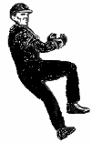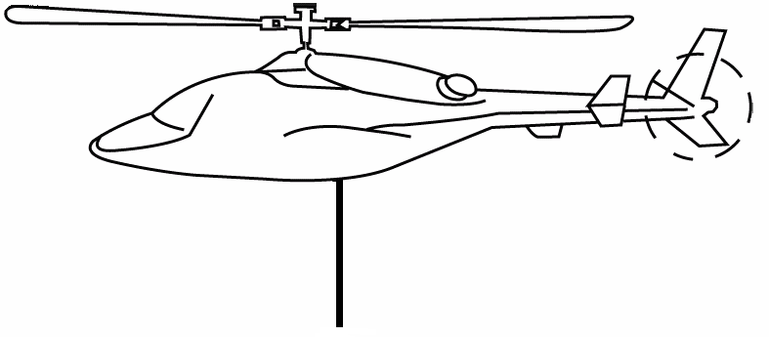

960 N

80 kg

11.1 State the work-energy theorem in words.

11.2 Draw a labelled free-body diagram showing ALL the forces acting on the soldier while

being lifted upwards.

11.3 Write down the name of a non-contact force that acts on the soldier during the upward

lift.

11.4 Use the WORK-ENERGY THEOREM to calculate the work done on the soldier by

friction after moving through the height of 20 m.

**QUESTION 4**

The bounce of a cricket ball is tested before it is used. The standard test is to drop a ball from a certain height onto a hard surface and then measure how high it bounces.

During such a test, a cricket ball of mass 0,15 kg is dropped from rest from a certain height and it strikes the floor at a speed of 6,2 m∙s-1. The ball bounces straight upwards at a velocity of

3,62 m∙s-1 to a height of 0,65 m, as shown in the diagram below. The effects of air friction may be ignored.

0,65 m

0,15 kg

4.1 Define the term impulse in words.

4.2 Calculate the magnitude of the impulse of the net force applied to the ball during its

collision with the floor.

4.3 To meet the requirements, a cricket ball must bounce to one third of the height that

it is initially dropped from.

Use ENERGY PRINCIPLES to determine whether this ball meets the minimum requirements.

**QUESTION 5**

A wooden block of mass 2 kg is released from rest at point **P** and slides down a curved slope from a vertical height of 2 m, as shown in the diagram below. It reaches its lowest position, point **Q**, at a speed of 5 m∙s-1.

2 m

**P**

**Q**

2 kg

9 kg

5.1 Define the term *gravitational potential energy*.

5.2 Use the work-energy theorem to calculate the work done by the average frictional

force on the wooden block when it reaches point **Q**.

5.3 Is mechanical energy conserved while the wooden block slides down the slope?

Give a reason for the answer.

5.4 The wooden block collides with a stationary crate of mass 9 kg at point **Q**. After the collision, the crate moves to the right at 1 m∙s-1.

5.4.1 Calculate the magnitude of the velocity of the wooden block immediately after

the collision.

5.4.2 The total kinetic energy of the system before the collision is 25 J. Use a

calculation to show that the collision between the wooden block and the crate

is inelastic.

**QUESTION 6**

The diagram below represents how water is funnelled into a pipe and directed to a turbine at a hydro-electric power plant. The force of the falling water rotates the turbine.

Each second, 200 m3 of water is funnelled down a vertical shaft to the turbine below. The vertical height through which the water falls upon reaching the turbine is 150 m. Ignore the effects of friction.

NOTE: One m3 of water has a mass of 1 000 kg.

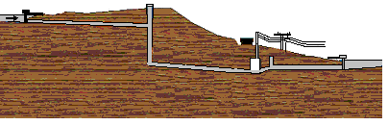

150 m

turbine

water inflow

6.1 Calculate the mass of water that enters the turbine each second.

6.2 Calculate the kinetic energy of this mass of water when entering the turbine. Use

energy principles.

6.3 Calculate the maximum speed at which this mass of water enters the turbine.

6.4 Assume that a generator converts 85% of this maximum kinetic energy gained by the

water into hydro-electricity. Calculate the electrical power output of the generator.

6.5 Explain what happens to the 15% of the kinetic energy that is NOT converted into

electrical energy.

**QUESTION 7**

A 3 kg block slides at a constant velocity of 7 m‧s-1 along a horizontal surface. It then strikes a rough surface, causing it to experience a constant frictional force of 30 N. The block slides 2 m under the influence of this frictional force before it moves up a frictionless ramp inclined at an angle of 20° to the horizontal, as shown in the diagram below.

The block moves a distance d up the ramp, before it comes to rest.

3 kg

3 kg

2 m

*d*

20°

7 m‧s-1

7.1 Show by calculation that the speed of the block at the bottom of the ramp is 3 m‧s-1.)

7.2 Draw a free-body diagram to show all the forces acting on the block in a direction

parallel to the incline, whilst the block is sliding up the ramp.

7.3 Calculate the distance, d, the block slides up the ramp.

**QUESTION 8**

John applies a force **F** to help his friend in a wheelchair to move up a ramp of length 10 m and a vertical height of 1,5 m, as shown in the diagram below. The combined mass of his friend and the wheelchair is 120 kg. The frictional force between the wheels of the wheelchair and the surface of the ramp is 50 N. The rotational effects of the wheels of the wheelchair may be ignored.

The wheelchair moves up the ramp at constant velocity.

*h* = 1,5 m

10 m

***F***

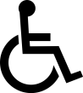

8.1 What is the magnitude of the net force acting on the wheelchair as it moves up the

ramp? Give a reason for your answer.

8.2 What is the magnitude of the net work done on the wheelchair on reaching the top

of the ramp?

8.3 Calculate the following:

8.3.1 Work done on the wheelchair by force **F**

8.3.2 The magnitude of force **F** exerted on the wheelchair by John

**QUESTION 1**

A 10 000 kg truck travels up a straight inclined road of length 23 m at a constant speed of

20 km∙h-1. The total work done by the engine of the truck to get there is 7 x 105 J. The work done to overcome friction is 8,5 x 104 J.

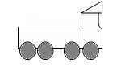

20 km∙h-1

20 km∙h-1

h

23 m

1.1 Calculate:

1.1.1 The height, h, reached by the truck at the top of the road

1.1.2 The instantaneous power delivered by the engine of truck

1.2 Arrestor beds are constructed as a safety measure to allow trucks to come to rest when their brakes fail whilst going downhill. Write down TWO design features of such arrestor beds.

**QUESTION 2**

A box of mass 60 kg starts from rest at height h and slides down a rough slope of length 10 m, which makes an angle of 25° with the horizontal. It undergoes a constant acceleration of magnitude 2 m∙s-2 while sliding down the slope.

*h*

25°

10 m

60 kg

2.1 State the work-energy theorem in words.

2.2 Draw a free-body diagram to show ALL the forces acting on the cardboard box while it slides down the slope.

2.3 The box reaches the bottom of the slope. Calculate the following:

2.3.1 The kinetic energy of the box, using the equations of motion

2.3.2 The work done on the box by the gravitational force

2.3.3 The work done on the box by the frictional force, using the work-energy theorem

2.3.4 The magnitude of the frictional force acting on the box

**QUESTION 3**

A crate of mass 70 kg slides down a rough incline that makes an angle of 20° with the horizontal, as shown in the diagram below. The crate experiences a constant frictional force of magnitude

190 N during its motion down the incline. The forces acting on the crate are represented by **R**, **S** and **T**.

**20°**

⦁

⦁

**12 m**

**A**

**B**

**R**

**S**

**T**

3.1 Label the forces **R**, **S** and **T**. (3)

3.2 Give a reason why force **R** does no work on the crate. (2)

The crate passes point **A** at a speed of 2 m∙s-1 and moves a distance of 12 m before reaching

point **B** lower down on the incline.

3.3 Calculate the net work done on the crate during its motion from point **A** to point **B**. (5)

3.4 Write down the work-energy theorem in words. (2)

3.5 Use the work-energy theorem to calculate the speed of the crate at point **B**. (4)

**[16]**

**QUESTION 9**

A steel ball of mass 0,5 kg is suspended from a string of negligible mass. It is released from rest at point **A**, as shown in the sketch below. As it passes through point **B**, which is 0,6 m above the ground, the magnitude of its velocity is 3 m∙s-1. (Ignore the effects of friction.)

**C**

3,5 m∙s-1

0,6 m

0,5 kg

**B**

**A**

**B**

9.1 Write down the principle of the conservation of mechanical energy in words.

9.2 Calculate the mechanical energy of the steel ball at point **B**.

As the steel ball swings through its lowest position at point **C**, it collides with a stationary crate of mass 0,1 kg. Immediately after the collision, the crate moves at a velocity of 3,5 m∙s-1 to the right.

9.3 Calculate the velocity of the steel ball immediately after the collision.

**QUESTION 12**

In order to measure the net force involved during a collision, a car is allowed to collide head-on with a flat, rigid barrier. The resulting crumple distance is measured. The crumple distance is the length by which the car becomes shorter in coming to rest.

Before collision After collision

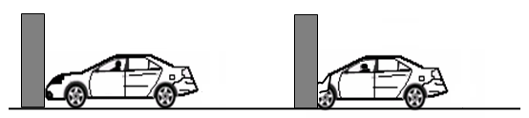

x1

x2

In one of the tests, a car of mass 1 200 kg strikes the barrier at a speed of 20 m∙s−1. The crumple distance, (x1 – x2), is measured as 1,02 m. (Ignore the effects of frictional forces during crumpling.)

12.1 Draw a labelled free-body diagram showing ALL the forces acting on the car during

the collision.

12.2 State the work-energy theorem in words.

12.3 Assume that the net force is constant during crumpling.

12.3.1 USE THE WORK-ENERGY THEOREM to calculate the magnitude of the net force

exerted on the car as it is brought to rest during crumpling.

12.3.2 Calculate the time it takes the car to come to rest during crumpling.