**REVISION**

**ELECTRICITY AND MAGNETISM: ELECTRIC CIRCUITS**

**Current** is the **rate of flow of charge.** In symbols: I = 

The amount of **energy transferred per coulomb of charge** is called the **potential difference**.

In symbols: V = 

**Ohm’s Law:** The current (I) **through** a conductor is directly proportional to the potential difference (V) **across** it, provided the temperature remains constant.

In symbols: R = 

Remember: R =  the V must be **across** R and the I through R

Know your rules for components in series or parallel or even a combination of the two.

|  |  |
| --- | --- |
| **Series Circuits** | **Parallel Circuits** |
| A series circuit is simply a circuit that has only one pathway. There are no branches in the circuit, and hence the electricity can only travel in one route. | Parallel circuits are circuits which have more than one branch, or pathway which charges can travel through. |
| http://www.antonine-education.co.uk/physics_as/module_3/Topic_3/circ_1.gif | **http://www.antonine-education.co.uk/physics_as/module_3/Topic_3/circ_3.gif** |
| * VT = V1 + V2 + V3 * The total potential difference (voltage) across all resistors will add up to the potential difference (voltage) off the power source, e.g. a battery. | * Vtot = V1 = V2 = V3 * The potential difference (voltage) in parallel circuits is actually the same for each branch, and equal to the potential difference (voltage) of the power source when the switch is closed. |
| * IT = I1  = I2 = I3 * In a series circuit the current is the same at any particular point in the circuit. The current does not vary as it passes through each individual resistor. | * Itot = I1 + I2 + I3 * Current is divided between the various branches. The current in one branch will not be the same as in other branches (unless of course all the resistances are the same). The sum of the current in each individual branch will add up to give the total current of the circuit. |
| **OR R =**  *Rtotal = R1 + R2 + R3 + ....* | **OR R =** |

**Internal resistance**

A battery is said to produce an **emf** (electromotive force). EMF is a **potential difference (voltage)**.

Note that EMF is energy per unit charge (V), NOT a force, which can lead to confusion

A good working definition of EMF is that it is the **open circuit terminal potential difference** (voltage) of the battery, i.e. **when there is no current in the external circuit**

Suppose we now add a load (component with resistance) as shown in the circuit diagram below.  We will assume the wires have **negligible** resistance.

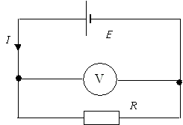

This time we find that the terminal potential difference (voltage) drops from Ɛ to *V*. Since V is **less** than the EMF, it tells us that not all of the potential difference (voltage) is being transferred to the outside circuit. Some is lost due to the internal resistance of the battery causing the battery to become hot.

EMF = terminal voltage + lost voltage In symbols:  = Vterminal + Vlost

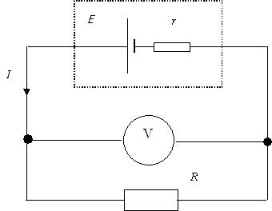

We can thus represent the circuit as in the accompanying circuit diagram.

We can now treat this as a simple series circuit and we know that the current, I, will be the same throughout the circuit.  We also know the potential difference (voltage)s in a series circuit add up to the battery potential difference (voltage).

Emf = V(external) + V(internal) In symbols: = IR +Ir = I(R + r)

Many learners panic at the sight of internal resistance problems. All you have to do is turn the cell with the internal resistance into a perfect battery in series with its internal resistor, and treat it as a simple series circuit.