Monyetla: Physical Sciences Grade 12

**MOMENTUM AND IMPULSE**

**03 February 2024**

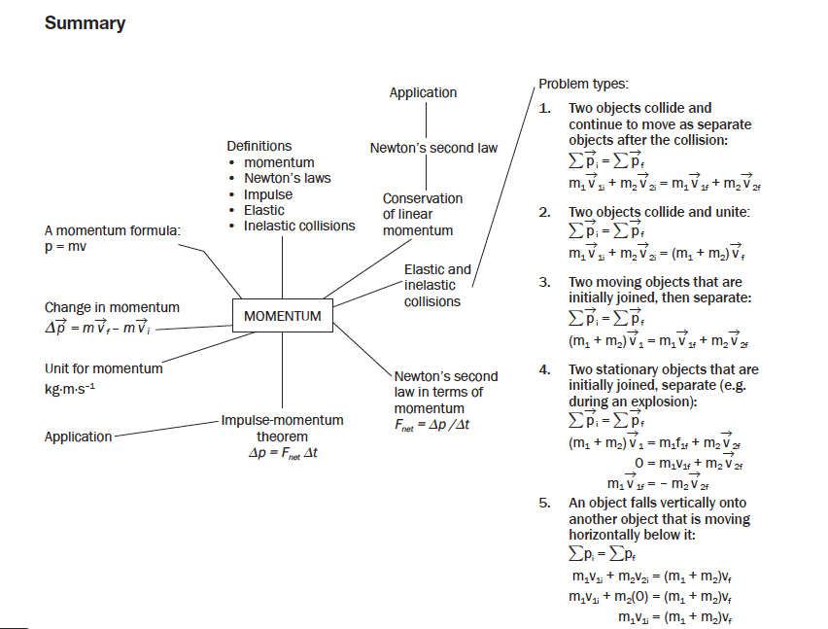

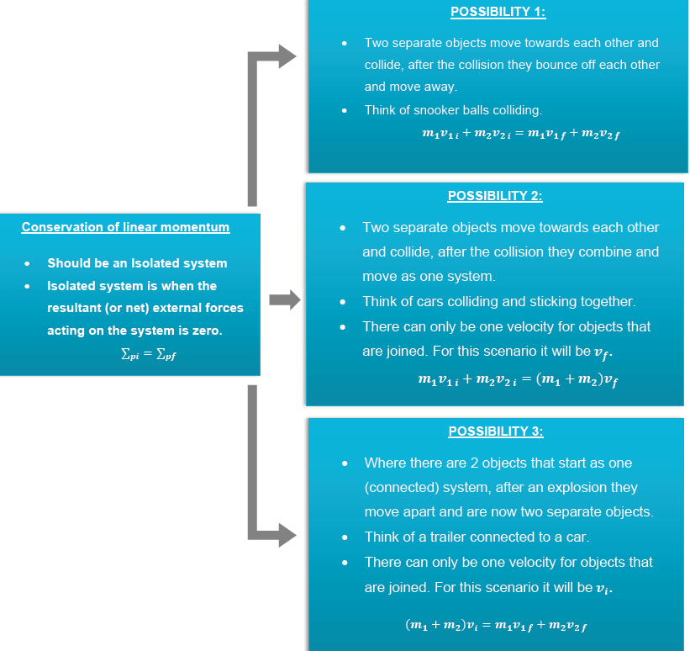

**May/ June 2021**

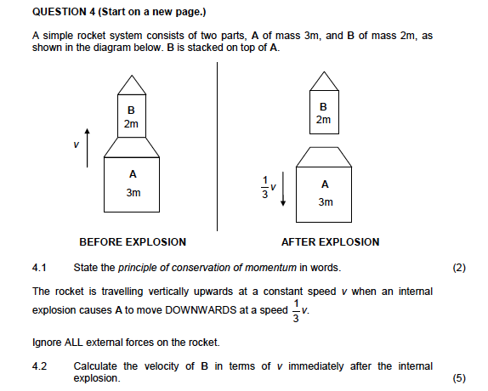

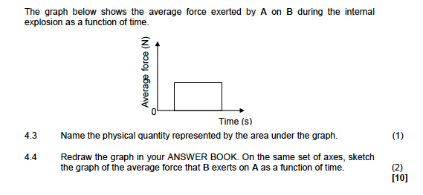

**May/ June 2022**

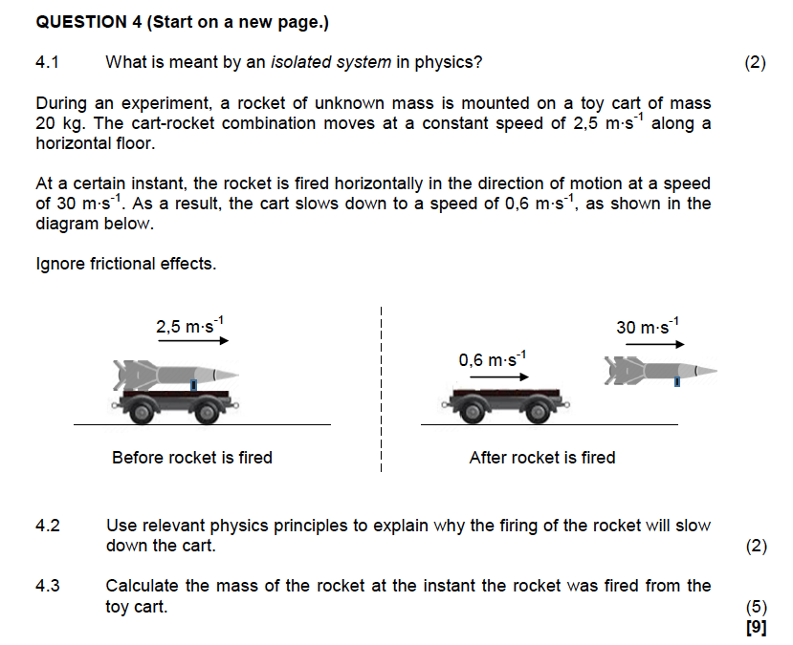

**QUESTION 8**

During a hockey game, a player hits a stationary ball, having a mass of 150 g. The graph shows how the force on the ball varies over time.

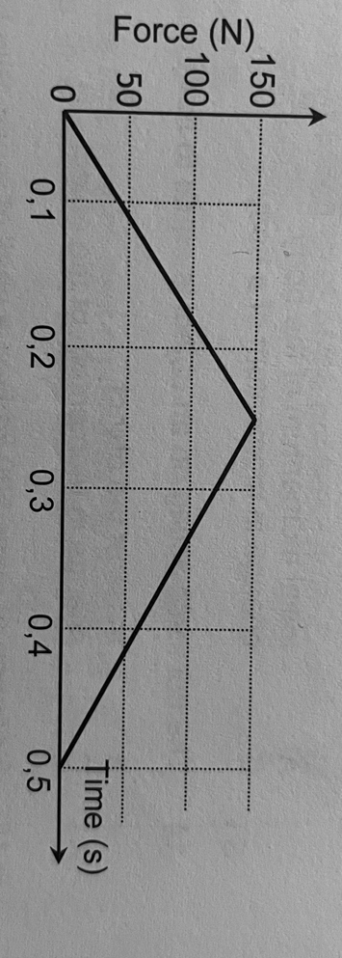

8.1 What is represented by the area under the graph?

8.2 Calculate the velocity at which the ball leaves the hockey stick.

