**THE HUMAN EAR**

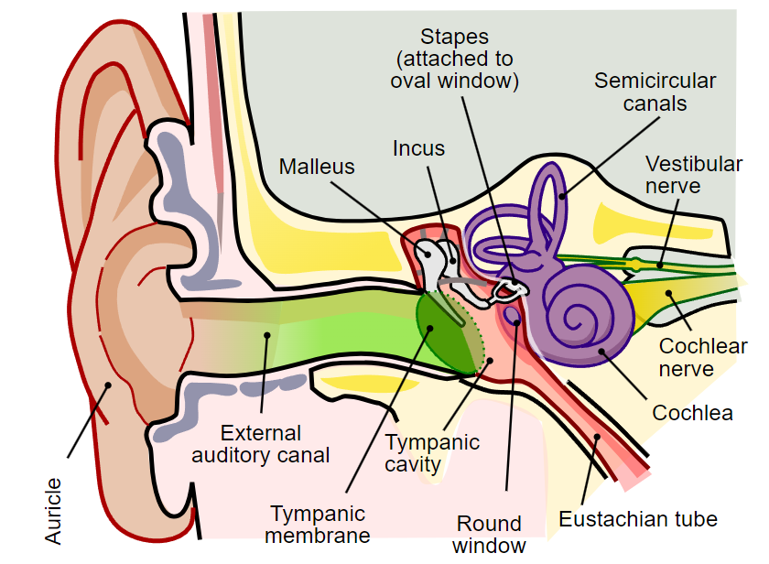

**Sound Waves**

**are converted to**

**Vibrations**

**are converted to**

**Pressure Waves**

**are converted to**

**Impulses which are conducted to the cerebrum via the Auditory Nerve.**