**MONYETLA BURSARY PROJECT – 11 MAY 2024**

**LIFE SCIENCES THE HUMAN EYE**

**PAST PAPER QUESTIONS**

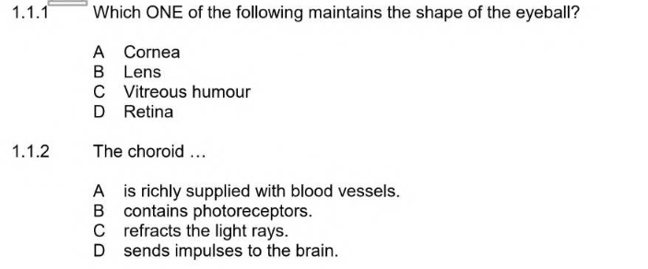

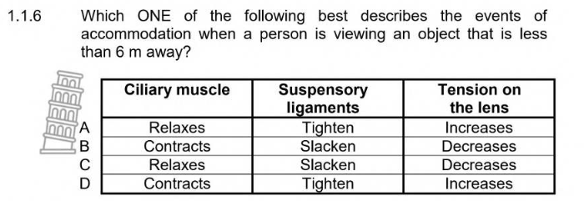

**ANSWERS**

* + 1. C
    2. A

1.1.6 B 3 x 2 (6)

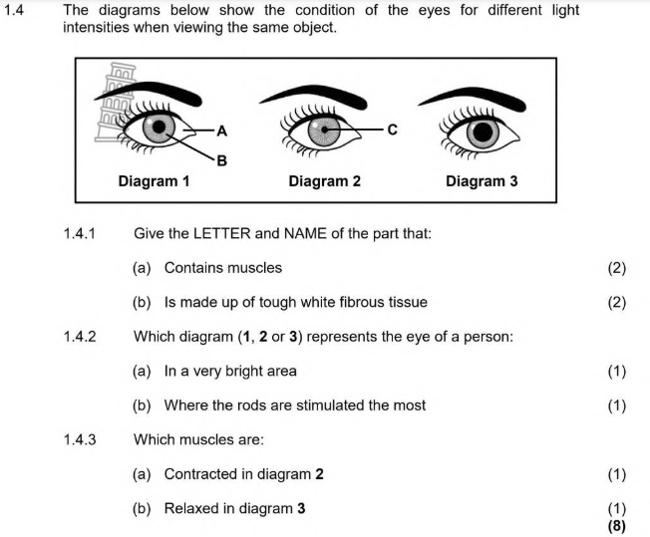

**ANSWERS**

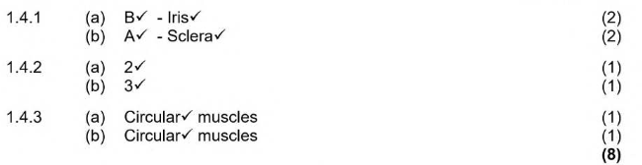

**NSC – Paper 1 (November 2018)**

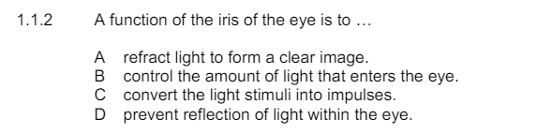

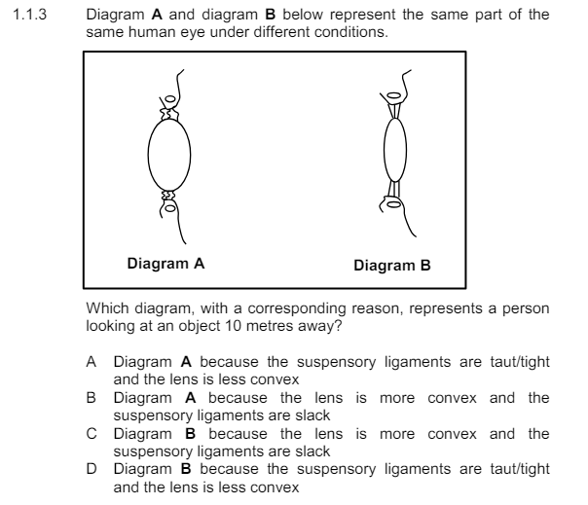

**ANSWERS**

1.1.2 B

* + 1. D 2 x 2 (4)

**NSC – Paper 1 (November 2016)**

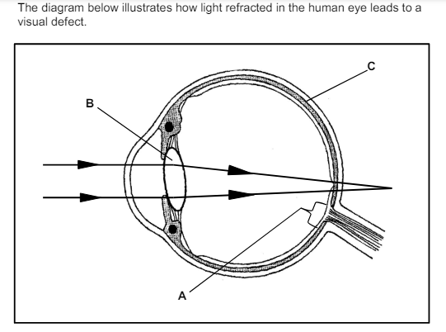

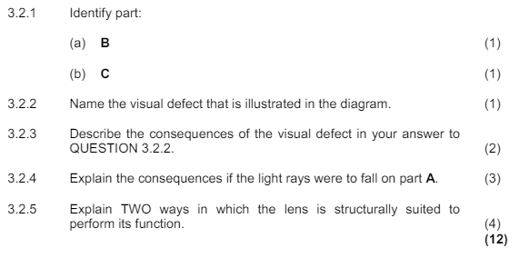

**ANSWERS**

