**ANSWERS** **Life Sciences Assessment Scientific Investigation December 2020**  

**Question 1**

A grade 11 learner was assigned to investigate the effect of temperature on the growth rate of pea plants *(Pisum sativum).* She planted 10 seeds in potting soil and kept the young plants in the Life Sciences classroom. She controlled the temperature of the room by closing all doors and windows and regulated the temperature by using an air conditioner. The duration of the investigation was 5 days. Every day she increased the temperature. The learner measured the length of the stems and compiled the following table of results.

|  |  |  |  |  |  |
| --- | --- | --- | --- | --- | --- |
| Temperature in the room (°C) | 20 | 25 | 30 | 35 | 40 |
| Average length of the stems (mm) | 15 | 18 | 20 | 21 | 21 |
| Day | 1 | 2 | 3 | 4 | 5 |

1.1 Provide a suitable heading for the table. (2)

1.1 The effect of temperature on the growth rate of *Pisum sativum. √√*

1.2 Write a hypothesis for the investigation. (2)

1.2 The higher the temperature, the lower the growth rate of pea plants will be. *√√*

**(since this is a prediction, candidates are allowed to write the opposite)**

Eg, The higher the temperature, the higher the growth rate will be.

1.3 Identify the independent variable in the experiment above. (1)

1.3 Temperature*√*

1.4 How can the learner ensure the validity of the experiment? (3)

1.4 The learner must keep all factors*√* such as the plant species, the room, the humidity and the wind the same.*√* She should only change the temperature. *√*

1.5 How can she make the results more reliable? (3)

1.5 Repeat *√* the investigation and take the average*√* She could also increase the number of participants. *√*

1.6 Calculate the **percentage increase** in the average length of stems from day 1 to day 2. (Show all working) (3)

1.6 % increase = increase/starting point x 100

3/15*√*  x 100*√*  = 20% increase*√*

**[14]**

**Question 2 (Adapted from NSC Paper 1 – 2016)**

A scientist did an investigation on a healthy individual to determine the effect of drinking water on urine production. The participant was requested not to eat or drink 4 hours before the investigation. The investigation was conducted over a period of 3 days.

The procedure was as follows:

* On day 1 the participant was given 600 ml of water to drink.
* On day 2 the participant was given 800 ml of water to drink.
* On day 3 the participant was given 1000 ml of water to drink.
* For each day the amount of urine produced by the participant was measured and recorded over the next 4 hours, an average was calculated.

2.1 Which of the following are considered to be planning steps?

(i) *√* Permission was obtained to participate in the

investigation.

(ii) *√*  The measuring tool to be used was decided upon.

(iii) Water was given to the participant to drink.

(iv) The amount of urine produced was measured. (2)

2.2 Describe TWO precautions to be taken in this investigation. (4)

2.2 The participant should not suffer from any underlying health conditions*√* because it could affect the functioning of the kidneys. *√*

The participant should not eat or drink 4 hours before the time*√* to ensure liquid consumed prior to the investigation does not influence*√*  the volume of urine produced.

2.3 Draw a line graph to indicate the influence of temperature

on the growth of *Pisum sativum.* (6)

**[12]**

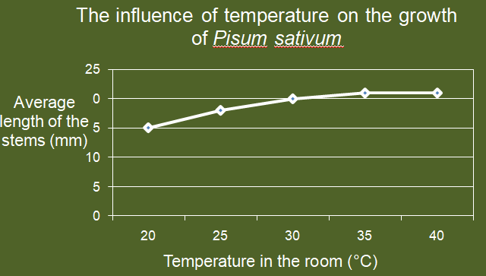

**Question 3 (Adapted from NSC Paper 1 2018)**

Study the graph and then answer the questions that follow:

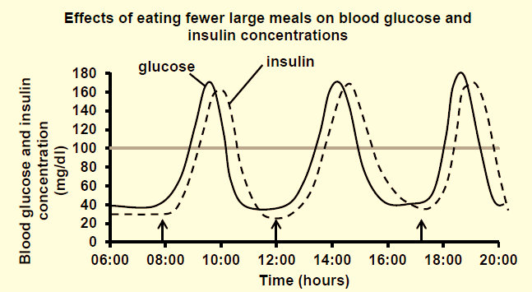

* 1. Use the graph to determine the time of the day when the

blood glucose concentration is at a minimum. (1)

3.1 7:45 and again 10:30 to 12:00*√*

* 1. Use the graph to describe the relationship between blood

glucose concentration and insulin concentration. (2)

3.2 When the glucose concentration in the blood increases*√*  after a meal, insulin concentration also increases*√* because insulin is secreted by the pancreas in response to the high glucose concentration in the blood.

* 1. If 100mg/dl glucose concentration is normal for blood

glucose levels, how long does it take for the person’s glucose concentration to be back to normal after the effects of the 12:00 lunch? (3)

3.3 Low [Glucose] at lunch, 12:00 Then exceeds the normal level of 100mg/dl and returns to normal (100mg/dl) by 15:30. *√*

Thus 3, 5 hours *√*  (15:30 – 12:00) *√*

* 1. The first peak of the day for blood glucose concentration

is at 9:45. Provide an explanation why the first peak for insulin concentration is at 10:00? (4)

3.4 Blood [Glucose] rises steeply after the meal at 08:00.*√* Food is digested and absorbed*√* into the blood to reach a peak at 9:45. Receptor cells in the pancreas detect this sudden increase in [Glucose] and the Islets of Langerhans in the pancreas secrete Insulin to lower the [Glucose] in the blood.*√* The delay is due to the fact that the pancreas had to detect the change and respond by secreting Insulin. *√*

* 1. Calculate the increase in blood glucose concentration

from the first meal of the day until the first peak in glucose concentration. (Show all working) (4)

**[14]**

3.5 [Glucose] at 08:00 = 35mg/dl*√*

[Glucose] peak at 9:45 = 170mg/dl*√*

Increase in [Glucose] = 170 – 35*√*

= 135*√* mg/dl

**Question 4 (Adapted from NSC Paper 1 – 2018) [10]**

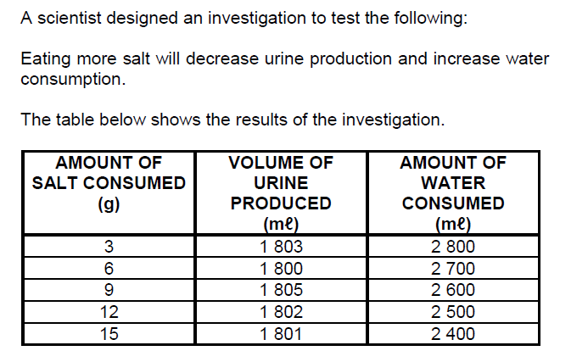

4.1 Provide a hypothesis to describe the influence of salt consumption on the volume of urine produced. (2)

4.1 Greater consumption of salt will result in a greater volume of urine produced and will cause greater consumption of water. *√√*

**This is a prediction. The opposite is also accepted.**

4.2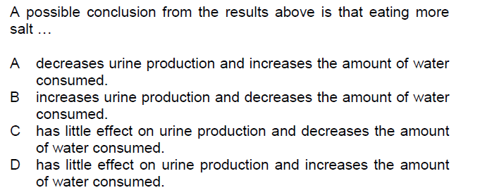

Answer: C *√√* (2)

4.3 Calculate the average urine production when 3g, 6g and 9g of salt was consumed. (Show all working) (3)

4.3 (1803 + 1800 + 1805) / 3*√*

= 1802,67*√* ml*√*

4.4 How can the reliability of the investigation be improved? (2)

4.4 Repeat *√* the investigation and take the average.The number of participants could also be increased. *√*

4.5 Name ONE dependent variable in this investigation. (1)

4.5 Volume of urine produced*√*

**OR**

Amount of water consumed

**[10]**

**TOTAL: 50**

I am sure you have done well! If not, watch the videos again and eliminate any misunderstandings.

Keep on practicing by doing more activities as provided under resources. Also download past matric papers from this website .

Best wishes

Mr Grobler