**Life Sciences Notes Homeostatic Control of Glucose December 2020**  

**Key Concepts – You need to understand and explain:**

* Homeostasis
* Hormones
* Endocrine Glands
* Target Organs
* Glucose Concentration
* The Role of Insulin in Reducing Glucose Concentration of the Blood.
* The Role of Glucagon in Increasing the Glucose Concentration of the Blood.
* Negative Feedback
* Two types of Diabetes
* Interpreting Graphs on Glucose and Insulin Concentration

**What is Homeostasis**

The processes of the human body to maintain a constant internal environment are referred to as homeostatic control processes or homeostasis. Many factors have to be controlled. In these notes we focus on the homeostatic control of **glucose** only.

When a person consumes a meal, carbohydrates, proteins and fats are all ultimately digested and converted to glucose. Glucose is absorbed into the blood in the small intestine. The **glucose concentration** of the blood now **increases**. Glucose is transported to all cells of the body by the blood.

Brain cells are very sensitive to low levels of glucose. All body cells absorb glucose from the blood and convert it to energy by means of CELLULAR RESPIRATION. The correct glucose concentration in the blood is 100mg of glucose for every 100ml of blood. **If** it is **below** 100mg/100ml, the production of energy in the body cells may be at a level too low for proper cell functioning. In this case, the homeostatic process will ensure that the glucose concentration in the blood **increases** and return to normal.

**IF** the glucose concentration is **higher than normal**, homeostatic processes will ensure that the glucose concentration in the blood is **reduced** to get back to the normal level of about 100mg/100ml of blood. In this discussion, look out for the roles of TWO hormones, **Insulin and Glucagon** in controlling blood sugar levels (glucose). Also note the roles of TWO organs in the homeostatic control of glucose – The PANCREAS and the LIVER.

If glucose concentration of the blood is out of control, either too high or too low, a person suffers from sugar diabetes.

**What are Hormones**

Hormones are **chemical messengers** secreted by glands called endocrine glands. Hormones travel in the blood and reach target organs where they stimulate certain reactions (trigger) or inhibit (stop) other processes.

**What are Endocrine Glands**

Glands that make their secretions **directly** into the blood. The secretions **do not** pass through a duct (small tube), these glands are DUCTLESS. Endocrine glands secrete chemical messengers – hormones.

**Observe the Pancreas and the Liver in the diagram below. The Pancreas is an Endocrine Gland with the function to detect incorrect glucose concentration. The Liver is a storage organ for extra glucose in the body.**

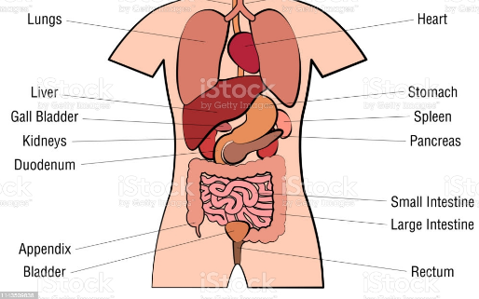

Picture from iStock

**What are Target Organs**

Organs, like the Liver that are stimulated by hormones to perform their function.

**What do we mean by *Glucose Concentration*?**

*Concentration* refers to the amount of a substance dissolved in a solvent. Eg the amount of glucose dissolved in a specific volume of blood. Some books abbreviate concentration by using square brackets, high [glucose] means high glucose concentration.

**The Role of Insulin in Reducing Glucose Concentration of the Blood.**

When the [glucose] in the blood **increases** after a meal, receptor cells in the PANCREAS **detect** the increase. The specialised cells in the pancreas called Islets of Langerhans secrete **Insulin** into the blood. Insulin is a hormone that stimulate the liver to store excess glucose from the blood as glycogen. (Glycogen is another form of glucose) Since glucose has been removed from the blood, the [glucose] in the blood now lowers and goes back to normal. **Insulin** also stimulates body cells, like muscle fibres to absorb more glucose from the blood. This contributes to lower levels of glucose in the blood.

**The Role of Glucagon in Increasing the Glucose Concentration of the Blood.**

When the [glucose] in the blood **decreases** to below normal, receptor cells in the PANCREAS **detect** the decrease. The Islets of Langerhans now secrete a hormone **opposite** to Insulin. It is called **Glucagon**. Glucagon causes an **increase** in blood [glucose] concentration. This is accomplished by stimulating the liver to **convert** the stored Glycogen **to** Glucose again and release it in the blood. The [glucose] in the blood **therefore increases** and goes back to normal. Glucagon also inhibits (prevents) the muscle cells and other body cells to absorb glucose from the blood.

Please **do not** confuse Glucagon with Glycogen. There is a BIG difference! Can you explain the difference? Refer to the information above.

**What is Negative Feedback**

Negative Feedback refers to a situation whereby ONE hormone **inhibits** the effect of **another hormone**. The secretion of one hormone may also **inhibit** the secretion of **another**. An example is glucagon. When it is secreted, it has the opposite effect to insulin. In scientific language we say, the two hormones are antagonistic in their functioning. “Antagonistic” in Physiology, refers to opposite functioning.

Examine the diagram below that illustrates the effects of insulin and glucagon. This diagram comes from *Life Sciences P1, NSC Matric Final Paper 2017*. Follow the **dotted line** that represents the functioning of **Insulin** and the **solid line** represents the functioning of **Glucagon.**

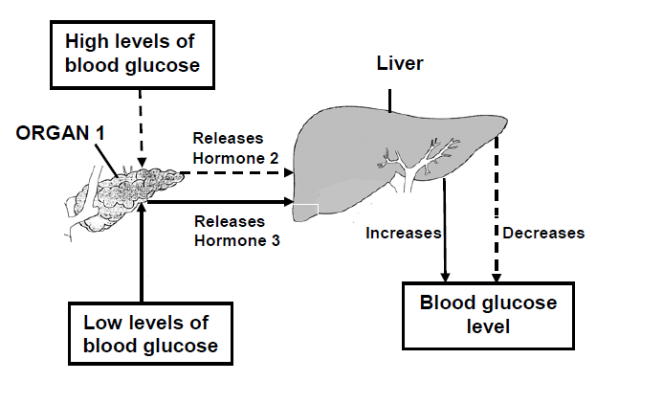

**Two types of Diabetes** Sugar diabetes or **Diabetes Mellitus** can be divided into 2 types: **Type 1diabetes** is a chronic condition whereby the pancreas does not produce insulin or does not produce enough insulin. **Type 2 diabetes** is a chronic condition whereby the body resists the functioning of insulin.

**Interpreting Graphs** See if you can spot the trends in these graphs. Is the concentration of glucose in the blood increasing? What could be a possible reason? How does the pancreas react to the increase in [blood glucose] concentration?

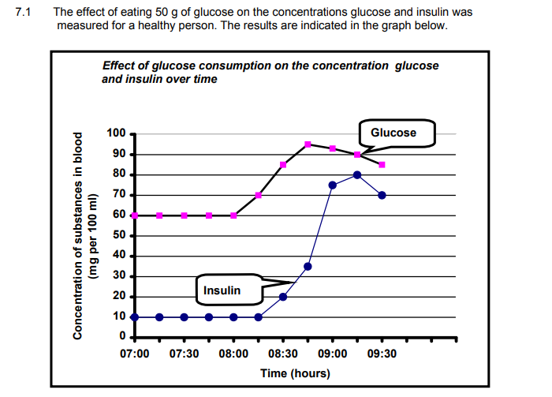

Best Wishes for the Upcoming Test on [www.monyetlaproject.co.za](http://www.monyetlaproject.co.za)

***C Grobler***