**ANSWERS**

**Life Sciences Assessment HOMEOSTATIC CONTROL OF GLUCOSE December 2020**  

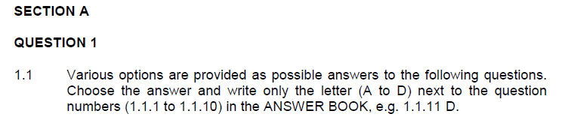

* + 1. Chemical messengers that travel in the blood and affect target organs are

A enzymes.

B biological catalysts.

C hormones. √√

D glycoproteins.

* + 1. The hormone that causes a greater concentration of glycogen in the liver is

A insulin. √√

B glucagon.

C islets of Langerhans.

D glycogen.

1.1.3 The medical condition that refers to chronic uncontrolled blood sugar levels is

A diabetes mellitus. √√ B type 1 diabetes only. C type 2 diabetes only. D hypertension. **3 x 2 (6)**



1.2.1 The collective process of maintaining a constant internal environment. Homeostasis √ 1.2.2 Organs that are stimulated by hormones. Target organs √ 1.2.3 Glands that secrete hormones. Endocrine glands √ 1.2.4 The process whereby one hormone inhibits the functioning of another.

Negative feedback √

1.2.5 Converted glucose stored in the liver. Glycogen √ 1.2.6 The hormone which has an opposite effect to insulin. Glucagon √ 1.2.7 The hormone responsible for reducing the [blood glucose]. Insulin √ 1.2.8 The endocrine gland responsible for the homeostatic control of glucose.

Pancreas √

**(8)**

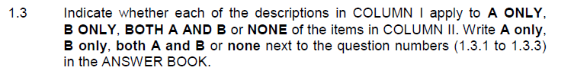

|  |  |
| --- | --- |
| **COLUMN I** | **COLUMN II** |
| 1.3.1 Insulin resistant diabetes. | A: Type 1 diabetes  B: Type 2 diabetes√√ |
| 1.3.2 Organ(s) involved in the homeostatic control of glucose. | A: Liver  B: Pancreas BOTH A & B√√ |
| 1.3.3 End product in the digestion of starch | A: Amino acids  B: Glucose √√ |

**3 x 2 (6)**

**SECTION A: 20**

**SECTION B**

**QUESTION 2**

2.1 Examine the diagram below of the homeostatic control of glucose and answer the questions that follow.

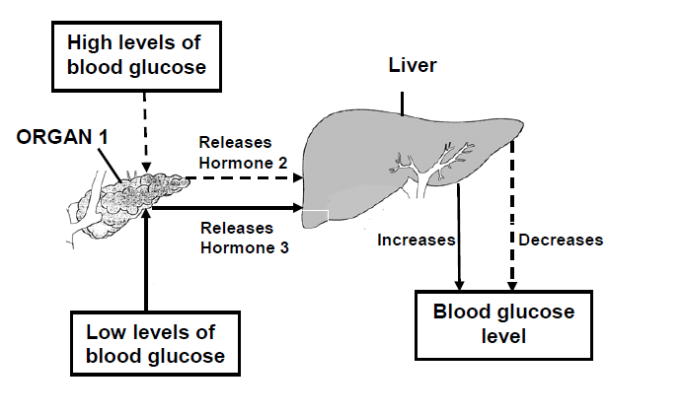

2.1.1 Explain why ORGAN 1 is known as an endocrine gland. (2)

The pancreas is a ductless gland √ that secretes hormones√ directly into the blood.

2.1.2 Name the hormones 2 and 3. 2. Insulin√ 3. Glucagon√ (2)

2.1.3 Describe the role of hormone 2 in the homeostatic control of glucose. (6)

When the [glucose] in the blood increases√after a meal, receptor cells in the pancreas√ detectthe increase. The specialised cells in the pancreas called Islets of Langerhans √ secrete insulin √into the blood. Insulin is a hormone that stimulate the liver to store excess glucose from the blood as glycogen.√ (Glycogen is another form of glucose) Since glucose has been removed from the blood, the [glucose] in the blood now lowers √ and goes back to normal. √ Insulinalso stimulates body cells, like muscle fibres to absorb more glucose √ from the blood. This contributes to lower levels of glucose in the blood. Any 6

2.1.4 Explain the concept of negative feedback by referring to the diagram above. (5)

In the event of high levels of glucose in the blood, insulin is secreted. √ Insulin stimulates the liver to store glucose as glycogen √ and the [blood glucose] decreases.√ If [blood glucose] decreases below normal, glucagon is secreted √ and inhibits further secretion of insulin. √ Glucagon also inhibits the functioning of insulin. √ Any 5 **[15]**

**QUESTION 3.3** (From NSC P1 – 2018)

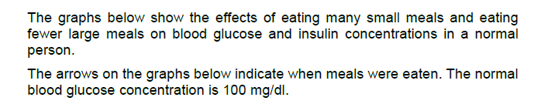

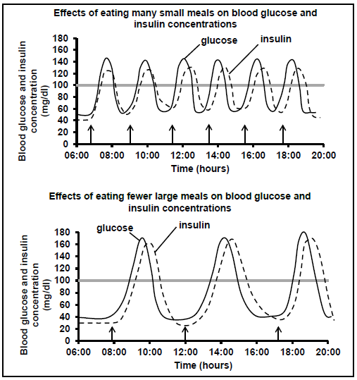

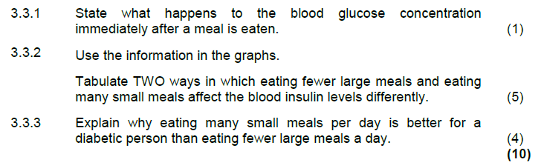

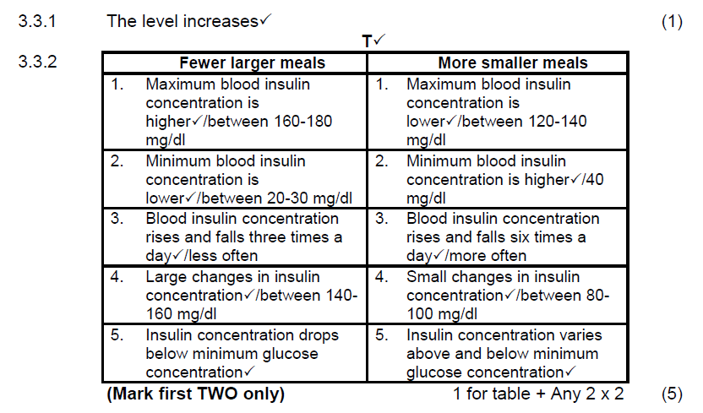

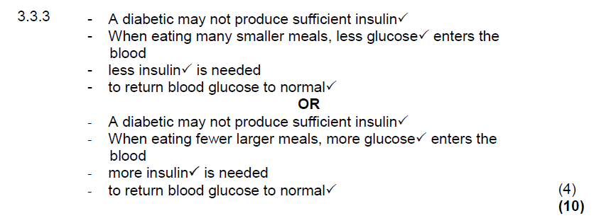

3.4 Examine the graphs below and answer the questions that follow.

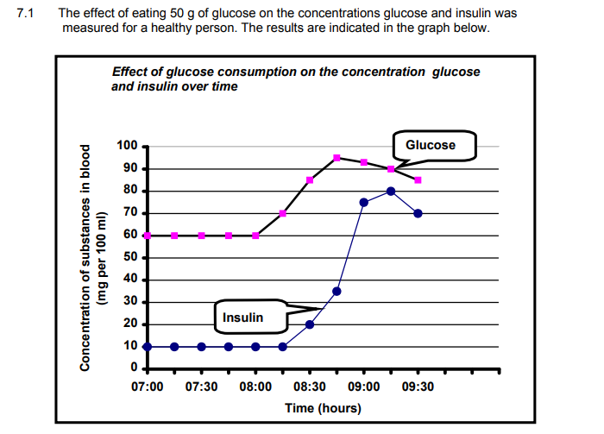

3.4.1 When did the person consume the glucose? 08:00 √ (1)

3.4.2 Provide a reason for the secretion of insulin at 8:15. (2)

After 08:00, glucose gets to be absorbed from the digestive system into the blood. √ Blood circulates the body and reaches the pancreas where receptor cells detect the increase. √ Only after these events, insulin is secreted. This may take several minutes. √

3.4.3 Calculate the percentage increase in [blood glucose] in the 45 minute period following the consumption of glucose. (2)

[blood glucose] at 08:00 = 60mg/100ml

[blood glucose] at 08:45 = 95mg/100ml

Increase = 95 – 60 = **35mg**/100ml

Starting from **60mg**/100ml

% Increase = Increase/Starting Point x 100

35/60 x 100√ = 58,33% increase in [blood glucose] √ **[15]**  **TOTAL: 50**