**REVISION**

**ELECTRICITY AND MAGNETISM: Electrostatics**

**ELECTROSTATICS**

Study of charges at rest

**Electrostatic force**

Like charges repel

Unlike charges attract

**Coulomb’s law**

FQ1Q2 and F

 k = 9 x 109 N∙m2∙C-2

**Charging of objects**

**By contact:** Electrons transferred from one object to another.

**Two kinds of charge**

**Positive:** electron deficient

**Negative:** excess of electrons

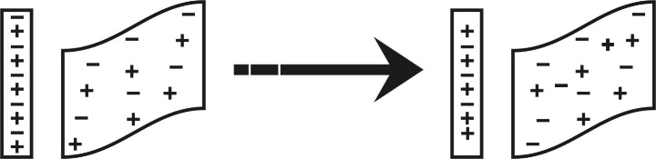

Rod: neutral

Cloth: neutral

Rubbing

Rod: positive (e- lost)

Cloth: negative (e- gained)

**Quantisation of charge**

All charges are multiples of the smallest charge i.e. the charge on one electron: 1,6 x 10-19 C

**Conservation of charge**

Charge cannot be created or destroyed. It can only be transferred from one object to another.

**Electric field**

Region in space where an electric charge experiences a force. Represented with field lines.

Definition of electric field: E = 

**Neutral** (uncharged):

Number of protons = number of electrons

**Electric potential**

**Electric potential energy**



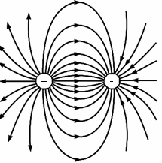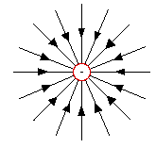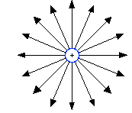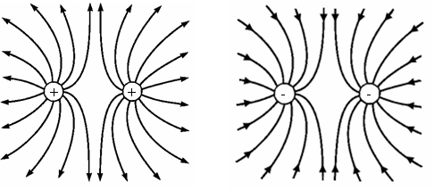

**Electric field patterns**

**Electric field at a certain distance from a point charge**: E = 

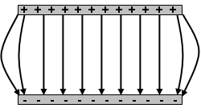

**Electric field pattern**

**Electric field between two parallel plates**: E = 

**Parallel-plate capacitor**

Stores charge

C = ; C = 

**Charge quantisation**

|  |  |
| --- | --- |
| **IMPORTANT DEFINITIONS/TERMS** | |
| Capacitance | Capacitance is the charge stored on the plates of the capacitor per unit potential difference between the plates.  In symbols: |
| Capacitor | An electronic device that stores electric charge and energy. |
| Charging by contact | The process in which an object obtains a charge by placing it in contact with an object that is already charged. |
| Charging by induction | The process in which an object obtains a charge without being in contact with a charged object. |
| Coloumb’s law | The magnitude of the electrostatic force exerted by one point charge (Q1) on another point charge (Q2) is directly proportional to the product of the magnitudes of the charges and inversely proportional to the square of the distance (r) between them. In symbols: |
| Dielectric | An insulating material placed between the plates of a capacitor. |
| Electric field | A region in space where a charge experiences an electrostatic force.  **Definition:**  The electric field at a point is the electrostatic force experienced per unit positive charge placed at that point.  In symbols: |
| Electric field line | An imaginary line drawn in such a way that it gives the direction of the force on a positive point charge placed at that point in the field. |
| Electric potential | The electric potential at a point is the electrical potential energy per unit charge situated at the point. |
| Electric potential energy | The energy of a charge because of its position relative to other charges that it interacts with.  For a system of two charges: |
| Law of conservation of charge | The net electric charge in an isolated system remains constant during any process.  OR  Charge cannot be created or destroyed, but can only be transferred from one object to another. |
| Parallel plate capacitor | A device that consists of two oppositely charged conducting plates separated by a small distance. |
| Potential difference | Electric potential difference is the work done per unit charge in moving the charge between two points in an electric field.  In symbols: |
| Quantisation of charge | All charges are integers of the charge on one electron i.e. 1,6 x 10-19 C. |

|  |  |
| --- | --- |
| **IMPORTANT UNITS** | |
| coulomb (C) | Unit of electric charge – the charge is 1 coulomb when a current of 1 ampere passes a point in a conductor in one second. (1 C = 1 A∙s) |
| farad (F) | Unit of capacitance – one farad is one coulomb per volt. (1 F = 1 C∙V-1) |
| volt (V) | Unit of potential difference – 1 volt is 1 joule per coulomb. (1 V = 1 J∙C-1) |
| N∙C-1 or V∙m-1 | Unit of electric field |
| newton (N) | Unit of force |
| joule (J) | Unit of energy or work done |