**ANSWERS - IMPERFECT**

1. **Natural monopolies**🗸

High development costs prevent ot🗸🗸hers from entering the market and therefore the government supplies the product. E.g. Electricity in South Africa is provided by the government enterprise, Eskom. It costs billions of rands to build and maintain power stations and therefore there are no other suppliers. 🗸

**Artificial monopolies** 🗸

Here the barriers to entry are not economic in nature. 🗸🗸 An example of a barrier is a patent. A patent is a legal and exclusive right to manufacture a product, e.g. Denel Land Systems manufacturing Casspirs. 🗸 (8)

2.

|  |  |  |  |  |
| --- | --- | --- | --- | --- |
| **Price** | **Quantity** | **Total revenue** | **Average revenue** | **Marginal revenue** |
| ---- | 0 | 0 | 0 | 0 |
| 100 | 1 | 100 | 100 | 100 |
| 90 | 2 | 180 | 90 | 80 |
| 80 | 3 | 240 | 80 | 60 |
| 70 | 4 | 280 | 70 | 40 |
| 60 | 5 | 300 | 60 | 20 |
| 50 | 6 | 300 | 50 | 0 |
| 40 | 7 | 280 | 40 | -20 |
| 30 | 8 | 240 | 30 | -40 |



• Since a monopolist faces a downward sloping demand curve, its marginal revenue curve and its demand curve are not the same curve as is the case with an individual producer under perfect competition. 🗸🗸

• Under perfect competition, the individual producer is a price taker and can sell any quantity at the market price and therefore faces a horizontal demand curve, which is also its marginal revenue curve. 🗸🗸

• The demand curve for a monopolist, which is downward sloping, implies that, if it wishes to increase its sales by an additional unit, it must decrease the price of the product. 🗸🗸

• The lower price applies to all its customers. Its marginal revenue – that is the amount by which total revenue increases if it sells an additional unit – will therefore be less than the price. 🗸🗸

• The marginal revenue curve and the demand curve are therefore not the same curve. The Marginal revenue curve will be lower than the demand

curve 🗸🗸 (8)

3.

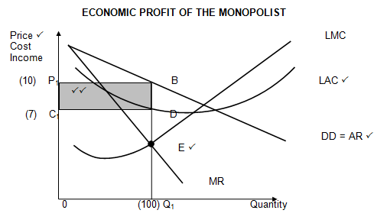

* In the long term the monopolist makes economic profit 🗸🗸
* The LMC curve intersects the LAC curve at its minimum point 🗸🗸
* Profit maximising point is at point E (LMC = MR) where production is Q1 at a price of P1 per unit/The monopolist will produce at Q1 (100) (profit maximisation point E) at a price of P1  (10) 🗸🗸
* At this production level the average revenue is R10 and average cost is R7 🗸🗸
* Therefore the monopolist is making a profit of R3 per unit (total economic profit of R300). The total economic profit is represented by the shaded area 🗸🗸 (8)

4.

* Businesses engage in non-price competition - when sellers focus on distinctive features of their products rather than the price it may lead to better operational success 🗸🗸
* The businesses can use the following methods of non- price competition:
  + **Branding**: This is a marketing tool that businesses use to create a specific perception in the minds of consumers and also identifies a business as being exclusive for a particular market 🗸🗸
  + **Advertising**: It is information provided by the company about its product usually through media and is used to achieve product differentiation and market control 🗸🗸
  + **Packaging**: It is the way the product is presented to the market, that protects the products, differentiate them and provides information about them. Businesses usually bring out the most important feature of their products through packaging 🗸🗸
  + **Service**: Businesses always improve their services to ensure that customers come back. Many people eat at restaurants because they enjoy the food and the service. Businesses should avoid treating customers in an incorrect manner🗸🗸
  + **Information**: Businesses strive to provide relevant and precise information which will definitely convince customers to increase their spending 🗸🗸