With big thanks to A Green of Metro North – A green

Compiled by: Metro North Education - A Green

**MICRO ECONOMICS: THE RELATIONSHIP BETWEEN MARKETS**

**THE DYNAMICS OF MARKETS**

**What is a market?**

* It is when buyers and sellers influence the price of a good or service.

OR

* It is an institution or mechanism that brings together the buyers and sellers of a good or a service.
* It exits as a result to the interaction between buyers (Demand) and sellers (Supply). It is also called the market mechanism.



**What is Market conduct?**

* Market conduct involves the things done by firms in their capacity as suppliers and buyers and relates to their objectives, competition methods to achieve their objectives and inter firm conduct.

**What are the objectives of the business?**

* To make profits
* To increase turnover
* In order for the business to grow

**The Market Structure**

The major organisational features of a market, (e.g. number of sellers/buyers the degree of product differentiation/the availability of information) are called the structure of the market.

**There are FOUR Market structures / types of markets.**

1. Perfect Competition
2. Imperfect competition: Monopolistic competition

Oligopolies

Monopolies

|  |  |
| --- | --- |
| **MC= Marginal Cost** | **MK = Grenskoste / Marginale koste** |
| It is the amount by which the total cost increase when one extra product is produced.  **∆Total Cost (TC) ÷ ∆ Output (Q) = MC** | Dit is die hoeveelheid waarteen totale koste toeneem om een bykomende (ekstra of addisionele) produk te geproduseer.  **∆ Totale Koste (TK) ÷ ∆ Uitset (Q)= MK** |
| **MR = Marginal Revenue** | **MI = Marginale Inkomste / Grensinkomste** |
| Marginal revenue refers to the extra amount of income earned when an additional (extra) unit of a product is sold.  **∆TR ÷∆ Q = MR** | Marginale inkomste verwys na die ekstra hoeveelheid inkomste wat verdien word deur ‘n addisionele (of ekstra ) eenheid van die produk te verkoop.  **∆TI ÷ ∆ = MI** |
| **AC = Average Cost** | **GK = Gemiddelde koste** |
| (Fixed costs + Variable costs) ÷ Total output = AC.  Also called unit cost. | (Vaste koste + Veranderlike koste) ÷ Totale uitset = GK.  Ook eenheidskoste genoem. |
| **AR = Average Revenue** | **GI = Gemiddelde Inkomste** |
| Average revenue refers to the amount the enterprise earns for every unit sold.  **TR ÷ Q = AR** | Gemiddelde Inkomste verwys na die hoeveelheid wat ‘n onderneming verdien vir elke eenheid wat verkoop word.  **TI ÷ Q = GI** |
| **AVC = Average Variable Cost** | **GVK = Gemiddelde Veranderlike Koste** |
| Variable cost divided by number of units produced.  Variable costs ÷ total output = AVC. | Veranderlike koste gedeel deur die getal eenhede geproduseer.  Veranderlike koste ÷ Totale uitset = GVK. |
| **P = Price** | **P = Prys** |
| A value that will purchase a definite quantity, weight, or other measure of a good or service. | Die waardewat ‘n definitiewe hoeveelheid, massa, of ander meetbare goedere en dienste sal koop. |
| **Q = Quantity** | **Q / H = Hoeveelheid** |
| The extent, size, or sum of countable or measurable discrete events, objects, or phenomenon, expressed as a numerical value. | Die omvang, grootte, of som van meetbare en telbare diskrete gebeurtenisse, voorwerpe, of verskynsel, uitgedruk as 'n numeriese waarde. |

**PERFRCT COMPETITION (PERFECT MARKETS)**

**Describe the term: Perfect Competition**

* It is a market structure with a large number of participants who are all price takers, there are no entry or exit barriers in the long run, all information is available to both the buyers and sellers and a homogeneous product is sold.

OR

* A market in which the conditions for perfect competition are satisfied

OR

* Perfect competition occurs when none of the individual market participants can influence the price of the product

**Examples of perfect competition**

* Stock exchange
* Foreign currency market
* Central grain market
* Market for agricultural produce

**Markets are impersonal**

* Businesses strive towards maximum profit and only take its own cost structure into account, when determining the production levels.
* All are price takers.

**CHARACTERISTICS OF PERFECT COMPETITION**

**Many buyers**:

* The number of buyers in the market is so large that individual market participants are insignificant in relation to the market as a whole.
* This has the important implication that no individual buyer is able to influence the market price.

**Many sellers**:

* The number of sellers in the market is so large that the individual seller cannot influence the market price (price takers).

**Homogenous product**:

* All the products sold in the specific market are homogenous, that is they are exactly the same regarding quality, appearance, ect.
* It makes no difference to a buyer where or from whom he/she buys the product.

**Freedom of entry / exit**:

* There is complete freedom of entry and exit, that is to say the market is fully accessible.
* Buyers and sellers are completely free to enter or to leave the market.
* Entry should not be subject to any restrictions in the form of legal, financial, technological or other barriers that curtail the freedom of movement of buyers and sellers.

**Mobility of factors of production**:

* All factors of production are completely mobile, in other words labour, capital and all other factors of production can move freely from one market to another.

**Perfect information**:

* Both buyers and sellers have full knowledge of all the prevailing market conditions.
* For example if one business ventured to raise its price above the market price, buyers would immediately became aware of it and would switch their purchases to businesses who still charge the lower price.

**No collusion**:

* Collusion between sellers does not occur.
* In a perfectly competitive market, each buyer and seller acts independently from one another.
* Collusive practices are illegal in South Africa, according to the Competition Act 1998.

**Unregulated market**:

* There is no government intervention that could affect buyers or sellers.
* Decisions are left to individual sellers or producers and buyers.

**No preferential treatment** (no discrimination)

* Nobody is advantaged above the others

**Efficient transport and communication**:

* Makes access to and from markets possible.

**THE INDIVIDUAL BUSINESS**

1. **In the market**

* Market price is determined by the interaction of demand and supply
* DD (Demand curve) slopes downwards from left to right and SS (Supply curve) slopes upwards from left to right.
* The point where Demand and Supply intersect is called the Market price.
* Individual business forms a small portion of the market, therefore they does not influence market price. Individual business is a price taker.
* Individual Business can offer any quantity on the market at the market price.
* Business will not chargea higher price, because buyers will buy elsewhere and they will not charge a lower price , because they can sell all their goods at the current market price.

**Sketch A Sketch B**



**Sketch B**

* Demand curve for individual business is a horizontal line at market price.
* For each unit sold, business receives the same price – the market price, therefore

P1 = AR = MR equals individual demand curve

* The average revenue the business receives is therefore equal to the market price and the horizontal demand curve represents the average revenue curve (AR).
* The revenue from any additional unit the business sells, that is the marginal revenue, is equal to market price P1 , and the horizontal demand curve therefore also represents the marginal revenue curve (MR)

**ECONOMIC COST**

Economic cost of production = Opportunity cost = Explicit cost + Implicit cost

**EXPLICIT COST**

* Explicit cost is the actual expenditure of a business on the purchase or hire of the inputs required for the production process.

**Explicit Costs include:**

* Wages of labourers / Interest on borrowed capital / Rent on leasing land and buildings

Expenditure on raw material / Water / Electricity / Property taxes /Motor car expenses

**IMPLICIT COSTS**

* Implicit costs = is the value of inputs that are owned by the entrepreneur and used in the production process.

**Implicit Costinclude:**

* Forfeited rent that could have been earned if the owner used his own building.
* Forfeited interest that could have been earned should the owner invested his/her money.
* Forfeited salary that could have been earned should the owner worked elsewhere and earned a salary.

1. **Production, Profit, Loss and Supply**
2. **Maximum profit for individual business**

* Under perfect competition the demand curve for the individual business is a horizontal line at the market price.
* To obtain maximum profits for the business, only the given market price and its own cost structureare taken into account when determining its production output.

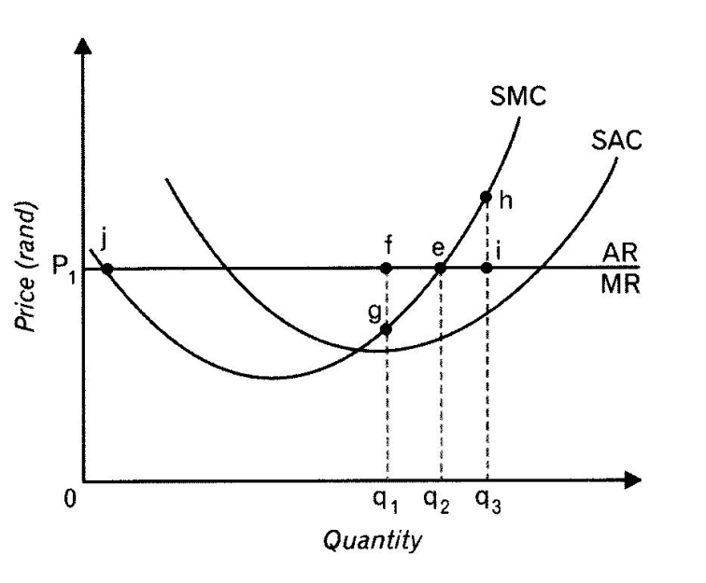

**At point e**

* Horisontal demand curve represents MR and AR.
* Maximum Profit at point e. This is the point where SMC = MR.
* It is known as the equilibrium point.
* Point e = Profit Maximization = Equilibrium

**At point g**

* Profits are not maximized.
* Businesses render revenue that is greater than the marginal cost.
* MR lies above SMC
* Business Expand its production up to a point where SMC = MR on the ascending part of the MC curve.

**At point h**

* The business makes a loss on each product when producing here and it reduces it profits.
* At point h , SMC ˃ MR (SMC more than MR)
* Production cost exceed income.
* It does not benefit the business to produce here , because it makes a loss.

**At point j**

* Maximum losses are made here.
* The business will not produce here.
* It is on the descending part of the SMC.

1. **Production and supply for business**

* Under perfect competition profits are maximized where SMC = MR and it is used to derive business’s supply curve
* The different market prices are taken to determine how much a business would produce at each price.
* The production determines the supply curve.
* Average variable cost are added (AVC) e.g.Labour cost, material cost, fuel and electricity cost, etc.

**Sketch A Sketch B**

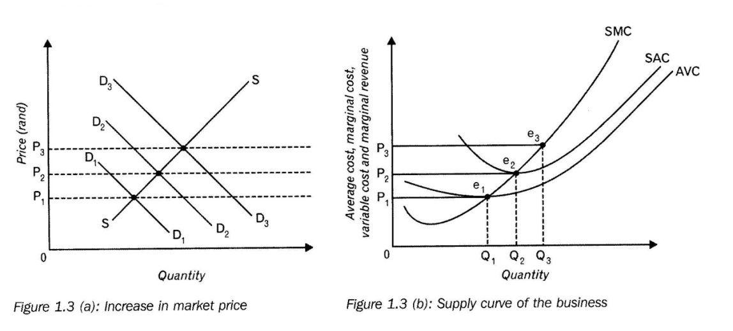

**Sketch A**

* The market price rises due to an increase in demand.
* The increase in the market price means that demand curve also increases.
* The horizontal demand curve shifts upwards.

**Sketch B**

* The horizontal demand curve for the business’ product shifts upward : Demand = AR = MR.
* The horizontal demand curve intersect the SMC at point e1, e2 and e3( to the right of the previous point)
* Each point shows the Profit Maximisation point where SMC = MR.
* Points e1 , e2 and e3 plot business’s supply at different market prices – supply begins at e.
* The amount supply by the business increase as price increase.

**Below point e1**

* To the left of point e1: Business cannot even cover its variable cost.
* The business can close its doors.
* Also known as closing down point.

**NB.**

* To determine the market supply, the supply curves of all the businesses are added horizontally.
* In the short term the supply curve is also called market supply curve.

**Equilibrium positions:**

* In a perfect market the individual business faces a perfectly horizontal demand curve.
* The market price is determined by the industry (demand and supply curves).
* This means that individual businesses are price takers i.e. they are not able to influence prices.
* An individual business can increase or decrease output in order to maximize profit.
* Profit is maximized where SMC = MR.
* This is the point at which profit is maximized; (loss minimized) which is known as equilibrium point.

1. **Profit or Loss for the Business**

**Normal Profit**

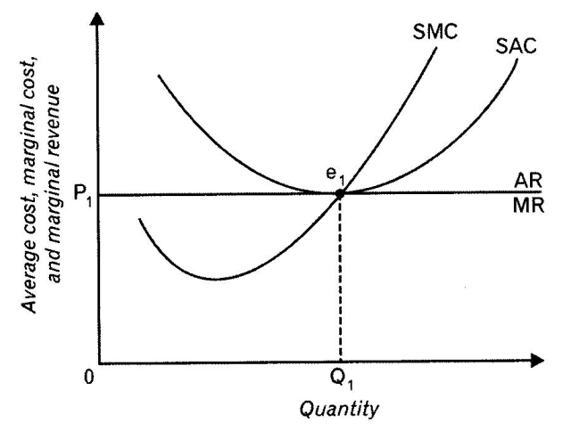

* The business makes normal profit which is the minimum earnings required to prevent the entrepreneur from closing the business and using his factors of production elsewhere.
* Equilibrium is at point e1. The business will produce at this point where SMC = MR.
* At point e1 , Q1 goods are produced at a price of P1.
* Point e1 is the Profit Maximisation point of the business.

**At point e:**

* Average cost is equal to price.
* The SAC curve is tangent to the demand curve which means that P/AR = SAC (TR = TC).
* It is only normal profits.

**Economic Profit**

* This is a profit which is made in addition to Normal Profits.
* This is the deference between Total Revenue and Total Cost.

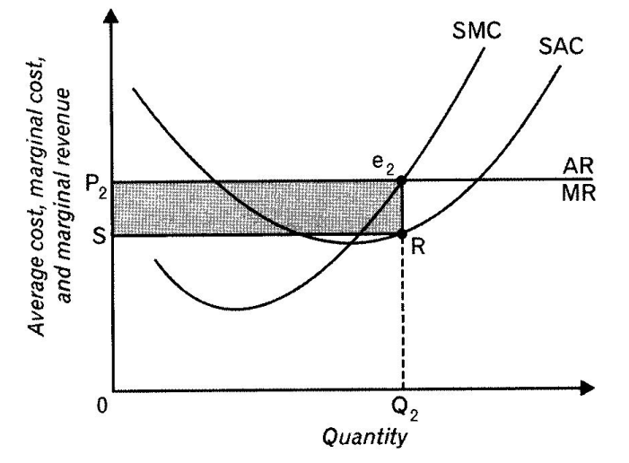

* Business Maximize profits at point e2.
* Equilibrium is at point e2. At this point SMC = MR.
* The business produces at market price P2 and the Quantity produced is Q2.
* The averages cost for Q2 units is point R on the SAC curve.
* Price /AR is greater than SAC. ( TR > TC)
* **E.g.**
* Total Revenue = OP2 x OQ2
* Total Cost = OS x OQ2
* Total revenue is more than Total cost.
* Business makes a profit
* The Profit Area: P2e2RS

**Loss**

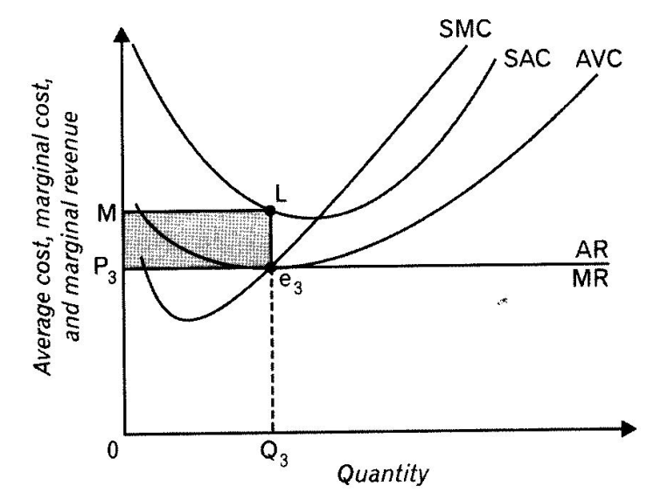

* The minimum point of the SAC curve is higher than the market price P3.
* The market is in equilibrium is at point e3. The firm will produce where SMC = MR.
* At point e3, Q3 goods are produced at a price of P3.
* At equilibrium ( point e3 ) price/AR is less than average cost
* The AC curve is lies above the demand curve which means that P/AR < AC (TR < TC)
* The business makes an economic loss.

E.g

* Total cost are represented by OM x OQ3 = OMLQ3
* Total Revenue are represented by OP3 x OQ3 = OP3e3Q3
* Total Revenue is Less Than Total Cost
* Business makes a Loss.
* The Loss Area is P3MLe3

**THE INDUSTRY**

1. **The Industry’s short term supply curve**

* The short term supply curve is also called the market supply curve.
* The market supply curve of the industry is derived by horizontally adding up the value of individual businesses.
* The market is used as a synonym for the industry.

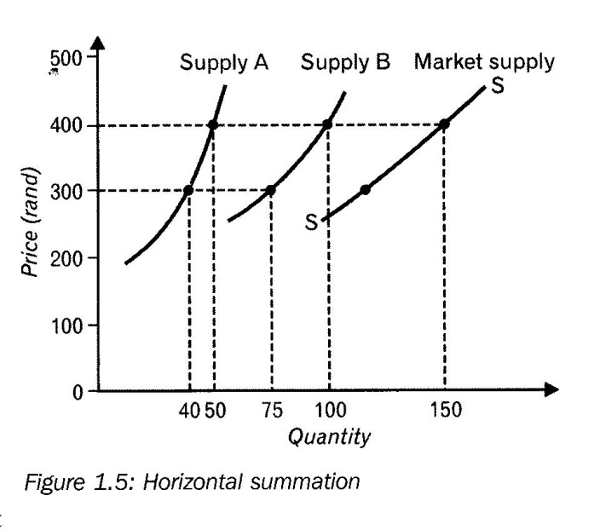

* At R400 business A supply 50 products and business B supply 100 products.
* The market supply is 150 products at a price of R400.
* The location and form of the supply curve are determined by technology and the price of factors of production.

1. **The Industry’s Short term Equilibrium**

* The industry is in equilibrium at a price that clears the market.
* That is at a price where demand is equal to supply.
* Short term equilibrium of the industry will not apply on the long term.
* Business that makes economic profit on the short term will have to expand their businesses on the long term.
* As a result of economic profit, more businesses will be attracted to the industry.
* Businesses that make losses and who are unable to adjust their business will have to close on the longterm.

1. **The Industry’s long-term equilibrium**

**Compare the individual firm and industry under conditions of perfect competition.**

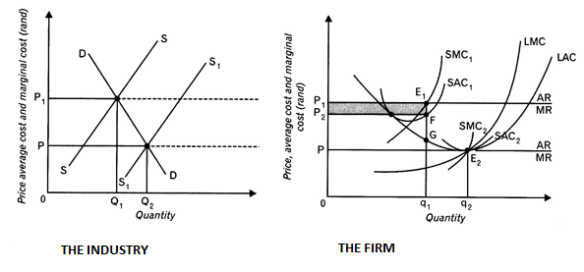

* The industry is in equilibrium at the price that clears the market.
* It is the price at which the quantity demanded is exactly equal to the quantity offered.

1. **In the long run, two things can change:**

Businesses can adjust their production capacity by:

1. New businesses can enter or leave the market.
2. All factors of production became variable and existing firms earning economic profit in the short run may decide to expand their plant size to realize economies of scale.

**2. Economic profit**

* Suppose the business's short-term plant is represented by SAC1.
* If the market price is P1 the business is making an economic profit of P1E1FP2 with the short-term plant-size represented by SAC1.
* At a price of P1 the business will maximise profit in the short-term at point E1 where the profit maximisation (MR=MC) applies, and the quantity q1will be produced.

**3. Bigger plant, lower unit cost**

* If the producer does a cost estimate, he/she will realize that, if he/she will be able to produce at a lower unit cost in the long-run,
* As illustrated by the downward sloping portion of the LAC curve.
* The prospect of increased profit would therefore encourage the producer to build a bigger plant.
* The business would however not be interested in producing output levels greater than those presented by the minimum point E2
* of the LAC because such output levels are only possible at higher cost levels – internal scale disadvantages cause the LAC to rise to the right of point E2.

**4. New entrants, increased supply**

* The economic profit that businesses make is likely to attract new businesses to the industry.
* Because the quantity offered on the market increases as a result of expansion by existing businesses and the entry of new businesses. The supply curve on the market will shift to the right from S to S1 and the price will drop until it eventually reaches P.
* At the price P, which is at the same level as the minimum point of the LAC curve, total revenue (0P X 0q) is equal to total cost (0q2 X q2 E2)
* And the business is making normal profit, because it is exactly covering its total cost.
* Over time all the businesses in the industry will make normal profit and will be in long-term equilibrium.

**5. Initial losses**

* Individual firms can be in equilibrium in the short run where it makes an economic profit or an economic loss.
* These positions, however, are not sustainable in the long run under conditions of perfect competition.
* If the market price is below the minimum point of the long-term average cost curve, the adjustment process simply works the other way around.
* Eventually the LAC curve will also form a tangent with the demand curve and the businesses that have remained in the industry will be making normal profit.

**6. Price in the long term**

* The above analyses leads to the conclusion that under perfect competition the price of a product in the long term will settle at a level that corresponds to the lowest point of the LAC curve.
* A point such as E2 represents the equilibrium point of the business in the long run.
* The business is making normal profit and there will be no incentive to leave or enter the industry.
* When a market price has been established under perfect competition at a level where each business is in equilibrium at the minimum point of its LAC curve and only making normal profit, the industry will also be in long-term equilibrium.

**7. Equilibrium**

* Once long-term equilibrium has been achieved, and provided that there are no changes in the technology or the factors of production, there will be no further entry or exit of businesses.

1. **The optimal utilsation of rsources / Conclusion**

Under perfect competition in the long-term, the market mechanism will lead to an optimal utilisation of factors of production due to the following reasons:

* The output is produced at the lowest possible cost (minimum pointof LAC)
* The consumer pay the lowest possible price for the product (price = the lowest cost at which the product can be produced)
* The price of the product = the opportunity cost of producing the product.
* All businesses are making normal profits only.

|  |
| --- |
| **Comparison between the different MARKET STRUCTURES** |

|  |  |  |  |
| --- | --- | --- | --- |
| **Perfect Competition** | **Imperfect Competition** | | |
| **Features** | **Perfect Competition** | **Monopoly** | **Oligopoly** | **Monopolistic Competition** |
| **Number of Firms / Businesses** | Large Number of buyers and sellers | Only ONE Seller and many buyers | Few numbers of businesses / sellers. | Large number of businesses / sellers. |
| **Nature of product** | Products sold on the market are homogeneous. | Products / Services are unique with no close substitutes | Products are Homogenous and Differentiated. | Products are differentiated. |
| **Entry** | Completely Free Entry | Completely Restricted or blocked | Entry into the market Varies from free to restrict. | Free entry and exit into the market. |
| **Market Information** | Both buyers and sellers have full knowledge of all the prevailing market conditions | Both buyers and sellers have full knowledge of all the prevailing market conditions | Incomplete information between buyers and sellers. | Information for buyers and sellers are incomplete. |
| **Collusion** | Impossible. Sellers act independently from each other. | Irrelevant, only one firm | Collusion is possible. | There are many sellers / producers and this make collusion impossible. |
| **Control over market price / Control over the price of the product** | Has no control over the price of the product.  Business is a price taker. | Considerable control over the price of the product, but limited by market demand and the goal of profit maximization. | Have control over prices. They are price makers. | Businesses have little control over prices of products. |
| **Demand Curve for firms’ / businesses product.** | Horisontal demand curve (Perfectly elastic) | Demand curve slope downward and it equals the market demand curve | Demand curve is downward sloping. | Demand curve is downward sloping. |
| **Long Term economic profit** | Zero (Make Normal profit only) | Can make economic profit in the long term. | Can make economic profit in the long term. | Make normal profit |
| **Examples** | International commodity markets e.g. gold, oil, etc.  Financial Markets (JSE). | Eskom  DSTV  Stainless Steel (Columbus steel). | Petrol and oil,  Cellular phones,  Motorcars, | Fast food outlets, Clothing stores, Household furniture, etc. |

**COMPETITON POLICY**

* Competition policy wants to promote competition and prevent the abuse and exploitation of economic power but rather exploit the advantages of healthy competition to benefit the society as a whole.
* Markets can only operate efficiently if there is healthy competition.
* The first step in promoting competition is to open up a country's economy to imports.
* South Africa was one of the founder members of the World Trade Organisation (WTO) in 1994.
* The WTO promotes free trade in the world by the reduction of import tariffs and the abolition of import control.

**THE AIMS OF COMPETITION POLICY IN SOUTH AFRICA.**

* Prevent the abuse of economic power, e.g. by a monopolist
* Regulate the growth of market power by means of takeovers and mergers
* Prevent restrictive practices, especially by oligopolists, such as fixing of selling prices, collusion in respect of tenders or price discrimination
* Contribute to the developmental objectives of the state
* To improve efficiency of markets through legislation
* Improve equity in markets e.g. Employment Equity Act
* Protect the consumer against unfair prices and inferior products e.g. Competition Act
* Prevent Price fixing
* Promote Competition

**THE ANC’s POLICY ON MONOPOLY FORMULATION**

* In 1994 the African National Congress, which propagated a strict anti-monopoly policy, came to power in South Africa.

**This meant a further boost for competition policy in the country:**

* A great deal of emphasis was placed on the fact that there should be no restrictions on entry (to any industry), because this would be to the detriment of previously disadvantaged groups.
* These groups should obtain access to resources and economic power in order to promote economic transformation in the country.
* A further objective was to curb the economic power of the big conglomerates in there South African economy in order to arrive at a more equitable distribution of income and wealth.
* The fact that South Africa was able to regain access to the world economy also served to make South African businesses more competitive.
* Another factor was that new trade agreements with other countries made it mandatory for South African competition law to comply with certain requirements.

**PROVISIONS OF THE COMPETITION ACT 89 OF 1998**

* The result of the above developments was the adoption of a new law, the Competition Act 89 of 1998.
* This act makes provision for a:

1. Competition Commission
2. A Competition Tribunal
3. **Competition Commission**

* The Competition Commission tries to give all South Africans equal opportunities to participate fairly in economic activities in order to make the economy more efficient.
* One of the provisions of the act is that the Competition Commission must be advised of any mergers and takeovers.
* Mergers cannot take place without the consent of the Commission.
* When the Commission evaluates mergers, any matters relating to competition and efficiency, and the public interest, must be taken into account.

1. **A Competition Tribunal**

* The Commission's recommendations are submitted to the Competition Tribunal,
* The Commission Tribunal can accept or reject the recommendation made by the competition commission.
* If there are any disputes over the recommendations, they are referred to the Competition Appeal Court.