Big thanks to A Green

Compiled by: Metro North Education District – A Green

**The Dynamics of Imperfect Markets**

**Examples of Imperfect markets**

* Monopolies
* Oligopolies
* Monopolistic Competition

1. **MONOPOLY**

* The word monopoly is derived from the Greek words monos meaning single and pole in meaning sell.
* In its pure form, monopoly is a market structure in which there is only one seller of a good or service that has no close substitutes.
* It is the opposite extreme to perfect competition in the spectrum of market

structures.

* Consumers cannot purchase the product from any other producer but the

monopolist.

* A further requirement is that entry to the market should be completely blocked.

**Definition of the word Monopoly**

* Is a market structure in which there is only ONE seller of a good or service that has no close substitutes, entry into that market is completely blocked.

1. **Features/Characteristics of a monopoly:**

**They are faced with demand curves**

* Monopolists are also confronted with a demand curve for their product, but because they are the only supplier of the product they can decide at what point on the demand curve they wish to be.
* Because the monopolist is the only supplier of the product in the market, the demand curve that confronts the monopolist is that of the market as a whole that is, the market demand curve which slope downwards from top left to right bottom.



**They decide on their production levels**

* Once a monopolist has decides on a price, the quantity sold is determined by

markets demand.

* By reducing the price, monopolists can sell more units of the product, and vice

versa.

* To a significant extent, monopolists can influence the price-quantity combination of the product they sell.
* Other participants cannot act because a basic requirement for the existence of a monopoly is that entry to the market is totally blocked.

**They are exposed to market forces**

* Although the monopolist is the only supplier of a product, the product is still

influenced by market forces in the economy.

* e.g. Consumers have limited budgets and therefore monopolies cannot demand excessive prices for their products.
* The monopolist's product has to compete for customers' favour with all the other products available in the economy.

**They face substitutes**

* There are few products that have no close substitutes whatsoever.
* For example, for many years, even though there was no competition for telephone services in South Africa, consumers could still consider using alternative forms of communication such as letters and messengers.

**They may exploit consumers**

* Because a monopolist is the only supplier of a product there is always the

possibility of consumer exploitation.

* Government continually taking steps to guard against such practices.
* Example: the Competition Act 89 of 1998

**They are protected by barriers of entry**

**Artificial Monopolies**

* Barriers to enter the market is not economic in nature
* May enjoy favourable circumstances/limited size of markets
* Sometimes an entrepreneur may enjoy favourable circumstances in certain

geographical area.

* Example: there may only be one supplier of milk in a particular town, or

hardware store, or hotel may be the only one of its kind in the vicinity.

* The exclusive ownership of raw material.
* Example: De Beers Consolidated Mines.
* Patent, which is the legal right whereby a patent holder obtains the exclusive

right to manufacture a product.

* Example: Kreepy-Krauly
* Licensing is another way in which artificial monopoly comes to existence.
* Example: SABC/Cell C/Vodacom/MTN
* Legal restrictions, where laws protecting them.
* Example: the Post Office in South Africa.
* Technical superiority, A business whose technological expertise vastly exceeds that of any potential competitor.
* Example: Microsoft
* Deliberately created entry barriers
* Example: To start costly lawsuits against new rivals.

**Natural monopolies**

* High development cost limit entry into the market.
* E.g. Electricity supply
* They are owned or regulated by the government.
* It is a large and expensive process – It can cost billions of Rands.
* A single business in the industry can serve the whole market.
* They can do it at a lower prices than two or more businesses together.

**Monopoly as a market Structure**

|  |  |
| --- | --- |
| **Number of firms** | The monopoly consists out of one single firm.  • The monopoly is also the industry.  • Example: Eskom or De Beers – diamond-selling |
| **Nature of product** | • The product is unique with no close substitute.  • Example: Diamonds are unique. |
| **Market entry** | Refers to how easy or difficult it is for businesses to enter or to leave the market  • Is entirely/completely blocked.  • A number of barriers to entry that may give rise to monopoly can be:  - Economies of scale  - Limited size of the market  - Exclusive ownership of raw materials  - Patents  - Licensing  - Sole rights  - Import restrictions |
| **Market Information** | This refers to market participant’s information on market conditions.  Both buyers and sellers have full knowledge of all the prevailing market conditions |
| **Control over price** | • In the case of a monopoly there are considerable price control, but limited by market demand and the goal of  profit maximisation.   * Monopolist is a Price Maker. |
| **Demand curve for the firm’s product** | • It equals the market demand curve  • Downward-sloping from left to right |
| **Long-run economic profit** | • Can be positive  • Because new entries are blocked and short-run economic profit therefore cannot be reduced by new competing firms entering the industry  • The monopoly can thus continue to earn economic profit as long as the demand for its product remains intact |

**B REVENUE**

* The monopoly is confronted with a normal demand curve.
* It slopes from left top to right bottom.

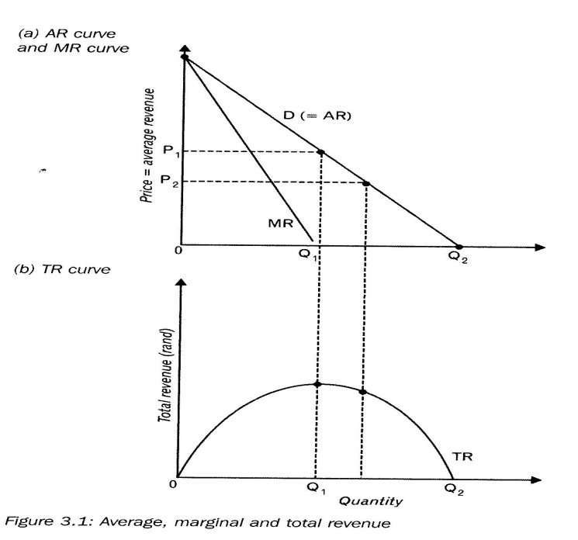

* Any point on the demand curve of the monopoly is an indication of the quantity of the product sold and at which price.
* At OP1 the monopolist can sell OQ1.
* The monopolist can sell each individual product at OP1.
* It means that OP1 = Average price or Average revenue that the monopolist earn for each unit.
* This applies for every price- quantity-combination on the demand curve.
* The demand curve is also the Average Revenue (AR) curve)

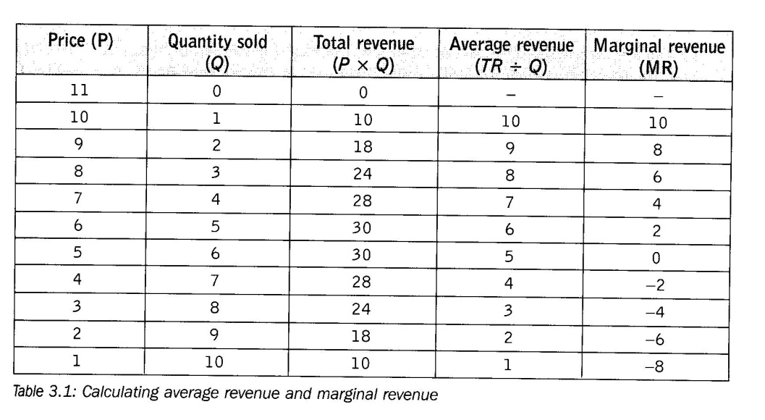

* The first two tables represent the demand curve.
* OP = the different prices.
* OQ = The Quantity demanded at each price.
* **Total Revenue** = Price x Quantity
* **Average Revenue** = Total Cost divided by Quantity
* **Marginal Revenue** = it is the change in Total revenue when one additional unit has been sold.

**THE IMPLICATIONS OF THE DOWNWARD SLOPING DEMAND CURVE**

1

* The marginal curve (MR) runs below the demand curve.
* The marginal revenue (MR) intersects the horizontal axe at a point that is exactly halfway between the origin and the point of intersection of the demand curve (AR).

2

* The monopolist will have a pricing policy.
* The monopolist is the only supplier on the market and has a downward demand curve.
* It is where each unit sold is associated with a unique price.
* When the price decreases more units are sold.
* The monopolist can influence the price-quantity combination to a great extent.

3

* The monopolist will not fix his/her price lower that the center point of demand curves.
* **Reason**: His/ her total revenue will decrease.
* When the price is in the lower part of the demand curve.
* A point will be reached where the marginal revenue will become negative.
* When the price is lower than OP1 = Sell more units.
* Will end up on a lower point on the total revenue curve.

**The AR and MR are TWO different curves because:**

* In a perfectly competitive market the AR = MR = P.
* A monopoly is confronted with a normal market demand curve, which slopes downwards from left to right D = AR.
* Any point on the monopolist’s demand curve (D) is an indication of the quantity of the product that can be sold and the price at which it will trade.
* The MR curve runs below the demand curve with the exception of the first unit,
* TR increases at a diminishing rate up until a point and then starts to decrease.
* MR is always lower than AR.
* The percentage increase in quantity demanded is greater than the % decrease in price at all points, therefore the MR will always lower than AR.

**C PROFIT AND LOSS IN THE SHORT TERM**

**Profit**

* Monopolist also tries to maximize profit on the short term and long term.

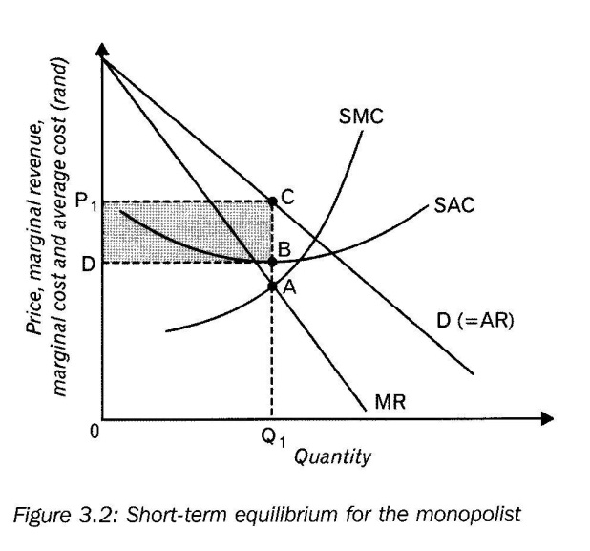

* Illustrate short term equilibrium
* The demand curve slopes from top left to right bottom.
* Demand curve = Average Revenue curve (AR)

**Cost curve are:**

1. The short term marginal cost curve (SMC)
2. The short term Average cost curve (SAC)

**Short term equilibrium is determined as follows:**

1. It is where Marginal cost is equal to Marginal revenue

SMC = MR

* The business increase production to a point where production cost of the last unit is equal to the revenue it earns.
* At Point A: SMC = MR: It is the profit maximisation point and the quantity is OQ1.

1. The price at which OQ1 must be sold must be determined

* Draw a line vertical upwards from point A up to point C till it reached the demand curve.
* The price at point C is OP1.
* The price is OP1 and the Quantity is OQ1.

**Calculate the short term profit**

**Total Revenue**

* Price x Quantity = Total Revenue
* OP1 x OQ1 = OP1CQ1

**Total Cost**

* Average Cost x Quantity = Total Cost
* D X OQ1 = ODBQ1

**Total profit**

* Total Revenue – Total cost = Total Profit
* OP1CQ1 - ODBQ1 = DP1CB

**Loss**

**Calculate Short term Loss**

* Monopolies can also make losses.
* Profitability depends on the demand for the product and the cost of production.

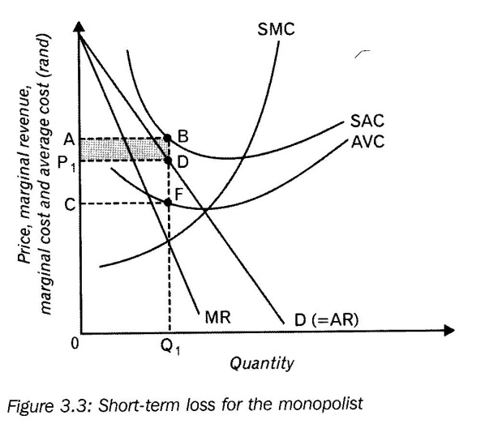

* The SAC lies above the demand curve.
* Equilibrium is where MR = SMC.
* It is a loss minimizing situation
* Monopolies are in equilibrium:
* Produce at OQ1 at a price of OP1.
* Price OP1 is lower than the SAC and is indicated by BD.

**Total cost**

* OQ1 x Q1B
* Output at Q1 = OQ1BA

**Total Revenue**

* OQ1 x Q1D = OQ1DP1

**The monopolist loss is:**

* ABDP1

**D LONG TERM EQUILIBRIUM**

* When the monopolist makes losses on the short term he/she will expand their plants sizes so that they can make profits.
* If they do not get it right, then they will have to close their businesses.
* When the monopolist makes profit on the short term then they will try to expand their plant size to make more profits.

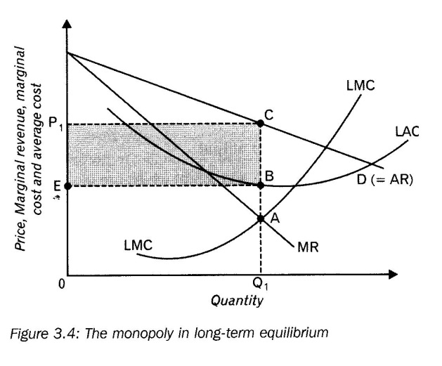

* The long term marginal cost (LMC) and the long term average cost curve (LAC) appear in the graph.
* Long term profit is maximised where MR = LMC.
* The MR = LMC at point A.
* Profit maximising output is OQ1 at a price of OP1.

**E Comparison of monopoly with the perfect competition**

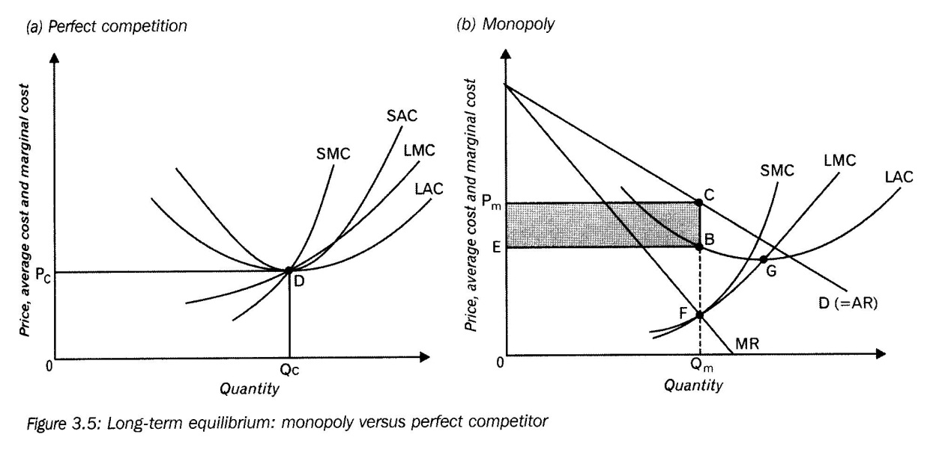

**1 Assumptions**

* We accept that all details of all businesses in perfect competition are added together.
* Their cost curves do not change.
* The collective cost curve are shown above
* Cost curves (structure) of the business (industry) is the same as that of the monopoly
* Businesses retain the characteristics of perfect competition and do not act like a monopoly.

**2 Higher prices, lower production**

* The two figures above are fully comparable.
* When businesses are in long term equilibrium under perfect competition, then they will produce at Quantity Qc an sell it at a price Pc.
* When businesses are in long term equilibrium under monopolies, then they will produce at Quantity Qm and sell it at a price of Pm.
* Monopolies produce less Qm < Qc and sell it at a higher price Pm > Pc.
* At perfect competition production takes place at the minimum point on the LAC curve
* With monopolies it is not the case.

1. **Economic profit**

* Perfect competition only earns normal profit on the short term as well as long term.
* Make normal profit at point D.
* Monopolies make economic profit on the short term as well as the long term.
* Make economic profit of PmCBE in the long term.

**Summary**

* In the long term:
* Produce a monopoly less.
* Charge higher prices for products.
* Does not produce at the lowest possible cost.
* Make economic profit.

1. **OLIGOPOLIE**
2. **Description**

* It is a market structure in which a few sellers dominate the market.
* Each seller does not influence the others, but has to consider them.
* Eg. Identical goods, Steel, cement, sugar.
* Eg. Highly differentiated goods: Motor cars, Newspapers, Airlines.
* When there are only TWO businesses in a oligopoly, then it is called a Duopoly.

**When does this market form exist?**

* It is a small group of large firms working together to dominate the price of a product in a market.

1. **The Kinked demand curve**

* The kinked demand curve shows the reason why we experience price rigidity in an oligopolistic market.

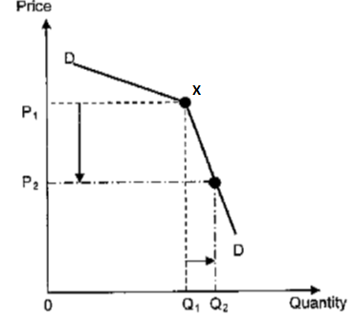

* Let us assume the Price of the Product is P1.
* Let us assume the firm is seeling at P1.
* **The firm has THREE options.**

1. **The firm can increase the price.**

* If the firm increase the price above its present price at P1, it is more likely that other firms will not increase their prices.
* The firm will end up losing customer to other firms because they will buy where the price is lower.
* A small price increase will cause a greater decrease in demand. Therefore, the decrease in demand will be greater than the price increase.
* The firm will face a relative elastic demand curve above the point “X”.

1. **The firm can lower the price.**

* If the firm lowers the price, it will start a price war
* Other firms will lower their prices too.
* It is more likely that the competitors will set their prices even lower than the firm.
* There will not be a great increase in demand even with a relatively high price cut.
* That is why a relatively big decrease in price will cause a small increase demand.
* The firm will face relative inelastic demand curve below the point “X”.

1. **The firm can keep the price the same.**

* The firm should therefore not change the price and should continue to sell at price “P1”'.
* When we combine both the demand curves we will get a demand curve kinked at point “X”.

**Therefore:**

* The best strategy is to stick to the existing price level.
* In order to avoid a price war firms will compete on other factors rather than price.
* This is known as non-price competition

1. **Characteristics of a typical oligopoly.**

**Type of product**

* The Product is homogeneous (pure oligopoly) or differentiated (differentiated oligopoly)

**Entry**

* New producers have free entry although not easily illustrated. There are only a few businesses in market.

**Control over prices**

* Producers generally have considerable control over price of products.

**Mutual dependence**

* Only a few businesses sell the product
* Businesses are influenced by other businesses actions
* Busiensses are mutually dependent on each other, thay is why competitors react to price changes.

1. **Non Price Competition**

* Oligopolists do not compete with each other on price because price wars will not benefit them.
* Prices are determined by mutual agreement.

**Forms of non-price competition.**

* Doing business over the internet
* After-sales service
* Loyalty rewards for customers
* Door-to-door deliveries
* Building brand loyalty and product recognition
* Offering additional services (free travel insurance by banks)
* They compete with each other on product differentiation and efficient service.
* Convenience shopping, E.g. extended shopping and business hours
* Firms make use of advertisements to increase awareness and to lure customers towards their products. E.g. Pick n Pay use extensive advertising to increase their market share.

1. **Collusion**

* No oligopoly can be sure of the behaviour and policy of their competitors.
* Businesses function in an uncertain environment.
* To reduce these uncertainties- businesses often collude.
* They agree over the prices of their products.
* They also decide on the amount to be produced.

**It causes**

* Higher prices
* Less uncertainties
* Make it difficult for other businesses that want to enter the market.

**TWO types of Collusion**

1. **Cartels**
2. **Price leadership**
3. **Cartels**

* It is when oligopolies collude openly and formally.

Definition of a Cartel

* It is an organization of oligopolistic businesses that comes into existence in an industry with the specific aim of forming a collective monopoly.
* Cartels control the production of goods and this influence the prices of products.
* E.g. OPEC

1. **Price leadership**

* Formal collusion (cartels) is mostly prohibited.
* Collusion agreements often fail.
* It leads to tacit collusion.
* Price signals are frequently the key element to tacit collusion.
* One business increase its price in the hope that his rivals will increase their prices – Known as price leaders.
* When the other businesses follow with the increase – Known as price followers.
* Price leaders are usually the strongest and most dominant business whose production cost is the lowest.
* E.g. Steel industry, Transports industry.

1. **Price and production levels**

* The prices and production levels of an oligopoly depend on the model of the market structure studied.

1. **Comparison with other perfect competition**

|  |  |  |
| --- | --- | --- |
|  | **Oligopoly** | **Perfect Competition** |
| **Profit** | * Can make economic profit in the long term | * Make only normal profit in the long term. |
| **Cost** | * Unlikely that they will produce at the lowest point on the long LAC curve. * Consumers do not get products at the lowest possible prices. | * Produce at the lowest possible point on the LAC curve. * Therefore the consumer receives the product at lowest possible price. |
| **Price** | * Price of the products is higher as than the MC (P > MC) * Consumers attach a greater value to the additional units than the resources required to produce it. * Businesses produce less and sell their products at a higher price. | * The price of the product will be equal to marginal cost (P = MC). * Businesses produce more products and sell any quantity at the market price. |

**MONOPOLISTC COMPETITON**

**A Characteristics of Monopolistic Competition**

1. **Entry into the market is free.**
2. **The business have little control over the prices of products**
3. **Information for buyers and sellers is incomplete.**
4. **The Nature of the product is Differentiated**

**Products are not identical.**

* Products is the same but not identical.
* They satisfy the same needs.
* e.g. Shoes, Men’s cloths, Women Cloths, etc.

**Differences may be imaginary**

* The name of the product differs but ingredients is exactly the same.
* Sometimes only the service of the seller differs from the others.

**Difference in packaging**

* e.g. Sugar and Salt
* Only the packaging makes the difference.

1. **Hybrid structure**

* Monopolistic competition is a combination Competition and a monopoly.

**Monopolistic Competition consist of the following elements**

|  |  |
| --- | --- |
| **Competition** | **Monopoly** |
| * There are many sellers of differentiated products. * Relatively small in relation to market demand. * Businesses can enter or leave the market freely on the long term. | * Product differentiation * Has a certain degree of monopolistic power. * The only producer of a specific brand or variant of the product. |

1. **Often it is local**

* Occurs generally in the retail or service sector.
* On National level we have
* E.g. Wine, Clothing, Furniture, etc.
* Locally there are numerous examples of Monopolistic competition.
* Especially in urban areas.
* E.g. Filling stations, Pharmacies, grocery stores, etc.
* All these businesses have a certain amount of monopolistic power.
* As a result of the uniqueness of the product, or favourable location, slightly lower prices, better service.
* Monopolistic power is not very strong because of the availability of substitutes.

1. **Large number of Diverse businesses**

* Because of product differentiation we cannot derive a demand and supply curve.
* A single equilibrium for a single product cannot be determined.
* A range of prices will apply. Different types of prices.
* A Graphic analysis does not focus on the industry but on the typical or representative business.
* The term industry refers to all the sellers of a differentiated product in a specific product group.

**B Non-price competition**

* It is competition on the basis of product differentiation, efficient service and by using advertisements, rather than on the basis of prices.
* With Monopolistic competition the products are differentiated.
* The opportunity is created to increase the demand for the product and to make it less price elastic.
* It is done by product variations and marketing campaigns.
* Differentiation may even be imaginary.
* e.g. medicine
* Different trade names but it consists of the same ingredients.
* E.g. beauty products.
* Try to articulate the feeling of beauty
* Huge sums of money are spent on research, development and advertisements to build a loyal consumer group.
* Brand names play an important role.
* Producers try to maintain his/her consumer group.
* e.g. Pick ‘n Pay
* No Name” Products
* Products are exactly the same as the known brand.
* It even originates form the same factory.

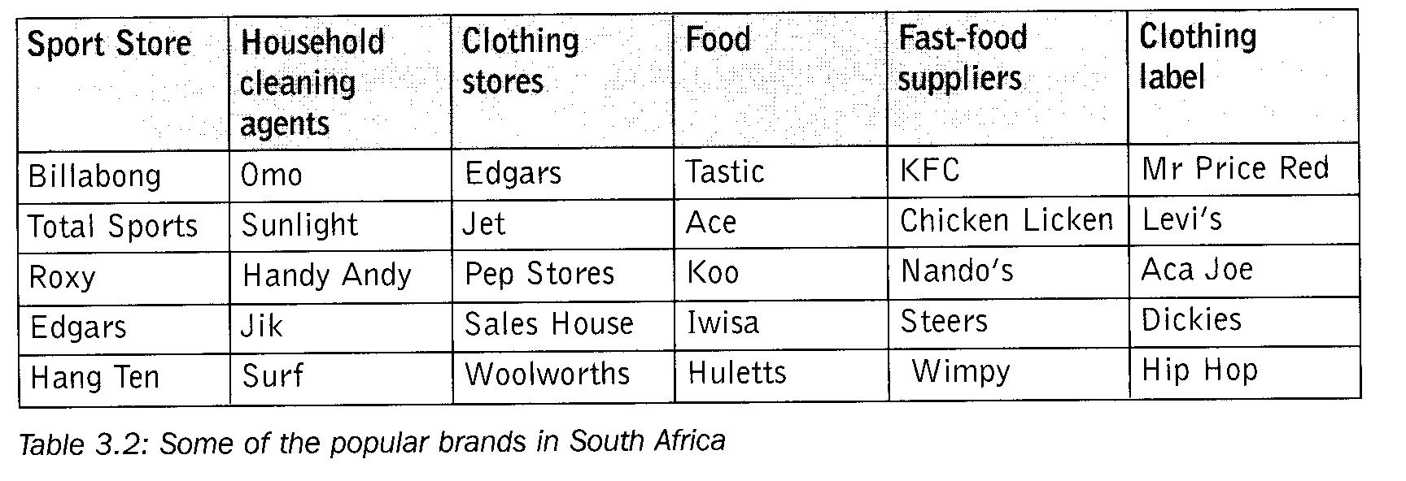

**C Collusion**

* There are many producers and this make collusion impossible.
* No agreements on things such as prices and production quantities.

**D Prices and production levels: Short term and Long Term**

* Demand curve slope from left to right bottom.
* Entry into the industry is unrestricted.
* Economic profit in the long term attracts new businesses with competitive products.
* This will eliminate economic profit.
* Short term equilibrium of monopolistic competition corresponds with the monopoly.
* In other words, the equilibrium quantity he/she are going to produce in the short term and at which price it will be sold.
* Short term equilibrium of the monopolistic competitor corresponds with the monopolist.
* The demand curve of Monopolistic competition is more elastic than the monopolist.
* Reason: There are a number of substitutes = this is not the case with monopolies.

1. **Short term**

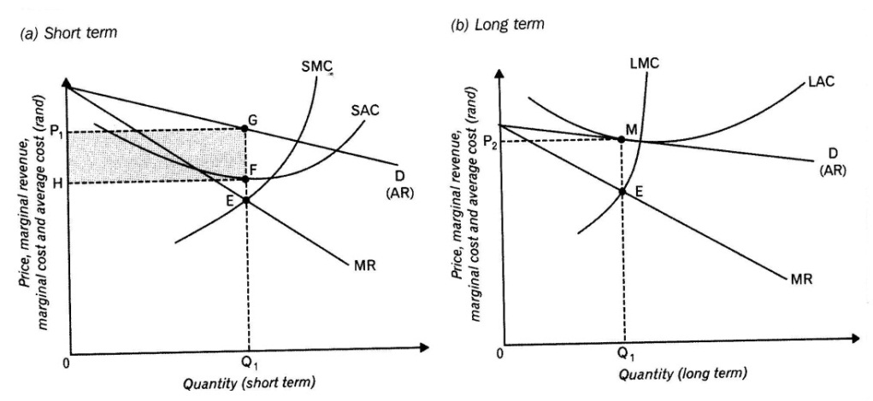

* Above we find a downward sloping demand curve of monopolistic competitor.
* The demand curve is also the Average revenue curve (AR)
* The marginal revenue curve (MR) lies under the AR curve.
* The SAC and the SMC are the cost curves.
* P1 = Profit maximization price.
* Q1 = Profit maximization quantity.
* The MR = MC at point E the profit maximization point.
* Price (P1) at point G exceeds the average cost at point F.
* The monopolistic competitor makes economic profit.
* Economic profit area is HP1GF.

**(ii) Long term**

* The situation between monopolistic competitor and monopolist differs dramatically.
* Monopolist is protected by barriers to entry and can make long term economic profit.
* Monopolistic competition is characterised by free entry to the market.
* Short term economic profit attracts more businesses in to the industry in the long term.
* The market demand curve shifts to the left.
* This is because there are more businesses in the market and each one’s market demand is less.
* Demand curve is more elastic because more substitute products are available in the market.
* Demand for certain businesses goods can decrease – cause that they must leave the industry.
* Demand curve will now shift to the right.
* This will continue until no-more businesses enter or leave the industry.
* All economic profit is eliminated.
* A long term equilibrium position will be reached where the business makes normal profit.
* The demand curve will form a tangent with the long term average cost curve.
  + 1. Long term profit
* Competition caused all economic profit to disappear.
* The long term averaged cost is equal to the price of the product.
* Only normal profit will be made.
* It is also the maximum profit that can be made.

**E Comparison with perfect competition**

* The long term equilibrium position of the business under perfect competition and monopolistic competition is shown.

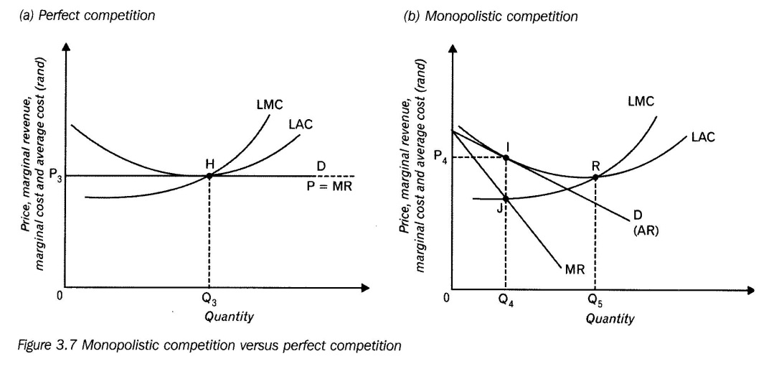

|  |  |  |
| --- | --- | --- |
|  | **Perfect competition** | **Monopolistic competition** |
| **Profit** | * Only Normal profit will be made over the long run | * Only normal profit will be made over the long run |
| **Price** | * the price of the product is equal to average cost Point H * Price = P3 * Businesses produce more products and sell any quantity at the market price. | * The price of the product is equal to average cost Point I. * Price = P4. * Business produces less and Consumers pay higher prices. |
| **Cost** | * They produce at the minimum point on the LAC curve. * Produce at Point H with an output of Q3. * There is no surplus capacity. * Therefore the consumer receives the product at lowest possible price | * Does not produce at the minimum point of the LAC * Produce at point I with an output Q4. * The difference between Q4 and Q5 is called surplus capacity * Consumers do not get products at the lowest possible prices they pay higher prices |

**Disadvantages of Monopolistic Competition for the firm and consumer**

* Consumers pay a higher price under monopolistic competition
* Output of monopolistic competition is less than that of the perfect competitor.
* Monopolistic competitor is unable to produce at the ideal production levels
* Monopolistic competition is therefore neither allocatively nor productively efficient
* Inefficient use of resources in the case of monopolistic competition – perfect competitor produces more at lower prices – therefore more efficient in the use of resources
* Market information on monopolistic competition is incomplete