**KINDS OF INFLATION**

**Description of inflation**

* **Inflation**: A general and sustained rise in the price levels of goods and services for a given period.
* Characteristics:
  + - It is a continuous process.
    - It refers to a rise in prices in general.
    - It involves a considerable increase in prices.
    - It causes a decline in the purchasing power of money.

**Kinds of inflation**

***Consumer inflation***

* There are four different types of consumer inflation:

o **Headline inflation**: as determined using the CPI.

o **CPIX inflation:** excludes mortgage bond interest rates.

o **Core inflation:** excludes items that have highly volatile prices and items that are affected by government intervention and policy.

▪ E.g. of excluded items are fresh and frozen meat and fish, VAT, etc.

o **Administered prices inflation:**

prices of goods and services that are set by government or controlled by government appointed authorities.

* In composing CPI, Stats SA does five things:
  + - * Identifies and selects the goods and services to be included in a „basket of items‟.
      * Assigns a weight to each good or service.
      * Decides on a base year.
      * Decides on a formula.
      * Decides on the collection of prices.

***Producers’ inflation***

* This is the production price index (PPI).
* Economics in action p257 Enjoy economics.

***All-inclusive inflation***

* When the prices of all final goods and services are checked, we use the *implicit* GDP deflator.

***Demand-pull inflation***

* The demand for goods and services increases and production remains the same or does not increase as fast. The excess demand results in prices being “pulled up”.
* Affected by:
* o Greater spending by households (C) (Also because credit has become more readily available).
  + - Investment spending by firms increases as a result of a drop in interest rates and/ or a positive business climate (I).
    - Increased government spending (G).
    - Higher earnings from exports (X).
* Monetarist school:

o Inflation arises when the supply of money increases more than the production capacity of a country.

* Keynesians:

o Inflation is caused by excessive demand.

***Cost-push inflation***

* Caused by an increase in the cost of production. Increased costs “push up” the price level.

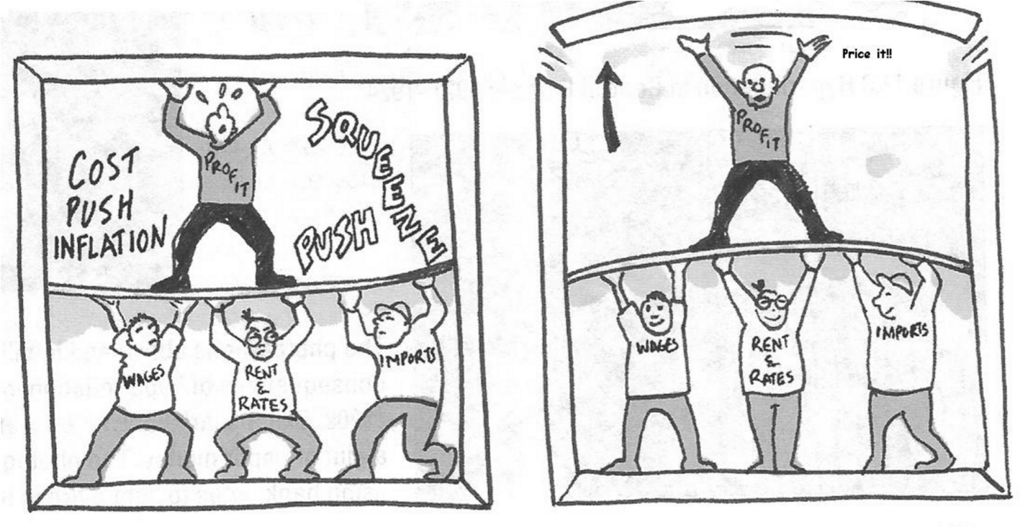

*Source: Focus on economics p159*

* Affected by:
  + - Wages (increases in wages and salaries).
    - Increase in price of key imported inputs.
    - Exchange rate depreciation.
    - Increase in profit margins.
    - Decrease in productivity for the same remuneration.
    - Natural disasters.

***Stagflation***

* A country persistently suffers from high inflation and high unemployment.

***Hyperinflation***

* Extremely rapid and substantial changes in the overall level of prices.
* Price increase is in excess of 50% per month.

***Deflation***

* Prices fall – opposite of inflation.
* Not the same as *disinflation*, which is a reduction in the rate of inflation.
* The inflation rate measures the trend in the average price level.

**MEASURES TO COMBAT INFLATION**

**Causes of inflation**

* Increase in the money supply.
* Increase in the input costs.
* Market failure.
* Imported inflation.
* Weaker exchange rate.
* Decline in productivity.
* Trade unions.

**Consequences of inflation**

* Inflation impacts negatively on economic growth.
  + - * Inflation brings about uncertainty in the economy.
      * Savings and investment are discouraged.
* Inflation affects the distribution of income.
  + - * Redistributes income from people with fixed incomes to those with flexible incomes. o Redistributes income from private individuals to the government.

Causes fiscal drag and bracket creep: salary increases move people into higher tax brackets and they could be effectively worse off. • Inflation has an adverse effect on a country‟s balance of payments.

* + - * If South Africa‟s rate of inflation is higher than that of our trading partners the result is a loss of international competitiveness.
* Inflation can cause a decrease in the real money value of savings.
* Inflation spiral: since people expect inflation to continue they do things that further fuel inflation.

**Measures to combat inflation**

***Fiscal measures****:*

* Increase direct taxes.
* Increase indirect taxes.
* Reduce government spending.
* Introduce measures to increase productivity, e.g. tax rebates.

***Monetary measures***:

* Increase interest rates of banks.
* Decrease money supply.
* Decrease availability of credit from banks.
* Decrease currency control.

***General measures*:**

* Increase productivity.
* Freeze prices and wages.
* Implement a wage restraint policy.
* Encourage personal savings.
* Implement control measures for consumer credit.
* Import control: make competing imported goods cheaper.
* Introduce price indexation: linking all prices to a particular index, e.g. CPI.
* Inflation targeting.