

**ENGLISH HL 13 April 2024**

**GRADE 12 LITERATURE NOTES ON: Life of Pi - Part 1**

|  |
| --- |
| **Setting, Plot and Characters** |

1. **Setting**

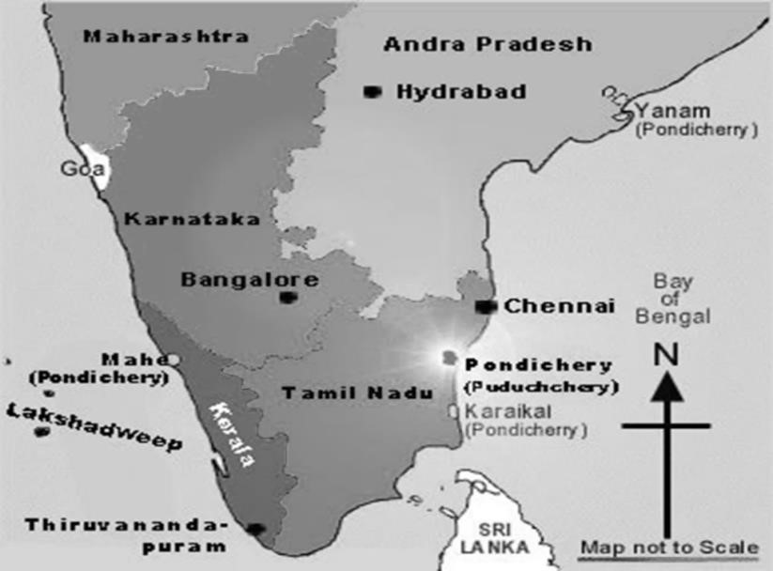**Part 1** of the novel is set in ***Pondicherry*** which was renamed Puducherry, a French colony in India. There was once a **zoo** in the Botanical Gardens in Pondicherry and the director of the film, *Life of Pi*, used the Botanical Gardens to film the zoo scenes in the movie. However, the zoo in the novel is mostly fictitious as the Pondicherry Zoo did not have the diverse species described by Pi.

In 1975, **Prime Minister Indira Gandhi** was found guilty of charges related to her 1971 election campaign. However, because of the unrest in India, she kept ruling and declared a “state of emergency” which lasted 18 months and ended in March 1977. Although India was economically successful, it was a controversial time period because she took away people’s rights and jailed her opponents. Pi’s father was nervous about the possibility of Gandhi taking over his business so he decides to move from India to Canada.

**The setting and the context** are important **plot devices** in the novel. As Pi’s family are zoo owners and because of the state of emergency, a vehicle is provided for the author to place the tiger into the lifeboat with Pi, without it seeming contrived. The focus of **Part 2** is Pi’s journey at sea in the Pacific Ocean. Martel s**trategically creates a situation where it is just the boy and the tiger alone at sea**. **Part 3** is set in Benito Juarez Infirmary, Tomatlán, Mexico. This is where the first two parts of the novel.

**2. The Plot**

* The novel tells the fantastical story of Pi Patel, a sixteen-year-old South Indian boy who survives at sea with a tiger for 227 days.
* Pi, born Piscine Molitor Patel, grows up in the South Indian city of Pondicherry, where his father runs a zoo.
* A precocious and intelligent boy, by the age of fifteen Pi – Hindu from an early age – has also adopted Christianity and Islam, and considers himself a pious devotee of all three religions. **(Polytheist)**
* Pi’s father decides to sell the Pondicherry Zoo and move to Canada as he is distressed about the government upheaval in his country. At this time, Pi is sixteen.
* Pi, his mother, father, and brother Ravi all board the Tsimtsum along with the zoo animals (who are on the way to be sold).
* The ship sinks and Pi is the only human to make it onto the lifeboat and survive.
* The hyena, a zebra, Orange Juice, the orangutan, and Richard Parker the tiger, end up on the lifeboat.
* The hyena kills and devours both the zebra and Orange Juice, before Richard Parker kills the hyena.
* Pi is left alone on a lifeboat with an adult male tiger.
* There is no land in sight and the ocean is shark-infested, so Pi builds a raft which he attaches to the lifeboat, to keep himself at a safer distance from the tiger.
* Eventually, however, life on the raft proves too exhausting, and Pi realizes that if Richard Parker gets hungry enough, he will swim to the raft and kill him.
* Pi decides that he must tame the tiger.
* Using a whistle, seasickness, and a turtle-shell shield, Pi manages to assert his authority over Richard Parker and delineate his own territory on the lifeboat, where he is comparatively safe from the tiger.
* While at sea, Pi and Richard Parker face many challenges, traumas, tragedies and miraculous occurrences.
* They never have sufficient food and fresh water, and the constant exposure to the weather elements is painful.
* A severe storm, which they miraculously survive, destroys the raft.
* Pi manages to capture and kill a bird.
* They are almost crushed by an oil tanker, which passes by without seeing them. The flare hits the side of the ship and is not seen by anyone.
* During an especially severe period of starvation, Pi and Richard Parker both go blind due to extreme dehydration and malnutrition.
* While blind, Pi hears a voice, and realizes that they have drawn near another lifeboat that contains a similarly starving and blind Frenchman.
* Pi and this man converse for a while, and bring their boats together.
* The Frenchman climbs onto Pi’s boat, and immediately attacks him, planning to kill and eat him.
* He doesn’t realize that there is a tiger on the boat and steps into Richard Parker’s territory.
* The tiger immediately attacks and kills him.
* Pi, saved at the cost of his attacker’s life, describes this as the beginning of his true moral suffering.
* Pi and Richard Parker finally reach an island that is made of algae with trees protruding from it, teeming with meerkats but no other life.
* Pi and Richard Parker stay on the island for weeks, eating the tubular vegetation and the meerkats, growing stronger, and bathing in and drinking from fresh water ponds.
* They never stay on the island at night, however, Pi because he feels safer from the tiger in his delineated territory, and Richard Parker for a reason unknown to Pi.
* Pi eventually starts to sleep on the island, and while doing so realizes that the island is carnivorous – it emits acid at night that dissolves anything on its surface.
* Pi discovers a complete set of human teeth in a fruit.
* Pi takes Richard Parker and they leave the island.
* Pi and Richard Parker eventually land on a Mexican beach.
* Richard Parker immediately runs off into the jungle without acknowledging Pi, which Pi finds very hurtful.
* Pi is found, fed, bathed, and taken to a hospital.
* There, two Japanese men come to question Pi about what caused the Tsimtsum to sink.
* He tells his story(animal story), which they do not believe, so he offers them a more plausible version, with the animal characters replaced by other humans, which casts doubt on the original story.
* Throughout the novel, the story is interrupted by the author’s notes on Pi as he is now, telling this story to the author.
* After recovering in Mexico, he went to Canada, where he spent a year finishing high school and then studied Religion and Zoology at the University of Toronto.
* At some point, he got married, and he now has two children. He still thinks of Richard Parker, and is still hurt by his final desertion.

**3. Characters**

|  |  |
| --- | --- |
| **CHARACTER** | **FACTS AND CHARACTER TRAITS** |
| **Pi**  **Piscine Molitor Patel** | * Narrator, protagonist and main character. * Son of a zookeeper. * As a teenager, he renames himself Pi. * He practises three religions - Christianity, Islam and Hinduism. * His faith and knowledge of animal psychology help him survive 227 days at sea in a lifeboat with a 450-pound Bengal tiger. * The adult Pi is described as a small, slim man, with dark hair and eyes and an expressive face. * He grows up in Pondicherry but now lives in Canada. * Pi studies Zoology and Religion at the University of Toronto. |
| **Richard Parker** | * A three-year-old Bengal tiger who is Pi’s only companion at sea. * Captured as a cub and transferred to the Pondicherry Zoo, which is owned by Pi’s father. * Becomes Pi’s nemesis (enemy/rival) as well as his reason to carry on living. * He has a human name as the result of a clerical error in which the real name of the tiger, *Thirsty*, and the name of his captor, *Richard Parker*, are accidentally reversed. * In Part 3, a story is presented to the Japanese officials showing   Richard Parker as Pi’s alter ego (a person’s alternative personality). |
| **The Author** | * Author and narrator. * Interviews adult Pi and describes his home and family life. * Adds authenticity to the story by reminding the reader that Pi’s story is the result of an interview process, not just a made-up story. |
| **Santosh Patel** | * Pi’s father ran a large hotel in Madras before moving to Pondicherry to direct the Pondicherry Zoo. * Teaches Pi about animal behaviour and to respect animals as savage beasts. * Dies in the sinking of the *Tsimtsum*. |

|  |  |  |
| --- | --- | --- |
| **Gita Patel** | • | Pi’s mother is calm, unruffled, loving and nurturing. |
|  | • | Reads widely. |
|  | • | Unlike Pi, she is not interested in religion. |
|  | • | Dies in the sinking of the *Tsimtsum*. |
|  | • | In Pi’s second story, her alter ego is Orange Juice, the orangutan. |
| **Ravi** | • | Pi’s older brother and captain of the cricket team. |
|  | • | Loves teasing Pi but the brothers are close. |
|  | • | Dies in the sinking of the *Tsimtsum*. |
| **Francis Adirubasamy**  **Mamaji** | • | A close friend of the Patel family and former competitive swimmer. He refers the author to Pi for “a story that will make you believe in God.” |
|  | • | Teaches Pi how to swim which is why Pi survives when the ship sinks. |
|  | • | Pi refers to him as *Mamaji*, *mama* meaning uncle and *ji* indicating respect and affection - therefore respected uncle. |
|  | • | Gives Pi his full name – Piscine Molitor. |
| **Sitaram** | • | Pi’s favourite worker at Pondicherry Zoo. |
|  | • | In charge of the orangutans. |
| **Mr Satish Kumar**  **Biology Teacher** | •  • | Pi’s favourite teacher at his school, Petit Sèminaire.  The first avowed atheist that Pi ever meets. Pi accepts him as a believer – but of another faith. |
|  | • | An active communist. |
|  | • | Sees nature as an illustration of the logic of science.  Inspires Pi to study Zoology at college. |
| **Mr Satish Kumar**  **Baker** | •  • | Muslim mystic (a Sufi) and baker.  Ironically, this man of faith has the same name as Pi’s atheist teacher. |
|  | • | Pi sees his shop and bakery as a sacred place and learns to practise Islam there. |
|  | • | Inspires Pi to study Religion at college. |
| **Father Martin** | • | Catholic priest who exemplifies Christ’s love. |
|  | • | Explains that Christ lived the way He did because of love. |
|  | • | Inspires Pi’s pursuit of multiple faiths. |
| **The zebra, hyena and orangutan** | •  • | Pi’s companions on the lifeboat in the more ‘factual’ story. The hyena kills the zebra and the orangutan. |
|  | • | The hyena is the French cook’s alter ego. |
|  | • | The zebra is the Chinese sailor’s alter ego. |
|  | • | The orangutan is Gita Patel’s alter ego. |
| **Mr Tomohiro Okamoto** | • | A member of the Maritime Department in the Japanese Ministry of Transport. |
|  | • | Interviews Pi in Mexico to find out what happened to the *Tsimtsum*. |
|  | • | Reluctant to believe Pi’s version of events but after hearing both stories, prefers the one with animals. |
| **Mr Atsuro Chiba** | • | Okamoto’s junior colleague who accompanies him to Mexico. |
|  | • | Seems to see a deeper meaning in Pi’s story, but goes along with whatever Mr Okamoto says. |
| **Meena Patel** | • | Pi’s wife - later in life. |
|  | • | Works as a pharmacist and is a second generation Canadian (born in Canada). |
| **Nikhil Patel** | • | Pi’s son - later in life. |
|  | • | Plays baseball. |
| **Usha Patel** | • | Pi’s four-year-old daughter - later in life. |
| **Auntieji** | • | Pi’s foster mother in Toronto, Canada. |

**QUESTION 8: *LIFE OF PI* – ESSAY QUESTION - NOVEMBER 2019**

|  |  |
| --- | --- |
| In *Life of Pi,* both the human and animal characters commit deeds of heroism and gruesomeness to survive.  Critically discuss the extent to which you agree with the above statement.  Your response should take the form of a well-constructed essay of 400–450 words (2–2½ pages). | **[25]** |

**MARKING GUIDELINES**

AGREE

* Pi's determination to survive after being stranded on the lifeboat might be considered a heroic response to an untenable situation; it takes courage to go against one's nature as Pi is forced to do.
* Pi displays fortitude, resourcefulness and strength of character that belies his age; these qualities sustain him throughout his ordeal and are a testament to his bravery.
* Pi is resolute in the loss of his family. Although he experiences a great sense of loss, he realizes that he needs to take control of his situation to ensure his survival.
* Pi overcomes his aversion to eating meat and later resorts to butchering fish, birds and turtles with little remorse. He even drinks turtle blood.
* In the first version of Pi's story, he selflessly rescues Richard Parker and is dauntless in his taming of the tiger.
* The orangutan bravely defends itself against the hyena but is cruelly killed by it.
* The hyena mercilessly feeds on the innards of the injured zebra, causing it to suffer a painful death.
* Richard Parker heroically saves Pi from the hyena and the blind Frenchman by brutally killing them, thus ensuring his own survival as Pi is still able to take care of him.
* At one point, Pi puts Richard Parker's faeces in his mouth to assert his dominance over the tiger. Later, he eats a piece of the blind Frenchman. Pi becomes uncivilized and bestial in his desperate attempt to survive.
* In the second version of Pi's story, the French cook amputates the sailor's broken leg, thus causing his death. He horrifyingly butchers the body and resorts to cannibalism.
* When Pi's mother tries to protect Pi from the French cook, she is gruesomely beheaded by him. He shockingly throws her head to Pi. In retaliation, Pi kills him and eats a piece of his flesh (cannibalism) and eventually murder.
* Pi is heroic in his ability to overcome the horrors he experiences at sea and to make a relatively well-adjusted life for himself in Canada.

**POSSIBLE INTRODUCTION**

In Yann Martel's novel "Life of Pi," both human and animal characters engage in acts of heroism and gruesomeness in their struggle for survival. This duality of behaviour highlights the complexity and moral ambiguity inherent in the characters' fight for life against the harsh forces of nature.

**POSSSIBLE CONCLUSION**

Overall, "Life of Pi" presents a nuanced exploration of heroism and gruesomeness in the context of survival. The characters' actions and choices reflect the complex interplay between instinctual responses and moral considerations in extreme situations. While heroism often emerges as a response to adversity, gruesomeness underscores the harsh realities of survival and the lengths to which individuals may go to preserve their own lives. Through the characters of Pi and Richard Parker, Martel invites readers to reflect on the multifaceted nature of survival and the moral complexities that arise when confronted with the primal urge to survive.