**Business Studies**

**Grade 12**

**Ethics and professionalism Notes**

**Define/Elaborate on the meaning of ethical behaviour.**

* Refers to acting in ways consistent with what society and individuals think are good values.
* Ethical behaviour is expected from every employee in the business.
* It means that the highest legal and moral standards are upheld when dealing with stakeholders.

**Give practical examples of ethical and unethical behaviour, e.g. using fair vs. unfair advertising techniques.**

|  |  |
| --- | --- |
| **Ethical business practices** | **Unethical business practices** |
| * Using fair advertising * Clients and employees information are not disclosed/used for the benefit of the business. * Business deals are conducted openly. * Paying fair wages * Operating within the law * Ensuring that the environment is not polluted. * Not engaging in illegal business practices * Not using child labour * Adopting codes of good ethical practice. * Establishing corporative social responsibility initiatives. * Encouraging employees to adopt ethical behaviour. * Treating all employees equally * Shareholders and employees personal interest and business interest do not conflict with one another. | * Unfair advertising * Pricing of goods in rural areas * Taxation/Tax evasion * Starting a venture at the expense of someone else * Paying employees unfair wages * Disobeying the law * Using bribery to gain business * Engaging in illegal business practices * Polluting the environment |

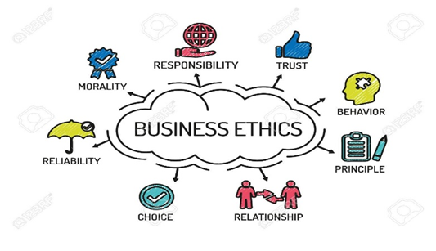

**Define/Elaborate on the meaning of professional behaviour.**

* Refers to the ethical and skilled ***behaviour*** that are appropriate within a particular work environment
* Professional behaviour ***entails*** to the specific ***work*** context
* Professional boards that ***dictate*** ***behaviours*** for people working within particular professions

**Give practical examples of professional and unprofessional behaviour, e.g. good use of work time and abuse of work time.**

|  |  |
| --- | --- |
| **Professional business practice** | **Unprofessional business practice** |
| * Using polite language to colleagues. * Good use of work time * Keeping clients details confidential/Not using clients’ information for personal gain. * Treating all people the same. | * Using rude/impolite language * Abuse of work time. * Discussing clients’ information/using clients’ information for personal gain. * Giving some people special favours. * Overstating the number of hours worked. * Unauthorised use of business resources. |

**Outline the differences/Differentiate/Distinguish between ethical and professional behaviour**

|  |  |
| --- | --- |
| **Professional behaviour/Professionalism** | **Ethical behaviour/Ethics** |
| * Refers to what is right/wrong/acceptable in a business | * Refers to the principles of right and wrong/acceptable in society |
| * Set of standards of expected behaviour | * Conforms to a set of values that are morally acceptable |
| * Applying a code of conduct of a profession or business | * Forms part of a code of conduct to guide employees to act ethically |
| * Focuses on developing a moral compass for decision making | * Focuses on upholding the reputation of a business/profession |
| * Includes guidelines on employees’ appearance/communication/attitude/ responsibility, etc. | * Involves following the principles of right and wrong in business activities/practices/dealings |

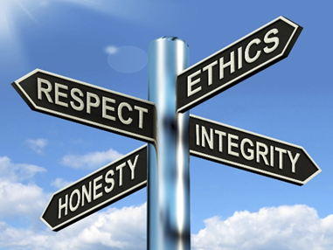

**Explain how businesses can apply the King Code principles of transparency, accountability and responsibility for good corporate governance to improve ethical business conduct.**

**Transparency**

* Decisions/Actions must be clear to all stakeholders.
* Staffing and other processes should be open and transparent.
* Employees/Shareholders/Directors should be aware of the employment policies of the business.
* Auditing and other reports must be accurate/ available to shareholders/employees.
* Regular audits should be done to determine the effectiveness of the business.
* Business deals should be conducted openly so that there is no hint/sign of dishonesty/corruption.
* Businesses should give details of shareholders' voting rights to them before/at the Annual General Meeting (AGM).
* The board of directors must report on both the negative and positive impact of the business on the community/environment.
* The board should ensure that the company's ethics are effectively implemented.

**Accountability**

* There must be regular communication between management and stakeholders.
* Company should appoint internal and external auditors to audit financial statements.
* The board should ensure that the company's ethics are effectively implemented.
* Businesses should be accountable/ responsible for their decisions/actions.
* Businesses should present accurate annual reports to shareholders at the

Annual General Meeting (AGM).

* Top management should ensure that other levels of management are clear

about their roles and responsibilities to improve accountability.

**Responsibility**

* The business/ board should develop and implement programmes that should be aimed at protecting the communities in which they operate.
* The business/ board should develop remedial programmes to protect the environment for example, reduce air and water pollution.

**Suggest/Recommend ways in which professional, responsible, ethical and effective business practice should be conducted, e.g. payment of fair wages, providing quality goods and services, not starting a business venture at someone else's expense, etc.**

* Businesses should treat all their employees equally, regardless of their race/colour/age/gender/disability etc.
* Mission statement should include values of equality/respect.
* Treat workers with respect/dignity by recognising work well done/the value of

human capital

* Pay fair wages/salaries which is in line with the minimum requirements of the BCEA/Remunerate employees for working overtime/during public holidays.
* All workers should have access to equal opportunities/positions/resources.
* Plan properly and put preventative measures in place.
* Ensure that employees work in a work environment that is conducive to safety/

fairness/ free from embarrassment.

* Refrain from starting a venture using other businesses' ideas that are protected by law.
* Engage in environmental awareness programmes/Refrain from polluting the environment, e.g. by legally disposing of toxic waste.
* Employers and employees need to comply with legislation with regard to equal

opportunities/ human rights in the workplace.

* Businesses should develop equity programmes/promote strategies to ensure that all employees are treated equally regardless of status/rank/power.
* Training/Information/Business policies should include issues such as diversity/

discrimination/ harassment.

* Employers should respond swiftly and fairly to reported incidents of discrimination in the workplace.
* Orders/Tasks should be given respectfully and allow the recipient/employee to

have a say in the manner in which the task should be performed.

**Identify the following types of unethical business practices from given scenarios/ statements: Unfair advertising and examples; Pricing of goods in rural areas; Taxation/Tax evasion**

|  |  |
| --- | --- |
| **Type of unethical/Unprofessional business practices** | **Examples** |
| Sexual harassment | -Manages who promise employees promotions if they agree to have a relationship with them. |
| Unauthorised use of workplace funds and resources | -Employees who download music and movies using the business’s resources  -An employee who uses business resources for his/her own personal gain. |
| Abuse of work time | -Making personal calls during work hours.  -Taking extended lunch breaks  -Doing personal business during work hours |
| Unfair advertising | -Giving goods deceptive names/False labelling.  -Selling second hand goods as new goods.  -Exaggerating the merits of the product/False promises  -Using fine print to conceal important information.  -Criticising competitor's goods.  -Exploitations of children's lack of understanding.  -Misuse of people with disabilities in advertisements.  -Advertising that encourages violence.  -Advertising goods at a very low price to attract customers but when the customer reaches the store the item is no longer there/Bait and switch.  -Advertising a product showing additional items, but do not clearly state that these items are excluded. |
| Pricing of goods in rural areas | -Inflating prices  -Charging higher for goods of inferior quality in rural areas. |
| Taxation/Tax evasion | -Businesses that do not declare all their income to SARS.  -Falsifying the business financial statements. |

**Explain how the below-stated types of unethical business practices pose challenges to businesses.**

**Sexual harassment**

* Manager promises an increase in salary/ a promotion/Quid pro quo harassment in exchange for sexual favours.
* A violation of basic human rights that normally happen when someone in power abuses his/her power/position, e.g. gesture/remark/action/suggestive behaviour which victimises the worker.
* The affected party is normally reluctant to report the incident due to fear of victimisation.
* Sexual harassment causes discomfort/humiliation and interferes with the job.

**Unauthorised use of workplace funds and resources**

* This form of fraud is the misuse of money without prior authorisation from a senior manager.
* Fraud increases the cost of doing business/affects competition/discourages investors when prices are increased to absorb the losses.
* Use of company assets for private use/personal gain.

**Abuse of work time**

* Employees abuse work time by arriving late/leaving early and taking longer lunch breaks.
* Employees use working hours for personal gain.
* Abuse of work time decreases productivity and loss of profits.
* Businesses can lose customers and not meet work deadlines.

**Unfair advertising**

* The use of false or misleading statements in advertising leading to misrepresentation of the concerned product, which may negatively affect consumers.
* Advertising influences a buyer’s decision to purchase a product.
* Businesses can make unwise advertising choices when they are under pressure to increase their profits.
* Unfair advertisements could be harmful to consumers.
* Some advertisements may be regarded as discriminatory because they exclude/target some sections of the population.

**Pricing of goods in rural areas**

* Some businesses in the rural areas exploit their customers by adding much more than necessary to their prices.
* Some consumers in rural areas have little economic power and are vulnerable to exploitation.
* Business may form monopolies in rural areas and increase their prices unilaterally.
* It may be common practice to pay higher prices for goods of inferior quality in rural areas.
* Business may form monopolies in rural areas and increase their prices unilaterally.

**Taxation/Tax evasion**

* The payment of tax reduces a business’s profit margin forcing some businesses to evade tax.
* Many businesses and individuals do not declare all their income to SARS.
* The accountant may charge high fees for falsify financial statements.
* Businesses who evade tax may face prosecution and fines/sent to prison if found guilty.
* Tax evasion may negatively impact on the business image.
* Businesses may lose key stakeholders if the act of tax evasion is reported.
* Businesses may not be familiar with the latest changes in tax legislation.

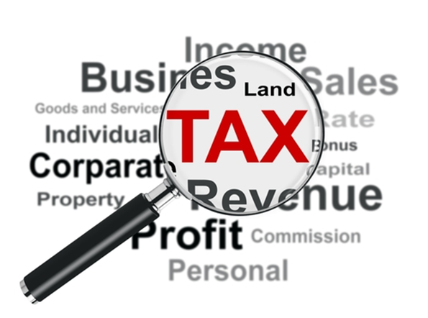**Identify the following types of unprofessional business practices from given scenarios/ statements: Sexual harassment Unauthorised use of workplace funds and resources Abuse of work time**

**Recommend/Suggest ways in which businesses could deal with above stated types of unethical business practices.**

**Sexual harassment**

* Implement internal complaints and disciplinary procedures.
* Educate employers on sexual harassment matters.
* Formulate a policy regarding sexual harassment.
* Create a good working environment where all employees' rights and dignity are respected.
* Internal investigation should be made in order to determine the seriousness of the harassment.
* 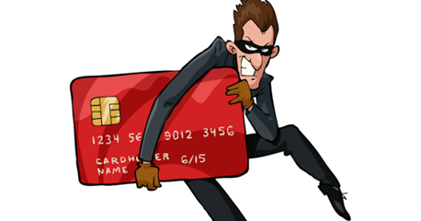Serious cases/matters on sexual harassment should be reported to the appropriate institutions such as the South African Police Services (SAPS).
* Ensure compliance with the law/business code of conduct.

**Unauthorised use of workplace funds and resources**

* Conduct regular audits.
* Identify risk areas/ vulnerable areas
* Limit the number of employees having access to business funds/assets.
* Implement/Introduce fraud prevention strategies.
* Educate employees about the impact of fraud.
* Fraud prevention should be a collective responsibility of business and workers.
* Clear policies should be in place so that employees are aware of what is considered to be fraud.
* Set up systems in the organisation for the reporting of fraud and corruption.

**Abuse of work time**

* Speak directly to those employees who abuse work time.
* Code of conduct/ethics should contain clear rules about abuse of work time.
* Conduct training on the contents of the code of conduct/ethics.
* Code of conduct/ethics should be signed by all employees so that they are aware of its contents.
* Monitor employees to ensure that tasks are completed.
* Structure working hours in such a way that employees have free/flexible time for personal matters.
* Create a culture of responsibility/strengthen team spirit in order for all employees to feel responsible for what has to be achieved

**Unfair advertising**

* Consumers must report unfair advertisements to the Advertising Standards Authority.
* Business should be encouraged to keep their advertising fair and in line with the constitution.

**Pricing of goods in rural areas**

* A business may lobby with other businesses in the area to convince government to improve infrastructure in the rural area.
* Charge fair/market related prices for goods and services.
* Avoid unethical business practices to attract customer loyalty.
* Investigate cost-effective ways of transporting products/Hire a large truck to combine deliveries to shop-owners in the same area.
* Work together with suppliers to share delivery costs to remote rural areas.

**Taxation/Tax evasion**

* Submit all tax returns on time.
* Businesses should pay the correct amount of tax to SARS.
* Keep financial records honestly and accurately.
* Make sure that all financial records are checked and audited.