**Business Studies**

**Grade 12**

**Business Strategies**

**NOTES**

**Definition of a strategy**

* A strategy is a long term plan of action to achieve a goal.
* A strategy is a plan of action to address an opportunity or to solve aproblem.
* The business needs a strategy to achieve its vision and mission.

**Outline/Explain/Discuss steps in developing a strategy.**

* Application of SWOT analysis/PESTLE/Porter's Five Forces/environmental scanning of the business environments.
* Formulate strategies to meet objectives/Develop measurable strategic

goals/ objectives.

* Implement strategies using action plans, etc.
* Evaluation of strategies/Compare the expected performance with the actual

performance/ Measure business performance in order to determine the reasons for deviations and analyse these reasons, etc.

**Outline/Describe/Explain/Discuss the strategic management process.**

* Have a clear vision, a mission statement and measurable/realistic objectives in place.
* Identify opportunities/weaknesses/strengths/threats by conducting environmental scanning/situational analysis.
* Tools available for environmental scanning may include a SWOT analysis/Porter's Five Forces model/PESTLE analysis/industrial analysis tools.
* Formulate alternative strategies to respond to the challenges.
* Develop (an) action plan(s), including the tasks to be done/deadlines to be met/resources to be procured, etc.
* Implement selected strategies by communicating it to all stakeholders/organising the business's resources/motivating staff.
* Continuously evaluate/monitor/measure strategies in order to take corrective action.

**INDUSTRIAL ANALYSIS TOOLS**

**Three INDUSTRIAL TOOLS can be used to do environmental scanning:**

* SWOT
* Porters forces
* PESTLE analysis

**SWOT analysis= ANALYSING MICRO ENVIRONMENT**

* Strengths (internal/ micro)
* Weaknesses (internal/ micro)
* Opportunities (external/ macro/ market)
* Threats (external/ macro/ market)

**PESTLE analysis= ANALYSING MACRO ENVIRONMENT**

* **P- Political-** Physical forces (BBBEE/Tax laws)
* **E-** **Economical-** (Interest-/ Inflation-/ Exchange rates)
* **S-** **Social-** Socially disadvantaged (income of people)
* **T-** **Technology-** Changes in technology (cell phones/ laptops)
* **L-** **Legal-** Trading laws/ labour laws
* **E-** **Environmental-** Ethical impact (draught, etc.)

**Porter’s Five Forces= ANALYSING MARKET ENVIRONMENT**

**Definition**

* Is based on five important forces that have an influence on the competitiveness of a business in its market environment.

**Five main factors that will have a big impact on a business ability to make a profit.**

**Competitive rivalry:**

* Selling similar/ same goods; be aware of who its competitors are.

**Threat** **of** **new** **entrants**:

* New businesses that will enter the market who can make high profits

**Bargaining power of Buyers** (**Customers**/ **clients**):

* People who buy the businesses goods; business must research how much power buyers have.

**Threats** **of** **substitute** **goods/** **services**:

* Goods that can easily be substituted; weakens the market power

**Bargaining power of Suppliers**:

* Businesses that supply raw materials and other inputs; must assess how much power supplier have over prices

**Compile a SWOT analysis of a particular business from a given scenario.**

**Explanation of a SWOT ANALYSIS**

|  |  |
| --- | --- |
| **STRENGTHS**   * What advantages does your organisation have and what do you do better than anyone else? * What unique or lowest-cost resources can you draw upon that others can't? * Do you have skilled employees and a strong customer base? * Do you provide high quality product? * Do you have sufficient resources? * What is your core competency? | **WEAKNESSES**   * High cost infrastructure * High employee turnover * Weak brand portfolio * High debts level * What are people in your market likely to see as weaknesses? * What factors cause loss of sales * Are your competitors doing any better than you? |
| **OPPORTUNITIES**   * Market growth for the business product. * New technology that will enhance quality services and products * Changing customer habits. * Disposable income level will increase. * Government’s incentives for ‘specific industry * Growing number of people buying on line (electronic marketing) * What good opportunities can you spot? | **THREATS**   * Corporate tax may increase * Rising pay levels. * Intense competition. * Increasing fuel price. * Aging population. * Stricter laws regulating environment pollution * Currency fluctuations. * Changing technology. |

**NOTE: The SWOT analysis can is usually assessed in the form of a scenario as indicated below:**

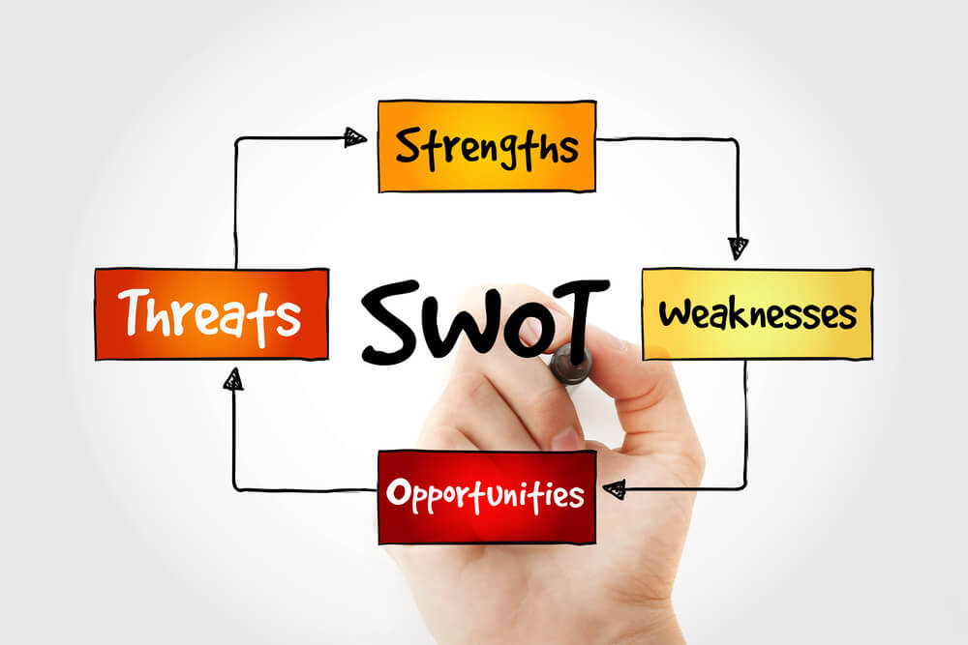

**Example of a scenario that requires learners to compile a SWOT analysis**

**DAVE DIGITAL SOUND (DDS)**

DDS specialises in selling radios and car sound systems. They employ qualified sound engineers. The business does not have sufficient capital to buy and sell sound systems that cater for large events. Businesses in the same industry are closing down due to ineffective marketing campaigns. DDS is located in a high crime area.

**SWOT analysis** **of Dave Digital Sound DDS**

|  |  |
| --- | --- |
| **STRENGTHS**   * DDS employs qualified sound   engineers.   * DDS specialises in selling radios   and car sound systems. | **WEAKNESSES**   * The business does not have sufficient capital to buy/sell sound systems that   cater for large events. |
| **OPPORTUNITIES**   * Businesses in the same industry are closing down due to ineffective marketing campaigns. | **THREATS**   * DDS is located in a high crime area. |

**NOTE: You need to quote verbatim (as is) from the scenario, otherwise you will lose marks for writing incomplete quotes or for writing a summary of the scenario.**

**Name and identify Porter's Five forces model from given statements/scenarios.**

**Power of suppliers**

* A business must assess the power of suppliers to influence prices.
* The more powerful the suppliers, the less control the business has over them.
* The smaller the number of suppliers, the more powerful they may be as the choice of suppliers may be limited.
* The business should identify the kind of power its suppliers have in terms of the quality of products/services/reliability/ability to make prompt deliveries.

**Power of buyers**

* Buyers buying in bulk can bargain for prices in their favour.
* If a business is dealing with a few powerful buyers, they are often able to dictate their terms to the business.
* If buyers can do without the business’s products then they have more power to determine the prices and terms of sale
* The business must assess how easy it is for buyers/customers to drive prices down.
* This will depend on the number of buyers/the importance of each buyer to the business and the cost of switching to other products.

**Power of competitors/Competitive rivalry**

* Competitive rivalry refers to the number of competitors and their ability to influence/control the market.
* If competitors have a unique product/service, then they will have greater power.
* A business with many competitors in the same market has very little power in their market.
* Businesses must draw up a competitor's profile so that they can determine their own strength as well as that of competitors.

**Threat of substitution/substitutes**

* Substitute products or services are different products/services that satisfy the same needs of consumers and can be used to replace one another.
* If the business’s product can be easily substituted, it weakens the power of the business in the market.
* Substitute products may cause the business to completely lose its market share.
* Unique products will not be threatened by substitute products.

**Threat/Barriers of new entrants to the market**

* New entrants are other businesses that are selling the same/similar products in the existing market for the first time.
* The power will depend on how easy it is for new businesses to enter the market.
* New competitors can quickly/easily enter the market, if it takes little time/ money to enter the market.
* If there are a few suppliers of a product/service but many buyers, it may be easy to enter the market.
* If the business is highly profitable, it will attract potential competitors that want to benefit from high profits.
* If the barriers to enter the market are low, then it is easy for new businesses to enter the market/industry.

**Explain/Advise businesses on how they could apply Porter's Five Forces model to analyse their position in the market.**

**Power of buyers:**

* Businesses must assess how easy it is for its buyers/ customers to drive prices down.
* Determine the number of buyers/ the importance of each buyer to the business and the cost of switching to other products.
* A few powerful buyers are often able to dictate terms to the business.
* Buyers buying in bulk can bargain for prices in their favour.
* If buyers/customers can do without the business’s products they may have more power to determine the prices and terms of sale.
* Conduct market research to gather more information about its products.

**Competitive rivalry:**

* If competitors have a unique product/service, they have greater power/impact on the market.
* Draw up a competitors profile of each similar business in the area to determine its strength/ Business should determine how many competitors there are and how influential they are in the market.
* If a business has many competitors with similar products, the business will have very little power in the market.
* Some businesses have the necessary resources to start price wars and continue selling at a loss until some/all competitors leave the market.

**Power of suppliers:**

* Suppliers that deliver high quality products may have power over the business.
* Asses the power of the suppliers in influencing prices.
* The more powerful the supplier, the less control the business has over them.
* The smaller the number of suppliers, the more powerful they may be as the choice of suppliers may be limited.
* Identify the kind of power suppliers’ have in terms of the quality of products/services/reliability/ability to make prompt deliveries.

**Threat/ Barriers of new entrants to the market:**

* If the barriers to enter the market are low, then it is easy for new businesses to enter the market.
* If the business is highly profitable, it will attract potential competitors that want to benefit from high profits.
* New competitors can quickly/easily enter the market, if it takes little time/money to enter the market.
* If there are a few suppliers of a product/service but many buyers, it may be easy to enter the market.

**Threat of substitution/substitutes:**

* Establish whether the seller of substitute products have improved their product/sell lower quality goods at lower prices.
* If the business’s product can be easily substituted, it weakens the power of the business in the market.
* If the business sells unique products it will not be threatened by substitute products.
* Assess if customers are using substitute products/services and determine the reasons for using substitutes.
* Change/Improve the design and quality of their products to remain competitive.

**Name and apply PESTLE analysis factors from given scenarios/statements.**

* **P- Political-** Physical forces (BBBEE/Tax laws)
* **E-** **Economical-** (Interest-/ Inflation-/ Exchange rates)
* **S-** **Social-** Socially disadvantaged (income of people)
* **T-** **Technology-** Changes in technology (cell phones/ laptops)
* **L-** **Legal-** Trading laws/ labour laws
* **E-** **Environmental-** Ethical impact (draught, etc.)

**QUESTION 1**

1.1 Identify the PESTLE element illustrated in each scenario below:

1.1.1 The government introduced the affirmative action policy to address past imbalances.

1.1.2 Governmental incentives are given to companies that sponsor nature conservation programmes.

1.1.3 Businesses are promoting online trading to reduce paperwork.

1.1.4 The introduction of the Consumer Protection Act, 2008 (Act 68 of 2008) eliminates consumer exploitation by businesses.

**ANSWER 1:**

* + 1. Political/ Legislation
    2. Environmental
    3. Technology
    4. Legislation

**Explain how PESTLE factors pose challenges to businesses. AND**

**Recommend ways in which businesses can deal with the challenges that are posed by PESTLE factors.**

**NOTE: You need to name the PESTLE factor, identify challenges of each factor and make recommend ways businesses can deal with the identified challenges as explained in the table below:**

|  |  |  |
| --- | --- | --- |
| **FACTOR** | **CHALLENGE** | **RECOMMENDATIONS** |
| Political | * Some government policies may affect businesses * Consumer rights organisations may prevent businesses from selling products if they do not meet certain requirements. * Trade agreements may prevent businesses from importing some medicine/products. | * Research recent government policies * Network and lobby with the NGOs and all consumer rights organisations. * Trade only with countries that have favourable trade agreements with the government. |
| Economic | * Inflation/Interest rates may negatively impact on business. * Loans may be expensive due to high interest rates. * Fluctuations in foreign currency may restrict import. | * Consider decreasing profit margins rather than increasing product prices. * Borrow money from financial institutions when interest rates are favourable. * Consider exchange rates when trading with other countries |
| Social | * Customers may not be able to afford products due to low income levels. * Businesses may not be conversant with the local language of their customers. | * Sell substitute/generic products at lower prices. * Learn local languages/Hire employees who are well conversant with the local language. |

|  |  |  |
| --- | --- | --- |
| Technological | * May not keep up with/be aware of the latest technology. * Employees may not be skilled to operate/maintain new technology/ equipment. * Businesses may not be able to afford new technology. * May not be able to cater for/ afford online transactions/e-commerce. | * Continuous research on the latest available technology/equipment in the market. * Train existing/appoint new employees to maintain/use new equipment. * Compare prices/Select suitable suppliers for new equipment at reasonable prices. * Businesses must be geared for online trading/e-commerce |
| Legal | * Consider certain Acts that may have a direct impact on a business, e.g. the CPA/BCEA. * Legal requirements for operating certain types of businesses time-consuming. * High legal costs involved in obtaining a licence/trade mark/patent may prevent some establishments. * Legalities of business contracts may limit business operations | * Comply with all relevant legislation that may impact on businesses. * Comply with the legal requirements for operating businesses, e.g. licence/trade mark registration/patents. * Budget for high legal establishment costs. * Businesses must know the legalities of business contracts so that they comply with all the requirements. |
| Environmental | * Chemicals/Ingredients in business’ products may be harmful to customers. * Measures to dispose of business waste may be expensive. * Packaging of some products may not be environmentally friendly may not be recyclable. | * Chemicals/Ingredients should be clearly indicated on labels/packaging to inform customers about possible side effects/correct use of products. * Implement cost effective measures to dispose of medical waste. * Implement recycling measures to prevent pollution of the environment/Use packaging that is re-usable/recyclable. |

**PESTLE analysis according to a case study:**

**CHIC CREATIONS CLOTHING (CCC) MANUFACTURER**

Chic Creations Manufacturer is situated in a rural area. They manufacture a range of clothing aimed at a target market in the 18 to 28 year age range, earning an income of more than R130 000 a year. Recently, management has noticed a decline in sales and that their customers, the large clothing retailers, can import clothing from China at a much cheaper price.

Chic Creations Clothing Manufacturer had to retrench staff to stay in business. Employees were unhappy with management as they did not follow the correct procedure. Some of the machinery at Chic Creations is outdated. The new computerised machinery from Japan is too expensive because of the unfavourable exchange rate.

Use the PESTLE model to identify the challenges facing Chic Creations Clothing Manufacturer. Suggest a strategy that may be implemented to overcome each challenge. Make use of a table.

|  |  |  |
| --- | --- | --- |
| **FACTOR** | **CHALLENGE** | **STRATEGY TO OVERCOME THE CHALLENGE** |
| Economic | Unfavourable exchange rate | * Purchase machinery from local manufacturer/ negotiate favourable prices with overseas suppliers. * Lease expensive machinery. |
| Expensive machinery | * Purchase machinery from local manufacturers. * Buy less expensive machines. * Become labour intensive. * Use other methods of production. * Budget for more expensive machinery. |
| Decline in sales | (it must be a macro strategy)  Forming partnership with overseas businesses. |

|  |  |  |
| --- | --- | --- |
| Social | Demographics- target market between 18 and 28 age range with an income of more than R130 000 | * Review target market- cater for more groups and all income levels. * Revise marketing strategy. * Find other customers, perhaps smaller exclusive boutiques. * Can also expert to customers overseas (must broaden his/her target market to other countries.) * Improve the quality of products by quality assurance. * Engage in an advertising campaign. * Advertise his business in local newspaper/ national newspaper. * Offer specials on certain days. * Offer incentives on the products, e.g. trade discount, quantity discount, etc. |
| Retrenchment/ unemployment | * “Buy SA products” campaign. * Retrain/ skills development. * Restructure the business. |
| Legislation | Procedure to retrench workers. | * Must follow the correct procedure in terms of the BCEA for retrenchments. * Before it takes the drastic action of retrenchments, the company should explore all other possible alternatives, such as offering them alternative positions in the company. * If the workers have to be retrenched, the company has an ethical obligation to reduce their suffering as much as possible and to help them find alternative employment. * Negotiate with staff, and keeping them informed, reduces anxiety. * Consult with workplace forums and trade unions. |
| Legislation/ Economic | Cheap Chinese imports. | * Lobby government to look into ways of controlling the importing of cheap clothing, example import quotas or increase import duties/ boycott Chinese products. |

**Describe/explain/discuss the different types of business strategies.**

**Different types of business strategies**

**Integration strategies**:

* ***Forward*** integration
* ***Backward*** integration
* ***Horizontal*** integrationt

**Intensive strategies**:

* ***Market*** penetration
* ***Market*** development
* ***Product*** development

**Diversification strategies**

* ***Concentric*** diversification
* ***Horizontal*** diversification
* ***Conglomerate*** diversification

**Defensive strategies**:

* Retrenchments
* Divestiture
* Liquidation

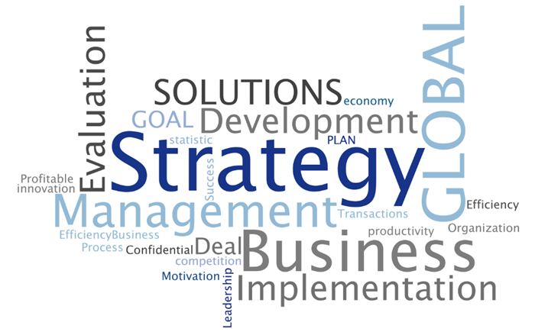

**Integration strategies**

**Forward integration**

* The business combines business with or take over its distributors.
* Involves expansion of business activities to gain control over the direct distribution of the products.
* Dairy factory bought shares in the company that distributes milk, yoghurt and cheese (***example***)

**Backward integration**

* The business combines business with or take over its suppliers.
* The aim is to decrease the business’s dependency on the supplier.
* Dairy factory bought shares in the dairy farm that supplies milk (***example***)

**Horizontal integration**

* A business takes control of/ incorporates other businesses in the same industry/which produce/sell the same goods/services.
* The aim is to reduce the threat of competition /substitute products/services.
* Dairy factory bought shares/ taken over another dairy factory that could have been a competitor (***example***)

**Intensive strategies**

**Market penetration**

* New products penetrate an existing market at a low price, until it is well known to the customers and then the prices increases.
* It is a growth strategy where businesses focus on selling existing products to existing markets.
* Focuses on gaining a larger share of the market by reducing prices to increase sales/increasing advertising and promotion.

**Market Development**

* It is a growth strategy where businesses aim to sell its existing products in new markets.
* This strategy involves finding new markets and new ways to distribute product.

**Product Development**

* It is a growth strategy where businesses aim to introduce new products into existing markets/modifies an existing product.
* Businesses generate new ideas and develop new products/services



**Diversification strategies**

**Concentric diversification**

* The business adds a new product or service that is related to existing products and which will appeal to new customers.
* Occurs when a business wants to increase its product range and markets.
* ***Cell phones sells tablets (example)***

**Horizontal diversification**

* The business adds new products or services that are unrelated/ different to existing products, but which may appeal to existing/current customers.
* Occurs when a business acquires or merges with a business that is at the same production stage, but it may offer a different product.
* ***Virgin mobile open virgin active (example)***

**Conglomerate diversification**

* The business adds new products or services that are unrelated to existing products which may appeal to new groups of customers.
* Conglomerate diversification means that a business grows into new products, services and markets.
* Occurs when a business wants to increase its product range and markets.
* ***Cell phone company selling children’s toys, camping gear, etc*** (example)

********

**Defensive strategies**

**Divestiture/ Divestment**

* The business disposes/sells some assets/divisions that are no longer profitable/ productive.
* Businesses may sell off divisions/product lines with slow growth potential.
* The business sells ownership by decreasing the number of shareholders.
* Unproductive assets are sold to pay off debts.
* Process used to withdraw its investment in another business (divesting).

**Retrenchment**

* Terminating the employment contracts of employees for operational reasons.
* Decreasing the number of product lines/Closing certain departments may result in some workers becoming redundant.

**Liquidation**

* All assets are sold to pay creditors due to a lack of capital/cash flow.
* Selling the entire business in order to pay all liabilities/close down the business.
* Companies in financial difficulty may apply for business rescue to avoid liquidation.
* Creditors may apply for forced liquidation in order to have their claims settled.



**Recommend/Suggest business strategies to deal with challenges identified from given case studies/scenarios.**

**QUESTION 1**

1.1 Identify the business strategy that was used in each of the following scenarios.

1.1.1 The owner of a wedding venue decided to build a guest house on the same premises for wedding guests to sleep over.

1.1.2 Fresh Juices Unlimited bought Potgieter’s grape farm.

1.1.3 Simunye Stores struggles to get fashionable swimming attire and decides to purchase Perseverance Sports (Pty) Ltd Clothing Manufacturer.

1.1.4 Summer Sports decreases the price of soccer balls drastically to influence customers to buy larger quantities.

**ANSWER 1:**

* + 1. Horizontal diversification/ diversification
    2. Backward integration
    3. Horizontal integration/ Diversification
    4. Market penetration

**Discuss/Elaborate on the effectiveness (positives/advantages) of EACH type of business strategy**

**INTEGRATION**

**Forward integration**

|  |  |
| --- | --- |
| **Evaluate the effectiveness (positives/negatives of each business strategy** | |
| **Positives** | **Negatives** |
| The business adds a stakeholder to its supply chain, cutting costs, and increasing potential profits. | Big investment needed and the risk needed to be managed. |

**Backward integration:**

|  |  |
| --- | --- |
| **Evaluate the effectiveness (positives/negatives of each business strategy** | |
| **Positives** | **Negatives** |
| The business adds a stakeholder to its supply chain, cutting costs, and increasing potential profits. | Big investment needed and the risk needed to be managed. |

**Horizontal integration:**

|  |  |
| --- | --- |
| **Evaluate the effectiveness (positives/negatives of each business strategy** | |
| **Positives** | **Negatives** |
| This type of strategy is attractive when an organization competes in a growing industry, where the achievement of economies of scale could provide cost benefits or other forms of competitive advantage and where an organization has both the capital and human talent needed to manage an expanded organization successfully.  It increases the market share | However it may also come up with added costs or re-structuring |

**INTENSIVE**

**Market penetration:**

|  |  |
| --- | --- |
| **Evaluate the effectiveness (positives/negatives of each business strategy** | |
| **Positives** | **Negatives** |
| It increases market share & product usage, drives competitors out of the market and takes dominant position in growth markets. | However it may also come up with added costs on advertising. |

**Market development:**

|  |  |
| --- | --- |
| **Evaluate the effectiveness (positives/negatives of each business strategy** | |
| **Positives** | **Negatives** |
| It requires investment in new market research | Can increase profits but may come with additional costs. |

**Product development:**

|  |  |
| --- | --- |
| **Evaluate the effectiveness (positives/negatives of each business strategy** | |
| **Positives** | **Negatives** |
| New products may be different/ of a higher quality than those of competitors.  It can increase profits but may come with additional production costs. | Image result for pictures new customersIt requires investment in new market research. |

**OR**

**Advantages of intensive strategies**

* Increased market share reduces the business's vulnerability to actions of competitors.
* Increase in sales/income and profitability.
* Improved service delivery may improve business image.
* Businesses may have more control over the prices of products/services.
* Gain loyal customers through effective promotion campaigns.
* Decrease in prices may influence customers to buy more products.
* Regular sales to existing customers may increase.
* Eliminate competitors and dominate market prices.
* Enables the business to focus on markets/well researched quality products that satisfy the needs of customers.

**DIVERSIFICTION**

**Concentric diversification:**

|  |  |
| --- | --- |
| **Evaluate the effectiveness (positives/negatives of each business strategy** | |
| **Positives** | **Negatives** |
| It can lead to an increase in market share.  Can expand the business’ client base.  Brings more diversity to the market  New businesses experience will be obtained. | The strategy is risky as it involves businesses moving into markets where they have little or no experience.  Businesses are required to acquire new skills, facilities and techniques when they apply this strategy.  Businesses must have enough capital if they want to apply the strategy which may not always work for a small business.  Diversification will require increased costs in labour, materials and technology.  The business will become more complex and difficult to manage and co-ordinate.  A great deal of creative thinking is required as the business may lose focus from its main company objectives and goals. |

**Horizontal diversification:**

|  |  |
| --- | --- |
| **Evaluate the effectiveness (positives/negatives of each business strategy** | |
| **Positives** | **Negatives** |
| It can lead to an increase in market share.  Can expand the business’ client base.  Brings more diversity to the market  New businesses experience will be obtained. | The strategy is risky as it involves businesses moving into markets where they have little or no experience.  Businesses are required to acquire new skills, facilities and techniques when they apply this strategy.  Businesses must have enough capital if they want to apply the strategy which may not always work for a small business. |

**Conglomerate diversification:**

|  |  |
| --- | --- |
| **Evaluate the effectiveness (positives/negatives of each business strategy** | |
| **Positives** | **Negatives** |
| It can lead to an increase in market share.  Can expand the business’ client base.  Brings more diversity to the market  New businesses experience will be obtained. | The strategy is risky as it involves businesses moving into markets where they have little or no experience.  Businesses are required to acquire new skills, facilities and techniques when they apply this strategy.  Businesses must have enough capital if they want to apply the strategy which may not always work for a small business. |

**OR**

**Advantages of diversification strategies**

* Increase sales and business growth.
* Diversification into a number of industries or product line can help create a balance during economic fluctuations.
* More products can be sold to existing customers and additional more new markets can be established.
* Businesses gain more technological capabilities through product modification.
* Business produce more output using less inputs as one factory may be used to manufacture more products.
* Improves the business brand and image.
* Reduces the risk of relying only on one product.

**STRATEGY EVALUATION**

**Outline/Explain/Recommend/Advise businesses on the steps in strategy evaluation**

* Examine the underlying basis of a business strategy.
* Look forward and backwards into the implementation process.
* Compare the expected results in order to determine the reasons for deviations and analyse these reasons.
* Take corrective action so that deviations may be corrected.
* Set specific dates for control and follow up.
* Draw up a table of the advantages and disadvantages of a strategy.
* Decide on the desired outcome.
* Consider the impact of the strategic implementation in the internal and external environments of the business.