**Cartoon June 2018**

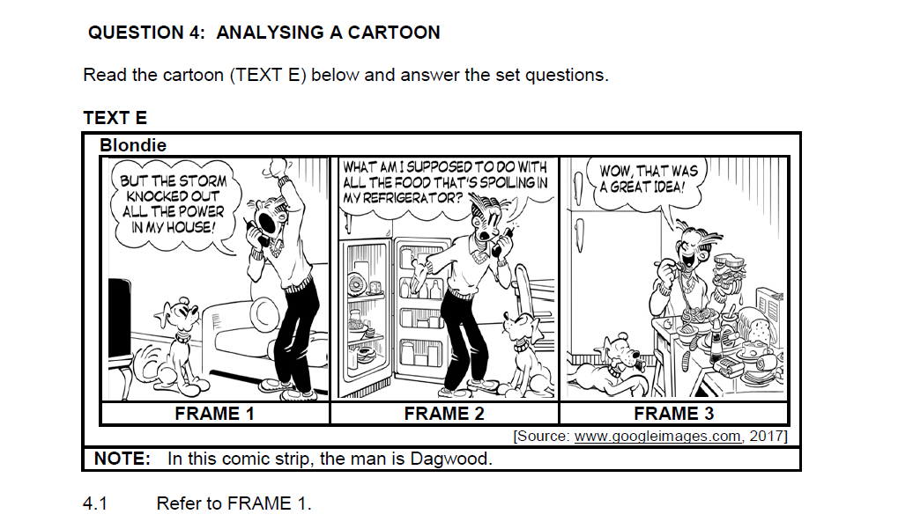 4.1.1 Which TWO visual clues indicate that Dagwood is angry? (2)

4.1.2 What is meant by 'knocked out'? (1)

4.2 What is the difference in setting in FRAMES 1 and 2? (2)

4.3 Refer to FRAME 3.

4.3.1 Choose the correct answer to complete the following sentence: The word, 'WOW,' suggests… (1)

A distress.

B delight.

C despair.

D desire.

4.3.2 How does the dog's body language in this frame support the suggestion made to Dagwood? (2)

4.4 In your opinion, is the solution that was suggested to Dagwood over the telephone a good one? Substantiate your response. (2)

[10]