Grade 12 Climatology
Summary and Notes
by Kim Frost 2021

The Basics
A few basic concepts to help us understand the What, How, Where and When of mid-latitudes in the Southern Hemisphere.

1. Warm air Rises and contains Moisture
2. Warm air leads to wet and warm conditions
3. Warm air forms a LOW Pressure cell
4. Moves in a clockwise direction in the Southern Hemisphere
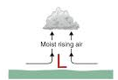
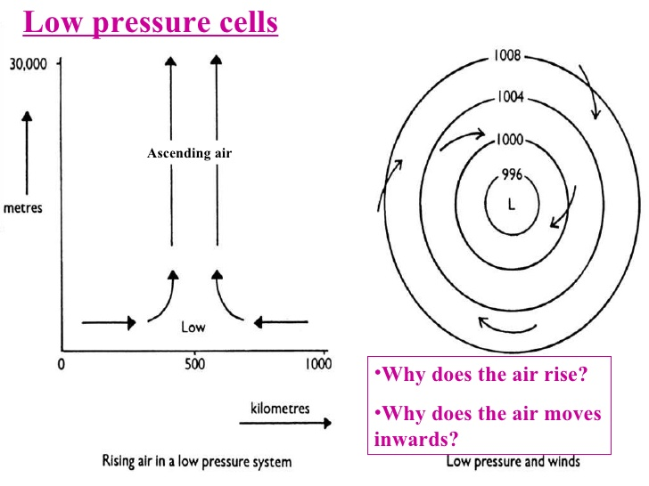
www.atmo.arizona.edu

4. Cold air sinks and leads to dry cool conditions.
5. Cool air forms a High Pressure cell
6 Moves in an anti-clockwise direction
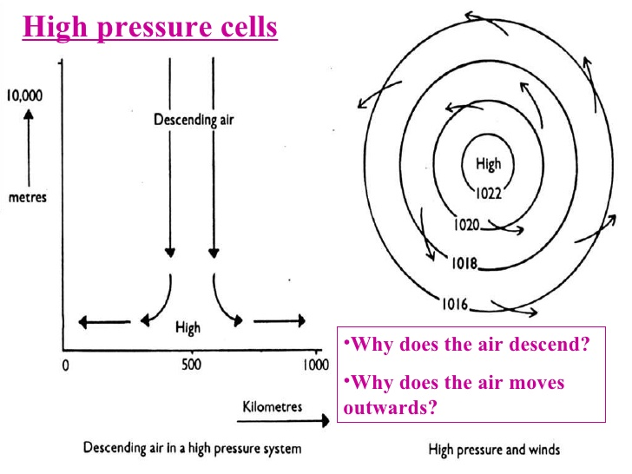

Weather conditions along the lines of latitude
0º - Warm rising air= Low pressure
30º – Dry and cool = High pressure
60º- wet and warm = Low pressure
90º- Dry and cool= High pressure
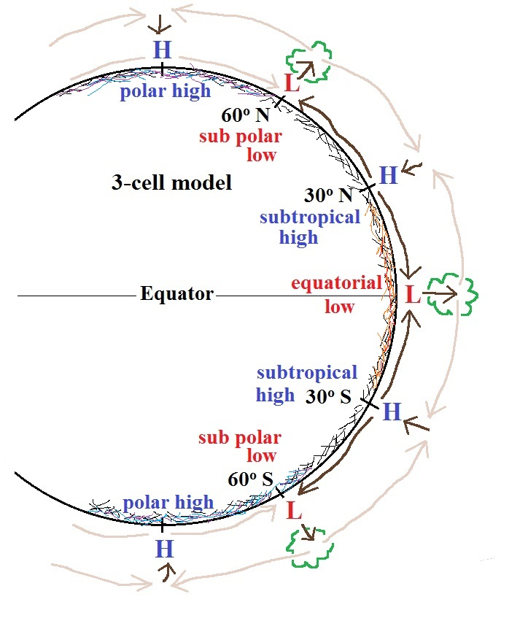

Oct 4, 2009 Rob Machetto

Global wind Patters and Direction
1. Wind always blows from a high pressure to a low pressure
H
L

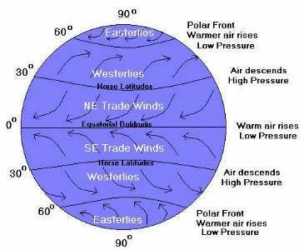
image 6 https://www.weatherwizkids.com/weather-wind.htm

Air rotation around High and Low pressure cells in the different hemispheres:

Northern Hemisphere:
Low pressure cells = anticlockwise
High pressure cell = clockwise

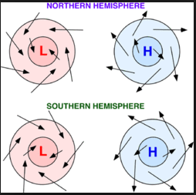

pressure cells - Tony Butt on 18th June 2019

Southern Hemisphere (South Africa)
Low pressure cells= clockwise
High Pressure cells = Anticlockwise

Mid-Latitude Cyclones
Exam preparation
Please Note: This information forms the very basic knowledge you need in order to pass your Climatology section in your paper. In order to get 60% and above, you will need to learn from multiple textbooks, past papers and notes.

1. General Characteristics of a Mid-Latitude Cyclone
- Low pressure cell
- Air moves in a clockwise direction in the Southern Hemisphere (anticlockwise in the northern hemisphere)
- Moves from West to East (easterly direction)
- Develops warm and cold fronts

2. Areas in which Mid-latitude Cyclones form

Form along the Polar front
At 60º N and S latitudes.

3. Conditions necessary for Mid-Latitude Cyclones to form

A warm air mass must meet a cold air mass along a polar front.

4. Stages of Development of a Mid-Latitude Cyclone:
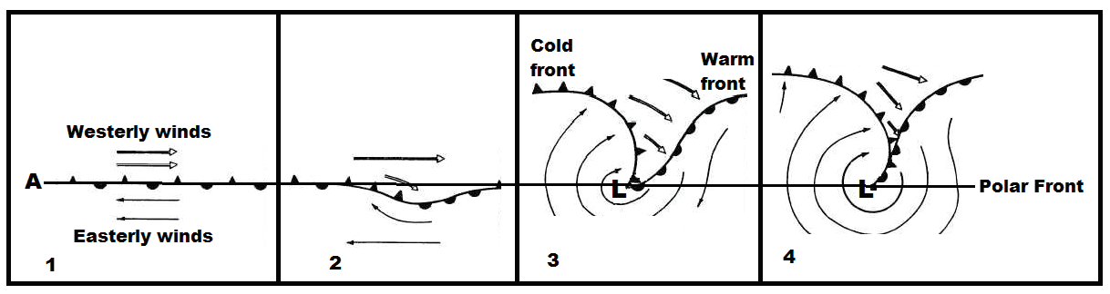

Stage 1- Initial Stage
- warm air meets cool air along the polar front

Stage 2- Developing stage
- warm air pushed into cool air
- a kink develops
- cool air is forced to move
- creates a rotation of air around the ‘’kink’’
- forms a low pressure centre

Weather conditions associated with Cold and Warm Fronts

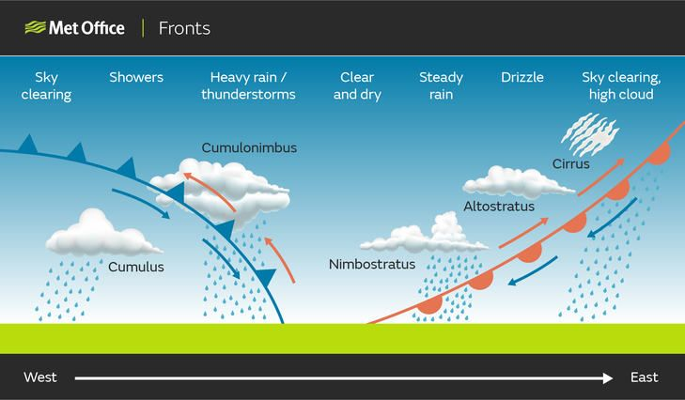

Copyright of futurelearn.com

Warm front: Cirrus and Altostratus clouds
light soft rainfall
wind direction: north easterly
Cool temperatures
Warm sector (behind warm front)
clear skies
Hot and dry conditions
strong winds: North or North Westerly direction

Cold Front: Cumulonimbus clouds
(cold sector) Heavy Rainfall
Very cold Temperatures
wind: South Westerly direction

Stage 3- Mature Stage
- distinct (clear low pressure)
- clear warm front
- clear cold front
- moves eastwards
- warm sector and cold sector

Stage 4- Occluded Stage
- Cool air catches up with warm air
- left with only cool air
- No more low pressure cell
- Goes back to normal
Weather conditions related to the Occluded Stage:

Cold Front Occlusion
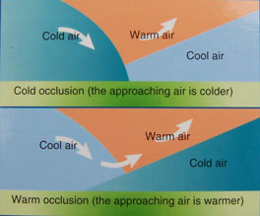
warm front Occlusion
Cold front Occlusion

- Air will be colder after the cold front
- Big Cumulonimbus clouds and heavy rainfall

Warm front Occlusion

- Air is colder before the cold front
- Altostratus clouds with light rainfall

Mid-Latitude Cyclones and the Impact on Human Activity

1st describe a weather condition, Then say how it impacts human activity.......

Negative Impacts
1. Berg Winds : Hot dry winds lead to veld fires which damage crops, kills livestock and causes damage to farm houses and sheds
Rough and dangerous seas in Cape Town

2. Heavy Rainfall – Damages crops and leads to soil erosion,
Flooding in Cape Town- damages buildings and infrastructure

3. Snowfall and very cold temperatures
- Leads to stock losses (animals die of cold)
- Grass is covered by snow – no food.
- slippery roads in towns- dangerous
4. Frost- frost is damaging to crops and vegetation.

Positive Impacts:
Rainfall- helps crops to grow
fills dams and rivers in winter
snow – melts it provides water to mountain regions

cold Temperatures kills harmful insects, ticks and fleas

