**TRIG. FORMULAE NOTES**

**RIGHT ANGLED TRIANGLE**

**USE TRIG FUNCTIONS:**

TRIGONOMETRY NOTES

|  |  |
| --- | --- |
| 5.1 |  |
| 5.2 |  |
| 5.3 |  |

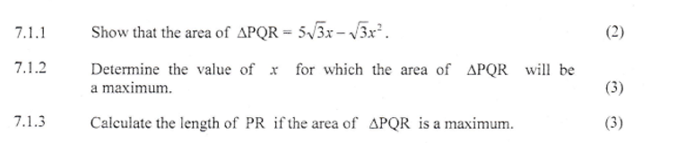

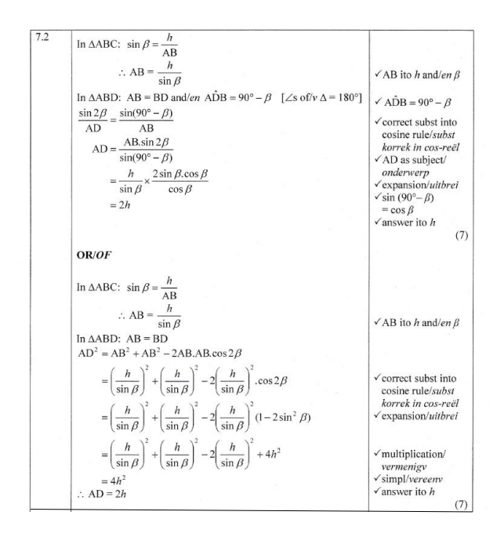

A triangle with a triangle and a triangle with a triangle and a triangle with a triangle with a triangle and a triangle with a triangle with a triangle with a triangle with a triangle and a triangle with

|  |  |  |
| --- | --- | --- |
| QUESTION 7 | | |
| 7.1 |  |  |
| 7.2 |  |  |
| 7.3 |  |  |

|  |  |
| --- | --- |
| MARCH 2018 | NOVEMBER 2018 |

