**LIFE SCIENCES**

**HUMAN REPRODUCTION – PAST PAPER QUESTIONS**

**DBE November 2019**

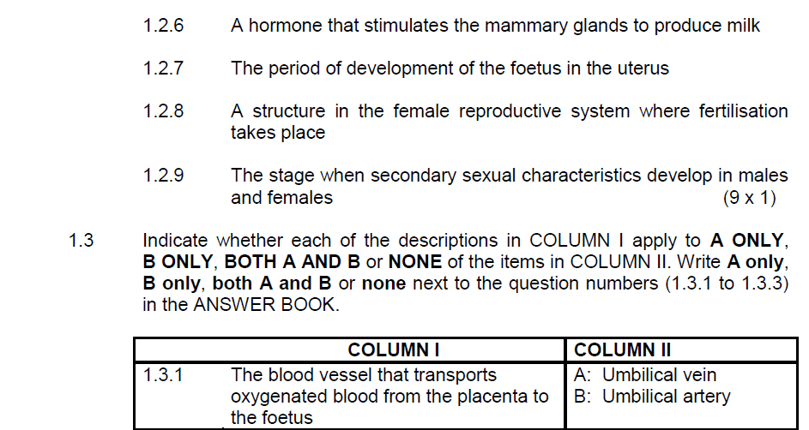

**LIFE SCIENCES**

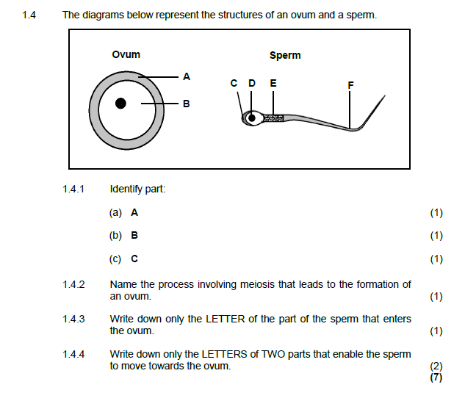

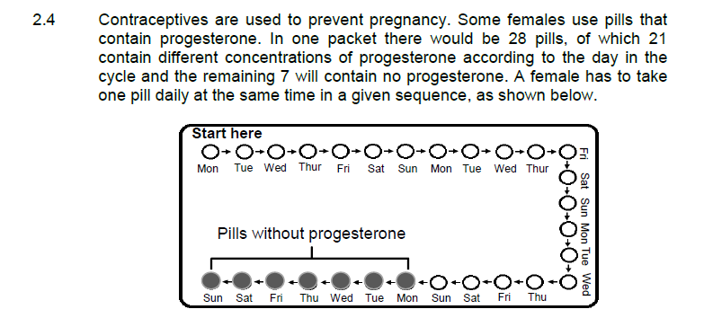

**LIFE SCIENCES**

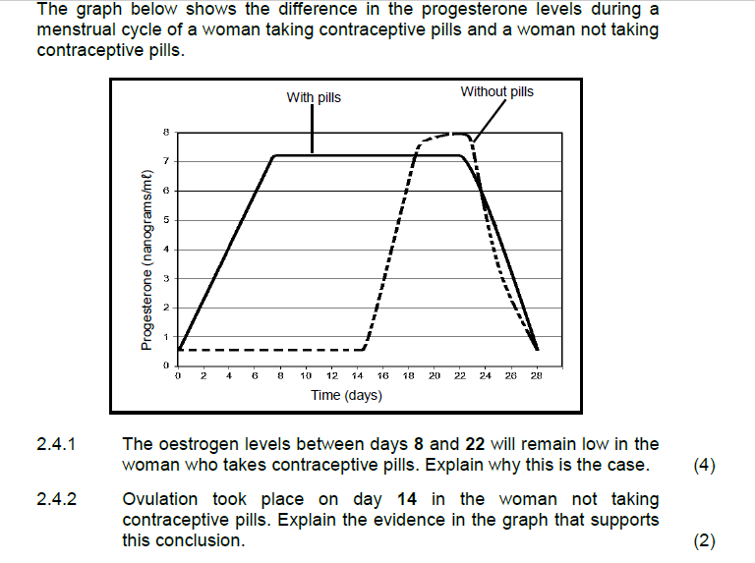

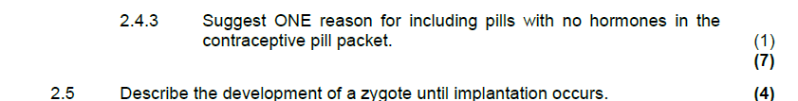

**LIFE SCIENCES**

**DBE November 2018**

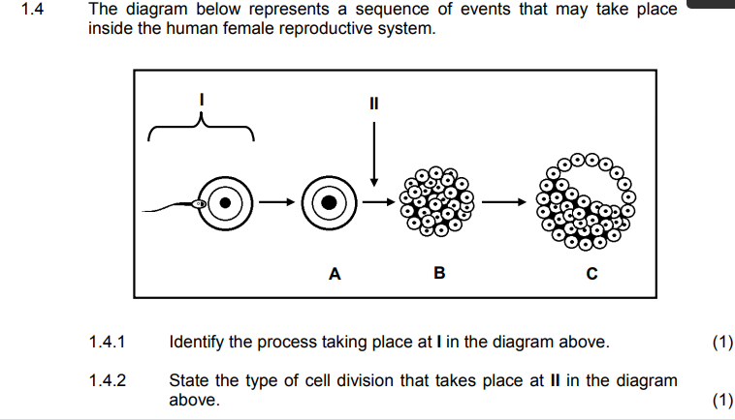

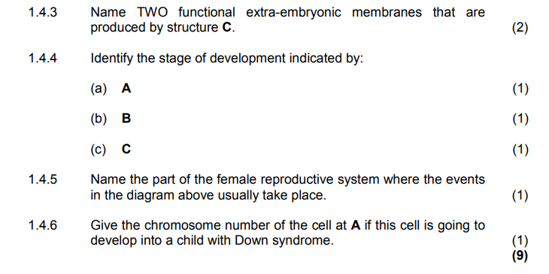

**LIFE SCIENCES**

**DBE November 2017**

